Topographical Map

Sudbury 1948 SE Quadrangle
http://docs.unh.edu/VT/sudb48se.jpg
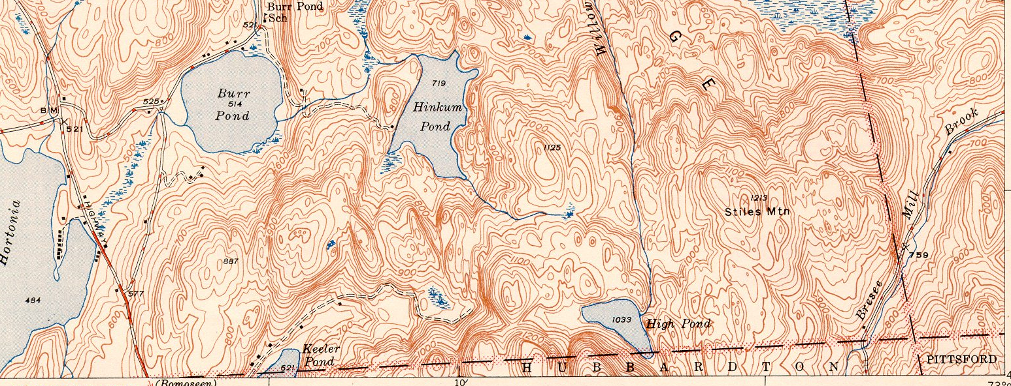
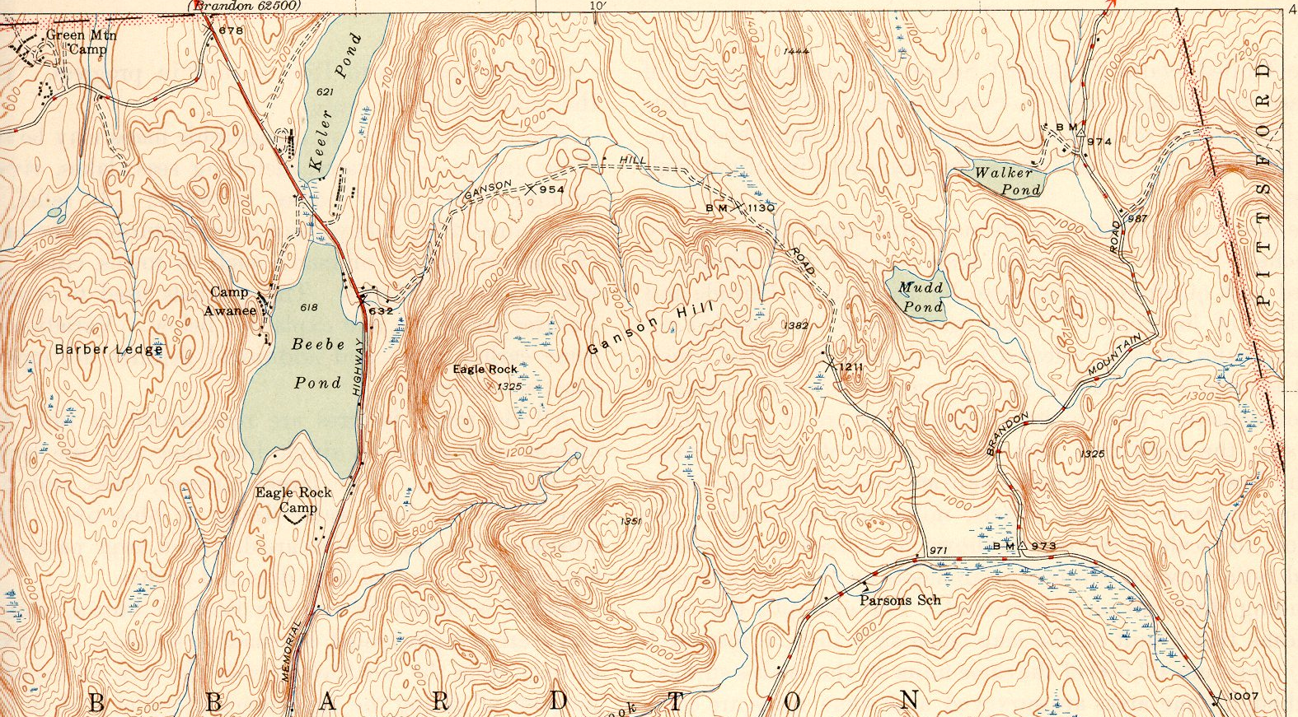
Bomoseen 1946 NE Quadrangle
http://docs.unh.edu/VT/bomo46ne.jpg

Some interesting topos are at:
Historic USGS Maps of New England: 1897 and 1946. http://docs.unh.edu/towns/HubbardtonVermontMapList.htm

