**SUMMER CAMPS on LAKE HORTONIA**

**There were two “Green Mountain” camps on Camp Road. They were started around 1920 and were referred to as camps for "brothers and sisters". Sam DuBoff and his wife Bernice “Tuck” Tucker bought these camps around 1950. They were divorced in 1963. Sam then ran Green Mountain Boys Camp and Tuck ran Green Mountain Girls Camp. Tuck changed the name to Camp Birchwood for Girls and married Dan Dell.**

**i) Green Mountain Boys Camp, was sold by Sam DuBoff to Martin “Bing” Rosen in late 1963 after June Sherline closed her girls camp on Beebe Pond. Bing changed the name to Vermont Wanee Camp and operated both Twin Lake Camp and Wanee until the early 1970’s. Wanee, whose lake frontage is in Sudbury, is on Camp Road about one half mile from Route 30. Around 1978 the property was sold to Sallie Adams who subdivided the property for vacation use and it is now called Green Mountain Village. The property consisted of over 100 acres and three-fourths of a mile of lake frontage. There was also a building for parents, similar to Twin Awanee Lodge on Echo Lake.**

**ii) Green Mountain Girls Camp, whose name was changed in 1964 to Camp Birchwood for Girls operated through 1981. Tuck Dell sold Camp Birchwood to Peter Shays around 1983, who in turn sold it to Birchwood Shores (some Lake Hortonia property owners) a year later. In 1986 James and Maria Weiss bought this property from Birchwood Shores, Inc. and renamed it Camp Wachusett after a defunct camp in New Hampshire. It then became a camp for boys and it is still in operation. This camp is also on Camp Road about one mile from Route 30 on 40 acres with 900 feet of lake frontage. (Bess Myerson went to Green Mountain Girls Camp around 1945 and acted in a play at the Sudbury Town Hall/Church).**

**A brochure for "Green Mountain Camp, The University of Nature" included the following:**

**Season: July First to September Second 1920. Directors: John Linker and Abraham Sachs. Head Counselor: John Gusick. Secretary: John Pelletier. Tuition is $275. Roundtrip rail from New York City is $15. Private instruction in horseback riding is an extra $50 for the season. Buildings: Administration, Auditorium (40' by 60'), Club House, Dining Room, Science Building, Lecture Hall, Boat House, Library, Camp Store, Wash Room, Laundry, Kitchen, Ice House, Work Shop, Machine Shop, Garage, Photo Room, Nurses Building, Infirmary, 20 Bungalows, and 2 Cottages. There is a separate building (60' by 60') for the "Midgets" (ages 8-10). Two doctors are in constant attendance. Gold, Silver, and Bronze medals are given to Midgets, Juniors, Sophomores, and Seniors in 18 different sports and competitions.**

**Camp Wachusett**

**Camp Wachusett was founded on Squam Lake in NH in 1903 and shut down in 1986. The Birchwood property was purchased from the Lake Hortonia Property Owners' Association and the name "Camp Wachusett" was moved to Lake Hortonia in 1986. It has operated since as a Boy's camp with 12 cabins, 25 counselors, and about 80 boys, who stay for 2, 3, 4, 5, and 7 weeks. One program includes being out over night…canoeing or hiking.** <http://www.campwachusett.com/>

**"Camp Wachusett provides a rich and varied recreational program in a lovely New England setting. It generates a spirit of fun, excitement, and adventure as it strives to realize its broader purpose of personal and social growth for each camper. It promotes a boy's sense of independence and self-confidence as well as his sense of himself as part of a group. It recognizes that an environment that is relatively small maximizes the opportunity to "care" for each boy in a special way and to devote the time and energy to his welfare that he deserves.**

**Camp Wachusett occupies 40 acres along the shores of Lake Hortonia in the town of Hubbardton, Vermont. Hubbardton lies about an hour south of Burlington and two hours northeast of Albany, with the Green Mountains just to the east and Lake Champlain a short distance to the west. Lake Hortonia, with approximately 450 acres, is a lake that is both clean and quiet. The camp's property includes about 900 feet of lakefront and accommodates an enrollment of seventy-five boys, ages 8 to 14.**

**The camp's waterfront consists of a large swimming beach, a main pier, and two rafts -- one with a sliding board and another for waterskiing. The camp owns a 240 horsepower ski boat, five rowboats, six sailboats, and fourteen canoes. Additional facilities include two playing fields, two full basketball courts, four tennis courts, an archery range, a rifle range, a Council Circle, and a large surfaced area for rainy day activities, roller blading, and street hockey.**

**Each of the twelve sleeping cabins will accommodate six to eight campers and one or two staff. Every camper is expected to keep his bed and belongings straight and to help with some of the collective responsibilities designed to keep the property attractive. Other buildings include a spacious dining room and a huge lodge which overlooks the lake and which features an auditorium and stage. A nurse oversees the daily health needs of the campers. If the services of a physician or hospital are needed, they are available in Rutland, thirty minutes away. The camp's health and safety records are superb.**

**Wachusett's schedule is an effort to combine structured and unstructured time within each day. Both are supervised, but the boys usually have greater freedom of choice during unstructured time. Each boy must attend meals, the instructional activities he has chosen, most General Swims, special periods devoted to team sports, and the final activity of the day. The least structured part of a typical day is the hour and fifteen minutes of free time after dinner, although there are other times during the day that boys are likely to have some free time available.**

|  |
| --- |
| **James and Maria Weiss Owners/Directors**  **Winter Address 11112 Waycross Way Kensington, MD 20895**  **(301) 933-1709 800-847-9763 Fax: (301) 933-0453**  **E-mail:** [**Director@campwachusett.com**](mailto:Director@campwachusett.com) |

**____________________________________________________**

|  |
| --- |
|  |
| **The White House** |

**Bill Steele, of Sudbury, Vermont purchased the White House, on the southwest corner of Camp Road and Route 30, from Stephen and Edith White in 1954. It was called a "Pop Stand". He sold ice cream, ice, gas and oil, cigs, and cigars. (a White Owl cigar cost 10 cents). The "Pop Stand" was about 60 feet by 40 feet, with a door you could go through to a second building 4 feet west, that was about 45 feet by 60 feet. He could seat 75 people in a back room where hamburgers, fries, etc were served. At one time there was a poster of Nixon drinking pop and standing outside the White House. Bill Steele sold the property to Dan Dell in 1964. Dan Dell ran it in conjunction with Camp Birchwood, and sold it to Perry McEdward in 1981. McEdwards sold the property to John Trombley a year later. The "Pop Stand" was torn down in 1983. John Trombley then sold the property to Patricia & Herbert Perkins in 1984.**

|  |
| --- |
|  |
| **The White House (Built around 1920)** |

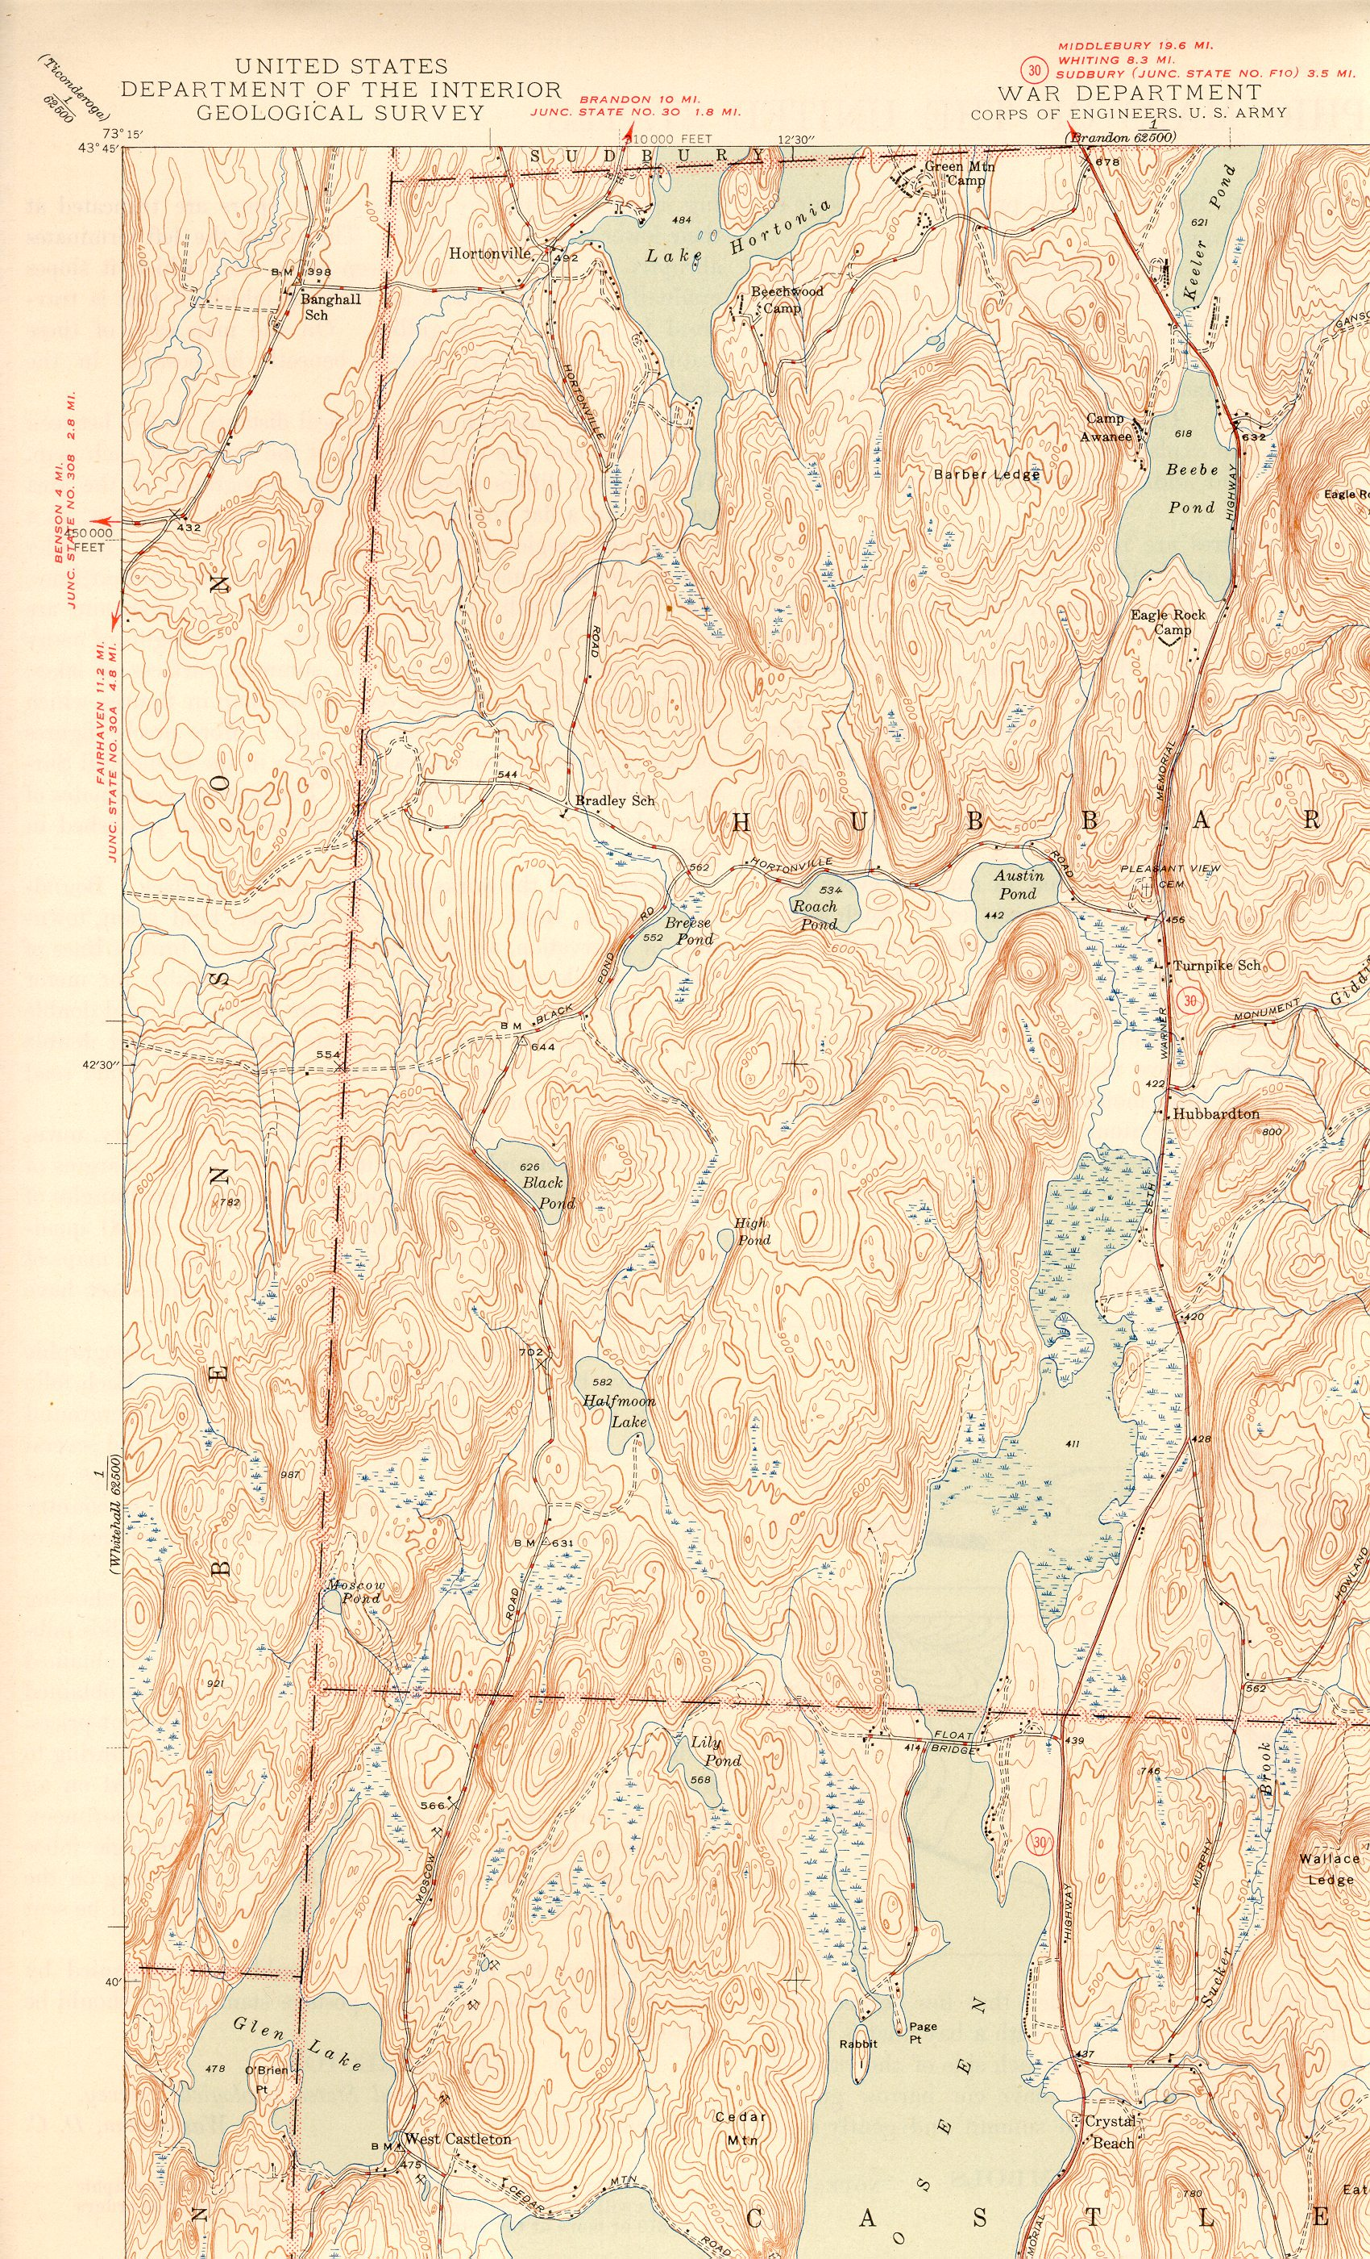

**The 1944 US Survey shows some of the camp locations in Hubbardton:**

**Beechwood Camp, Green Mountain Camp, Camp Awanee, and Eagle Rock Camp (Camp Columbia)**