EAGLES in VERMONT

Two bald eagles fledge in Vermont
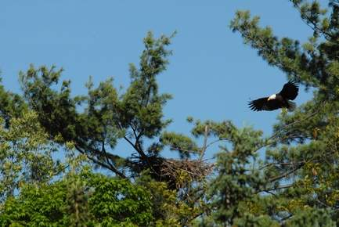 | An adult bald eagle makes a return to its nest in Barnet. For the first time in 60 years, two bald eagles have successfully fledged in Vermont — one in Concord, the other in Barnet.  John Hall / Vt. Fish & Wildlife

By Dennis Jensen Staff Writer - Published: July 30, 2009
Last year, Vermont had just one. This year, Vermont saw two successful bald eagle nesting sites, with two eagles hatching, fledging and taking to flight.
It was the most successful fledging in Vermont since the 1940s.
One bird fledged from a nest in Concord — in what was a repeat of a successful nesting one year ago — and another bald eagle fledged from a nest in Barnet, according to Paul Hamelin, a biologist with the Vermont Fish & Wildlife Department.
Both birds fledged and took to flight last week, Hamelin said. It followed by one year the first successful fledging of a bald eagle in Vermont in some 60 years.
"Now we have two successful hatchings, two eagles," he said. "We've doubled our nesting population. It says we're on the right track to recovery and, hopefully, a robust eagle population in Vermont."
Fish & Wildlife biologists did not learn about last year's fledging in Concord until after the fact, Hamelin said.
"A gentleman had been watching the eagles and kept it a secret," he said. "He didn't want it to be disturbed. He watched the chick as it was growing and kind of observed them through the summer, right up until it flew from the nest."
In Concord, after the adult eagles had a successful breeding season in 2008 and left the nest, Fish & Wildlife biologists returned to the site to help protect it from raccoons, fishers and other predators that might raid the nest, Hamelin said.
"We went back to that successful nest during the wintertime, in early March, and installed some predator deterrents," he said. "We put aluminum predator guard around some trees to help ensure their success this year."
Hamelin said the department was thrilled when the eagles returned to the site this year.
"Then we went back to that nest site April 1 and there was an adult eagle. They came back to the same nest. Then, throughout the summer, I watched them periodically and they again raised one more eagle chick," he said.
Last year, in Barnet, a resident observed a pair of bald eagles building what Hamelin called a "practice nest," but no one contacted Fish & Wildlife about the nesting.
"We call them a practice nest or a honeymoon nest. A pair of eagles will actually build a nest and then not nest. It's a part of their pairing up, a bonding, sort of like humans living together," Hamelin said. "They'll meet again at the site the next spring, lay eggs and raise young there."
On March 25, a fledgling eagle was observed in the Barnet nest, the biologist said.
"The eagle probably hatched right around the first of May or the end of April," he said.
The flight of a fledgling bald eagle is not accomplished overnight, Hamelin said.
"It's a real slow process," he said. "They do a lot of beating of their wings, building up the wing muscles. There's a lot of little test flights, not a big leap of faith from the nest. Their first flight might be 20 feet up into the treetops."
Even after they take flight, immature bald eagles are dependent upon the adults for food.
"They can't feed themselves," Hamelin said. "They'll come back to the nest and beg for food. They'll sit, perched for hours, while the adults are off fishing or hunting."
Eventually, the adults wean their young, forcing them to hunt and fish for their own food.
Fish make up most of the prey for bald eagles, Hamelin said.
Bald eagles are marked by a bright-white head and white tail. Females are larger than males, can weigh up to 14 pounds and have a wing span of about 8 feet. The smaller males weigh about 10 pounds, with a wing span of about 6 feet.
Hamelin was emphatic about humans going out of their way not to go anywhere near an active bald eagle nest.
"Eagle nest sites are very sensitive to human disturbance and human presence," he said. "The best thing you can do is give them a lot of space, especially when it comes to human activity, whether it's boating too close, hiking, an ATV, whatever."
If humans do venture too closely, "it could cause them (the eagles) to leave that site forever," Hamelin said.
The last recorded nesting of a bald eagle in Vermont was near Lake Bomoseen in the 1940s, Hamelin said.
Habitat loss and the use of DDT led to the disappearance of bald eagles in Vermont, he said.
"A lot of Vermont was deforested, particularly the large pines, which are primarily the nesting sites for bald eagles," he said.
Hopefully, Hamelin said, bald eagles will follow the same path of the osprey, which vanished from Vermont in the late 1980s.
"Ospreys are common now. You can see them on the top of utility poles or in a dead tree," he said.
Over time, bald eagles should slowly become a part of the Vermont landscape, Hamelin said.
"I think they're on their way back. Look at the surrounding states for the future," he said.
Vermont is something like the "hole in the doughnut" to bald eagle recovery, Hamelin said.
Bald eagles are always associated with large bodies of water. The birds were first recolonized along the Atlantic Coast, Hamelin said. Massachusetts and Connecticut, both coastal states, already have "great populations" of this country's national symbol, Hamelin said. "Eagles are all around us.
"This is fantastic news," he said. "This is one of the last, large, really obvious wildlife species in the state that we've been lacking for the last 60 years."
Vermont had six nesting sites this year — two in southeastern Vermont, one in southwestern Vermont and three in the Northeast Kingdom, Hamelin said. Only two produced young.
"I think we will continue to see more successful nests every year. We'll probably have some ups and downs but, overall, I expect they will be an increasing trend," he said.
dennis.jensen@rutlandherald.com
EAGLE at BEEBE POND
The picture below was taken by Wendy Buser in July 2009. He liked to perch in the dead tree across from the Brundages. He was around all summer.
He returned to Beebe in late March 2010.
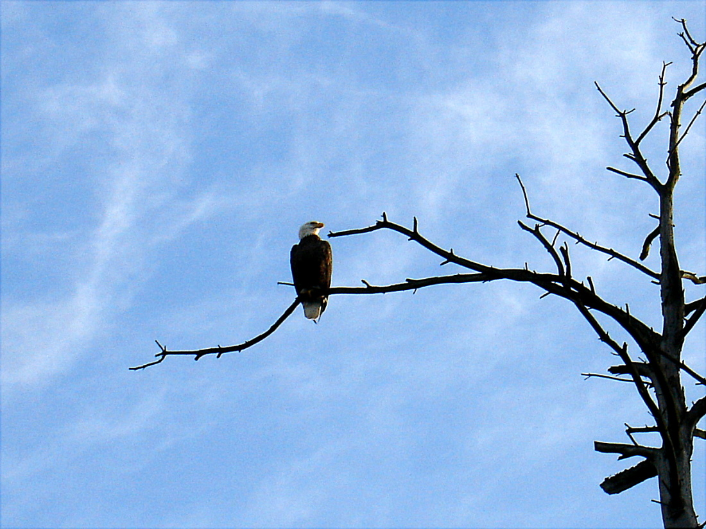

EAGLE on Bald Eagle Drive in NAPLES, FLORIDA November 2009
