Former Pavilion Property on Lake Hortonia

92 Walker Grove Road Sudbury, VT 05733
$639,000

4 Bed, 2.5 Bath | 3,850 Sq Ft on 1.64 Acres |

MLS #2912433

PRISTINE YEAR ROUND LAKE HOME
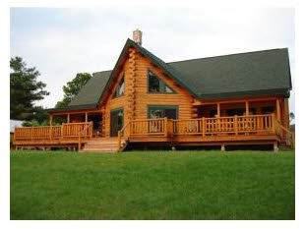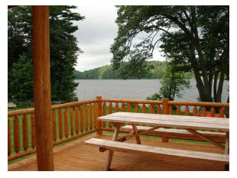
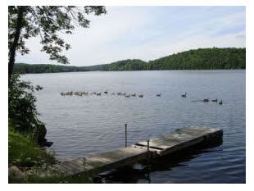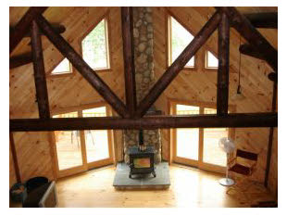

Property Information for 92 Walker Grove Road
Embracing Lake Hortonia with 250’ of beautiful lake frontage nestled on a peninsula, this is a premium, one-of-a-kind setting! 2007 incredible log construction with soaring 20’ ceilings, massive log beams, a river rock wood stove hearth and impressive windows galore. Spectacular great room, 4 bedrooms and upscale cherry wood kitchen and baths. Unprecedented 1.64 acres enhanced by a level beach for swimming, fire pit and great dockage. Priced to sell.

Property Features
- Single Family Property  - Status: Active  - Area: Rutland  - County: Rutland  - Subdivision: None (Sud)  - 4 total bedroom(s)  - 2.5 total bath(s)  - 2 total full bath(s)  - 1 total half bath(s)  - 8 total rooms  - Approximately 3850 sq. ft.  - Two story  - Type: Log, Single Family | - Master bedroom  - Living room  - Kitchen  - Basement  - Bedroom(s) on main floor  - Master bedroom is 16'X16'  - Living room is 38'X21.6  - Family room is 14'X17'6"  - Kitchen is 13'X15'  - Basement is Bulkhead/Bilco, Full, Unfinished  - Fireplace(s)  - Fireplace features: Wood Stove Flu/Hearth  - Heating features: Propane, Radiant, Wood | - Inclusions: Exhaust Hood, Wall Oven  - Exterior construction: Log  - Roofing: Archit. Shingle  - View  - Hill/mountain view  - Waterfront property  - Waterfront features: Lake Access, Lake Frontage  - Approximately 1.64 acre(s)  - Lot size is between 1 and 2 acres  - Utilities present: Drilled Well, Conventional Leach Field, Septic Sewer  - Elementary School: Sudburys Country School  - Middle School: Homeowner Choice  - High School: Homeowner Choice
Interior Features
Exercise Room, Great Room, Master Bath, Master Bedroom on Main Level, Propane Water Heater, Eat-In Kitchen, Living/Dining Combo, Softwood Floors, 220 Plug, Ceiling Fan, Vaulted Ceiling, Walk-in Closet, Poured Concrete Foundation, Bedroom 2 is 11'X15', Bedroom 3 is 17'X13', Bedroom 4 is 17'X13', Utility Room is 12'X10'
Exterior Features
Covered Porch, Deck(s), Outbuilding(s), Shed, Road Frontage is 265 SQ FT, Driveway Gravel/Crushed Stone

