MOUNT GREYLOCK and ART MUSEUMS in WILLIAMSTOWN and NORTH ADAMS MASSACHUSETTS
http://www.huffingtonpost.com/malerie-yolencohen/top-six-things-to-do-in-w_b_6865638.html

Top Six Things to Do in Williamstown and North Adams MA: Astounding Art and More in the Northern Berkshires
0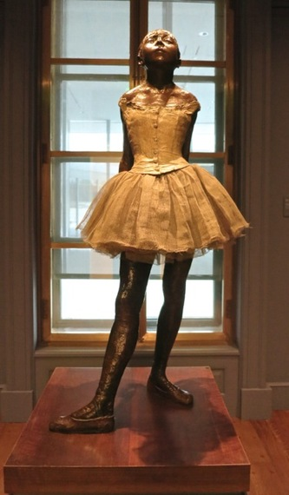
What is it about the extreme northwestern corner of Massachusetts, squeezed between Mt. Greylock and the Green Mountains of Vermont, that draws such exceptional art institutions? Both the ballsy Massachusetts Museum of Contemporary Art (MassMOCA) and the reinvented Clark Art Institute (formerly named the Sterling and Francine Art Museum) have very different - polar opposite - origin stories but have changed the local landscape in similar ways (primarily by boosting tourism).
North Adams - a thriving mill town until Sprague Electric closed up shop, and Williamstown - home to preppy Williams College, have their own styles and vibes but are both worth exploring for a weekend or more.
For more information on these destinations and others in the Northeast USA and beyond, consult the Getaway Mavens at GetawayMavens.com.

Here are the Top Six Things To Do in Massachusetts's Artsy Corner:

0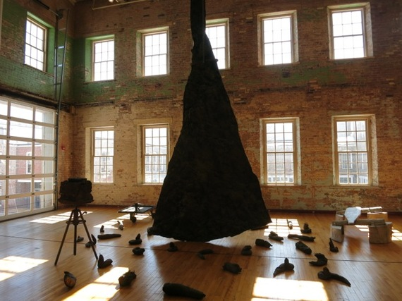
- Spend the good part of a day at MassMoCA (Massachusetts Museum of Contemporary Art). Housed in a repurposed 19th century mill complex, you'll find massive sculptural, projection and painted installations from Sol LeWitt, Anselm Kiefer and many others throughout a labyrinth of rooms. The 26-building compound, which once housed a textile dye factory and then Sprague Electric (1930-1985), is now a cutting-edge world-renowned art museum and performance space. The institution is expanding out, refurbishing and taking over other mill buildings, drawing the likes of the fine Gramercy Bistro restaurant, book publishers, lawyers, accountants and other businesses. Most of the Museum exhibits are temporary and site-specific. And thrilling. Kids love it here - it's a dynamic place, and worth returning to again and again.

0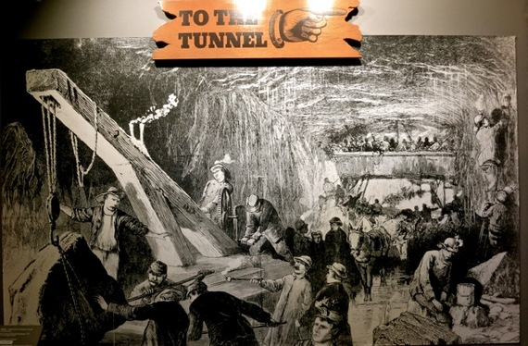
2. Check out Western Heritage Gateway State Park Visitor's Center. North Adams would have never been a mill-town in the first place if it weren't for the brave men who engineered, blasted and constructed the Hoosac Tunnel, which connected Boston to Albany via this section of Massachusetts. Civil Engineers of the day devised a way, without computers or machine drills, to blast through 25,000 linear feet of dirt and rock (working from each side of the mountain), meeting in the middle with a total alignment error of less than an inch. It took over two decades (from 1851-1875), and much loss of life (over 200 men died, mostly from nitroglycerine explosions), but this feat of engineering remains, at 4.75 miles, the "longest railroad tunnel in North America east of the Rocky Mountains". The harrowing story of the building of the Hoosac Tunnel is recounted in the excellent Heritage Gateway Visitor's Center, located in the former Boston and Maine freight yard, and is a great way to round out a visit to North Adams.
0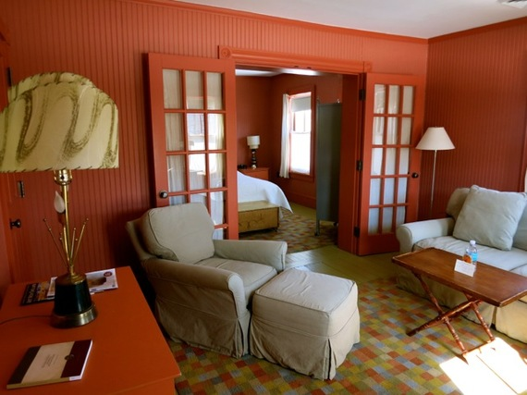
3. Stay in former millworkers row homes at the boutique Porches Inn. Once a dilapidated series of row houses for the millworkers who toiled across the street (in the mill that now serves as MassMoCa), each guest room has been reworked as an upscale, charmingly quirky take on blue-collar Victoriana. One-bedroom suites are equipped with Queen beds and pocket doors that close off a sitting room with desk, settee and pullout couch. Touches include pumpkin-colored wainscoting, linen curtains that look like hanging laundry, TV/Minibar cabinets built to resemble apothecary cases, and in the gleaming bathrooms - white subway tiles, slate floor, and mirrors framed with wood salvaged from the original homes. Though a Continental Breakfast is set out in the Reception Building, opt for breakfast delivered to your room; a coffee-filled thermos and cakey croissant arrive in a vintage galvanized lunch-box.

0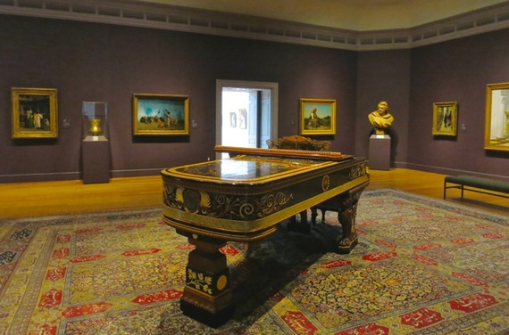
- Spend a day at the Sterling and Francine Clark Art Institute aka The Clark (Williamstown). The reopening of The Clark in July 2014 after a $145 million dollar expansion and renovation made international news, especially after it garnered a positive and prominent Arts Section review in the New York Times. The new Clark Center building, designed by Japanese Architect, Tadao Ando, practically disappears into the hillside. Surrounded by meadows, reflecting pools, hills and trails, the Clark Center, linked to the renovated Museum Building via a granite and glass walkway, is a visually pleasing addition to the landscape. The Clark's original white marble Museum building has been brought into this new century by architect, Annabelle Selldorf, whose mission was to "make the museum space better without anyone noticing." What one notices are the deeply hued gallery walls and standout French Impressionist collection that includes over thirty Renoirs, some Degas, Monet's, Manet's, along with classic American artists and a selection of Renaissance and Religious pieces. Be sure to spend time wandering the grounds, or, in warmer weather, take a seat on the patio and savor the view.

0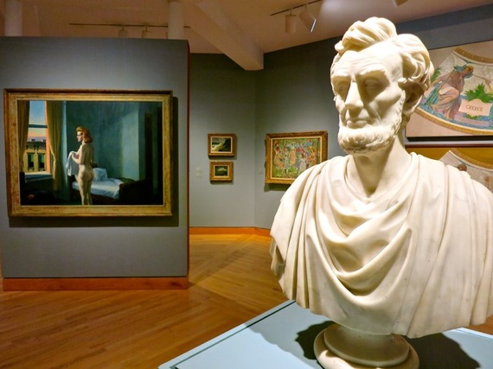
- Stop in to The Williams College Museum of Art. On the Williams College campus, the collection spans the history of art, with focus on work from 18th century to present. As a "teaching" museum, permanent galleries sport a whimsical juxtaposition of objects; for example, a bust of Abe Lincoln seeming to disapprove of a nearby Edward Hopper nude. Temporary shows are both important and popular (Frank Lloyd Wright's Early Work is up until May '15, and Andy Warhol By the Book though August '15).

0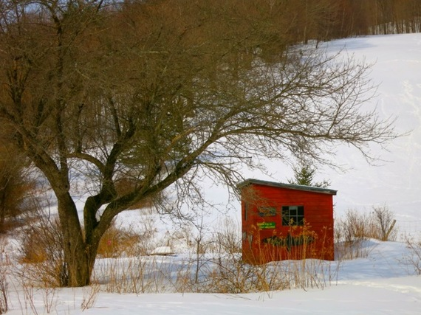
6. Stretch your legs on Sheep Hill - or any of the other 13 properties owned by The Williamstown Rural Lands Foundation. There something very alluring about a bright red shed sitting at the foot of a snow covered hill, made even more so by the fact that it's stocked with backpacks and binoculars for nature-starved visitors. Head to Sheep Hill for programs (e.g. Firefly Hikes, Animal Tracking, Nature Walks), to grab a backpack and pair of binoculars from the little red shed, for a robust hike, or to pick up trail information and maps to all 14 properties. Views are as stunning as any you'll find in area art museums.

http://www.mass.gov/eea/agencies/dcr/massparks/region-west/western-gateway-heritage-state-park-generic.html

Western Gateway Heritage State Park
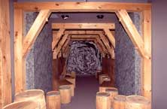
115 State Street
Building 4
North Adams, MA 01247
413 663-6312
Visitors Museum Summer Hours
May 16 through October 17
Open: Daily 9:30AM – 4:30PM
Due to staff limitations, we advise calling to verify hours.
A former railroad yard, this urban park uses historical artifacts and exhibits to bring to life the controversial and danger-filled construction of the Hoosac Tunnel, one of the greatest engineering feats of the 19th century. The tunnel was dug 4.75 miles through Hoosac Mountain, linking Massachusetts to Albany, NY. 200 men lost their lives building the tunnel, which is still being used today. An audio-visual presentation takes visitors back in time, where the sounds of dripping water, pickaxes against stone, explosions, and debates re-create the hardships and heroism of the tunnel's construction.
Several beautifully restored buildings that were once used to store freight and commodities surround a cobblestone courtyard. The buildings are listed on the National Register of Historic Places. Programs and exhibits in history, science, culture and environmental education are offered regularly to the public.

Park Directions
Western Gateway HSP is located in the northern part of the Berkshires in western Massachusetts.
From South:
Take I-90 to Lee exit
Go north on Route 20 then north on Route 7 to Williamstown
At rotary, go east on Route 2
Turn right on Route 8 north
Take a right after the Hadley Overpass into parking lot
From East:
Take Route 2 West to Route 8 South
Take a right after the Hadley Overpass into the parking lot
From West:
Take Route 2 East to Route 8 South
Take a right after the Hadley Overpass into the parking lot

The Visitors Museum
The heart of the park is the Visitors Museum. Imaginative exhibits are designed to reveal the impact that the railroad industry and the Hoosac Tunnel project had on both northern Berkshire County and America. Children and adults can experiment with a vintage floor scale that was used for weighing loads up to half a ton. A 30-minute documentary film provides a history of the Hoosac Tunnel. Allow approximately one hour to view the exhibits.

The Gateway to Greylock Museum
The Gateway to Greylock Museum provides an educational and visual experience for those who want to learn more about Mount Greylock and for those who wish to visit its summit which can be reached from the Park. It features a six minute film and ten exhibit themes covering the history, science and culture of the mountain in approximately 1500 square feet of space. It is located in Building 5C just across from the DCR’s Visitors Museum in Building 4. Information about the museum is available by calling 413-663-6312

Things to know before you go…
Admission and parking is free. The building and exhibits are universally accessible. Program access may vary. Reasonable accommodations available upon request. Group tours and school visits may be arranged by calling in advance. While touring northern Berkshire County in the spring, summer and fall consider visiting: Natural Bridge State Park, just two miles away on Rte. 8; and Mount Greylock State Reservation, with its summit at 3,491 feet, the highest peak in Massachusetts. The drive from Western Gateway offers spectacular views of the Berkshire landscape. It can be easily reached from the Furnace Street exit of Western Gateway.
http://www.mass.gov/eea/agencies/dcr/massparks/region-west/mt-greylock-state-reservation-generic.html

Mount Greylock State Reservation
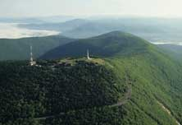
Visitor Center
30 Rockwell Road,
P.O Box 138
Lanesborough, MA 01237
413-499-4262
mount.greylock@state.ma.us
- Auto roads to the summit open for the 2015 season
- 2015 day use parking fee changes, summit parking lot only: $5 MA Vehicle, $6 non-MA Vehicle
- The Veterans War Memorial tower on the summit is closed for renovations through 2016
At 3,491 feet, Mount Greylock is the highest point in Massachusetts. Rising above the surrounding Berkshire landscape, dramatic views of 60-90 miles distant may be seen. It became Massachusetts' first wilderness state park, acquired by the Commonwealth in 1898, to preserve its natural environment for public enjoyment. Wild and rugged yet intimate and accessible, Mount Greylock rewards the visitor exploring this special place of scenic and natural beauty.
Explore Plan Your Visit for basic visitor services information, maps and brochures, operating hours and seasons.
Visit Recreation for more detailed information on rules and regulations for backpack camping, snowmobiling, visiting with pets and hunting seasons.
Bascom Lodge on the summit offers overnight accommodations and meals from late-May through mid/late-October. For other lodge details call 413-743-1591 or click here.

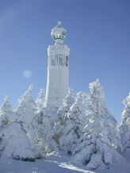
The roads to the summit are open seasonally from late-May through November 1; weather permitting into fall, please call ahead for current road conditions. Since the 2007-08 Historic Parkway Rehabilitation Project, the restored road system offers numerous opportunities for scenic viewing and short hikes along this state-designated Scenic Byway. Bascom Lodge and the Veterans War Memorial Tower are open seasonally. The Mount Greylock Campground (primitive overnight area) is accessible by hiking only.
The Massachusetts Veterans War Memorial Tower (shown at right, in winter) was built in 1932 and crowns the highest point in the state. The memorial was dedicated in June 1933 as a tribute to courage, endurance, loyalty and self-sacrifice, wherever these qualities have been shown, by the state’s men and women in the uniform of the state or nation.

Park Maps, Brochures and Campground Maps
These electronic maps are intended for general reference only. Please pick up a printed map at the Visitors Center, or contact DCR.

Directions
Mount Greylock is located in the rugged northern Berkshires of western Massachusetts, approximately three hours west of Boston and north of New York City.
To Visitor Center, 30 Rockwell Rd., Lanesborough (01237), from the South, East or West via MassPike (I-90): Take Exit 2 in Lee. Follow US Rte. 20 west to US Rte. 7 north to Pittsfield for 11.8 miles. From downtown Pittsfield continue north on US Rte. 7 to Lanesborough for 6.6 miles. At the brown Mount Greylock sign turn right onto North Main Street. Follow the brown lead-in signs 1.5 miles from Rte. 7 to the Visitor Center and park entrance. Driving distance from Visitor Center to summit is 8 miles.
http://www.bascomlodge.net/default.aspx
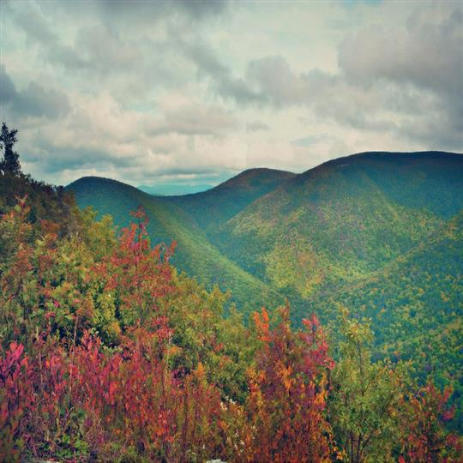
FOR OVERNIGHT ACCOMMODATIONS
mail@bascomlodge.net or 413-743-1591

BASCOM LODGE IS A RUSTICARTS AND CRAFTS MOUNTAIN LODGE BUILT IN THE 1930'SBY VOLUNTEERS FROM THE CIVILIAN CONSERVATION CORPS. CONSTRUCTED OF LOCAL STONE AND OLD GROWTH RED SPRUCE TIMBERS, THE LODGE WAS DESIGNED IN AN ARCHITECTURAL STYLE THAT WOULD LATER BECOME THE BLUEPRINT FOR AMERICA'S NATIONAL PARKS. NESTLED ON THE SUMMIT OF MT. GREYLOCK, THE STATE'S HIGHEST MOUNTAIN, THE LODGE IS THE CENTERPIECE OF A 12,500 ACRE WILDERNESS PARK. CREATED IN 1898, THE PARK WAS THE FIRST LAND PRESERVE ESTABLISHED BY THE STATE AND IS THE FLAGSHIP PROPERTY OF THE DEPARTMENT OF CONSERVATION AND RECREATION.
IN CONTINUOUS OPERATION FOR OVER 78 YEARS, THE LODGE WAS ORIGINALLY DESIGNED TO PROVIDE HEARTY SOULS IN SEARCH OF ADVENTURE AND SPIRITUAL RENEWAL WITH A PLACE TO REST AND TO TAKE SHELTER FROM THE ELEMENTS.
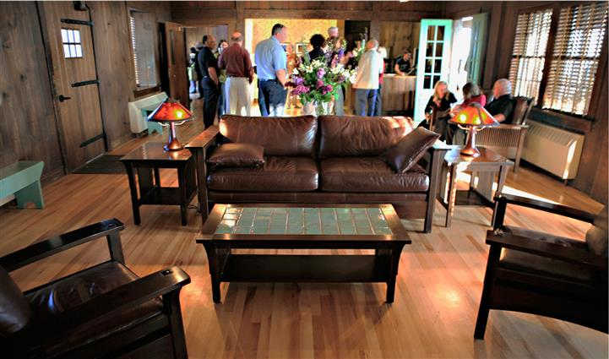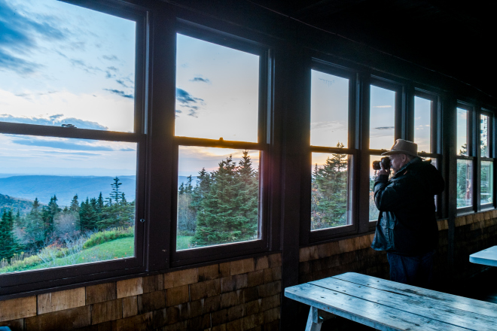

TODAY HOWEVER, THE LODGE SERVES A MUCH MORE COMPLEX AND DIVERSE ARRAY OF PATRONS WHOSE NEEDS AND EXPECTATIONS GO BEYOND MERE ROOM AND BOARD. FROM HIKERS AND CYCLISTS OUT FOR THE DAY, LODGERS ATTENDING A MUSIC CONCERT OR SUMMER STOCK THEATER, SCHOOL CHILDREN ON A FIELD TRIP, TO "HOLIDAY MAKERS" VISITING THE BERKSHIRES FOR THE FIRST TIME, THE LODGE PROVIDES A CASUAL SETTING TO REFRESH THE SPIRIT AND NURISH THE BODY.
SEASON AND HOURS OF OPERATION
JULY THROUGH OCTOBER - OPEN SEVEN DAYS A WEEK FOR BREAKFAST, LUNCH , DINNER, AND OVERNIGHT ACCOMMO-DATIONS.
BREAKFAST - 8:00AM TO 10:00AM
LUNCH - 11:00AM TO 4:30PM
DINNER - 7:00PM (ONE SEATING ONLY) RESERVATIONS NEEDED.
RESERVATIONS REQUESTED (Seven private rooms and 2 bunk rooms. No private bath. $125/nite)

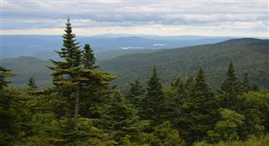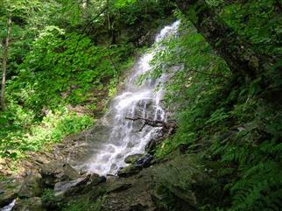

THE RESERVATION WITH OVER 70 MILES OF WOODLAND TRAILS, INCLUDING AN 11.5 MILE SECTION OF THE APPALACHIAN TRAIL PASSING WITHIN A FEW FEET OF THE LODGE'S FRONT DOOR, GUESTS HAVE ACCESS TO A DIVERSE ARRAY OF OUTDOOR EXPERIENCES. BE IT A STRENUOUS CLIMB UP THE MOUNTAIN'S EASTERN FACE, OR A WALK THROUGH A SPRAWLING CLIFF-TOP LOW-BUSH BLUEBERRY PATCH, THE RESERVATION'S MANY TRAILS AND VARING TERRAINS AFFORD AN ENDLESS VARIETY OF ADVENTURES THAT CHANGE FROM SEASON-TO-SEASON AND DAY-TO-DAY.

http://www.mass.gov/eea/agencies/dcr/massparks/region-west/natural-bridge-state-park-generic.html

Natural Bridge State Park
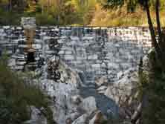
McCauley Road, off Rte. 8
P.O. Box 1757, North Adams 01247
(413) 663-6392
natural.bridge@state.ma.us
Off-season: (413) 499-4262 Mt. Greylock Visitors Center
Daily Parking Fee: $5 MA Vehicle, $6 non-MA Vehicle
Discover a geologic wonder at this 48 acre park. Examine the only naturally formed white marble arch and man-made white marble dam in North America, and tour an abandoned marble quarry. The "natural bridge" for which the park is named, according to geologists, is 550 million year old bedrock marble, carved into an arch by the force of glacial melt water over 13,000 years ago; one of the best places in New England to demonstrate the effects of glaciation. The bridge spans rushing Hudson Brook as it twists and tumbles through a steep 60-foot deep gorge.
Noted Romantic writer, Nathaniel Hawthorne, visited here in 1838 and recorded his experience about Hudson's Cave (or Falls) in An American Notebook "The cave makes a fresh impression on me every time I visit it ... so deep, so irregular, so gloomy, so stern." The site was an active commercial quarry from 1810 to 1947, producing coarse-grained white marble used in local buildings and cemeteries. From 1950 to 1983 it was a privately-owned and popular roadside tourist attraction off the Mohawk Trail. Natural Bridge became a state park in 1985, to preserve its unique geologic features.
In the summer months, knowledgeable park interpreters are on hand to explain the natural forces that created the bridge and its more recent human-related history. There is a 0.25 mile walkway above and through the chasm, and a 0.5 mile wooded walking trail.

Park Directions
Natural Bridge State Park is located in the northern Berkshires in western Massachusetts.
From East or West/Rte. 2: Take MA Rte. 2 to North Adams and intersection with MA Rte. 8 north. Turn onto Rte. 8 north and continue for 0.5 miles to McCauley Road and park entrance on the left. Follow the dirt road; it soon becomes paved.
From North: From VT Rte. 8/100 at the Massachusetts-Vermont line, follow MA Rte. 8 south for 3 miles. Turn right on McCauley Road and park entrance. Follow the dirt road; it soon becomes paved.
From South/MassPike (I-90): Take Exit 2 in Lee and follow US Rte. 20 west to US Rte. 7 north to Williamstown for 31.7 miles. Take MA Rte. 2 east for 6.2 miles, through downtown North Adams to MA Rte. 8. Turn left onto Rte. 8 north and follow for 0.5 miles. Turn left onto McCauley Road and park entrance. Follow the dirt road; it soon becomes paved.

