Water under the bridge: Plan approved to save pond at Naples Zoo
- By KATHERINE ALBERS

- Posted July 24, 2012 at 11:34 a.m.

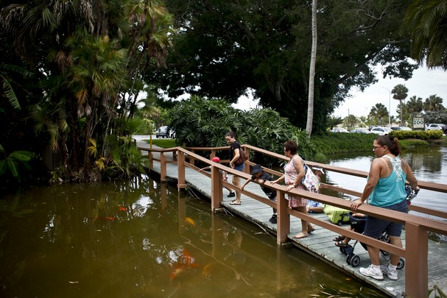
William DeShazer/Staff Naples Zoo goers make their way across the pond towards the entrance on Thursday June 21, 2012.
NAPLES —With all sides declaring a victory for compromise, Collier County Commissioners approved a plan that will allow most of the lily pond to stay at the entrance to the Naples Zoo.
Collier County Commissioners unanimously approved Alternative D — one of five on the table – to allow the lily pond to stay.
“It's a beautiful entrance and it was going to be very ugly,” said Paul Arsenault, a local artist who made plans to remove the pond public months ago. “This was a very successful and collaborative effort.”
That option would keep part of the current pond, while providing for an access road to the new parking lot at the Naples Zoo and to the zoo's offices being relocated to the north part of the zoo property. In addition, two additional ponds will be added closer to Goodlette Frank Road.
The plan was approved with several modifications, including that all of the ponds would be connected underground through a culvert pipe; that the lilies, koi fish and turtles will be maintained, acknowledging that there may be biological challenges beyond the control of the Naples Zoo; and that the road to the north will not remove any existing Nehrling trees.
The estimated increased cost of the modifications is about $138,000, according to Mike Delate, a project manager with Q Grady Minor — the group that initially designed the plans for the zoo entrance. That cost will be split equally between the county and the zoo.
The county is planning to put a parking lot on the south end of the zoo property, which would connect to a kayak launch for the Gordon River Greenway. The new parking lot will also increase the availability of parking space for zoo patrons, who frequently have to park across Goodlette Frank Road on busy days.
David Tetzlaff, executive director of the Naples Zoo, said he is ready to move on. The Naples Zoo Board of Directors approved Alternative D with modifications.
“We're a growing zoo and this is one baby step,” he said. “I am happy with the new entrance. I think it looks nice.”
Commissioner Georgia Hiller praised those involved, including a stakeholders group of individuals who worked on developing alternatives for the zoo.
“You have done a marvelous job. This just shows what consensus can do. It is a beautiful entrance.”
Work on the new zoo entrance is expected to begin this winter, according to Steve Carnell, interim public services director for the county.

Naples Zoo pond alternatives

