KELLY’s FISH HOUSE http://www.kellysfishhousediningroom.com/a_history.html
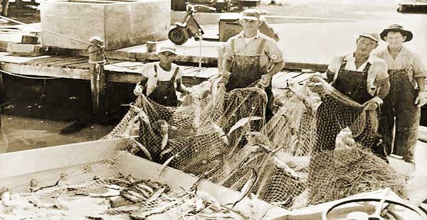 |  | 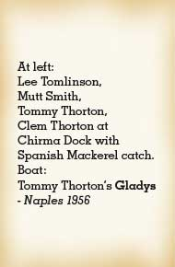
In operation since 1952, Kelly’s is a true landmark. Beginning as a net and gear shop frequented by shrimpers and other local fishermen it grew into what is now the oldest and most respected seafood restaurant in Naples.
Hawiian-born "Mama Kelly" and her late husband, Hewitt McGill, bought the picturesque property in 1971 from the Combs family, one of the pioneering families of Naples.
Throughout the years, the family has maintained its original comfortable, homey atmosphere, and it looks much the same as it did fifty-some years ago.
These priceless original photos and many others of the working waterfront as it once was, can be seen as you enter the restaurant.
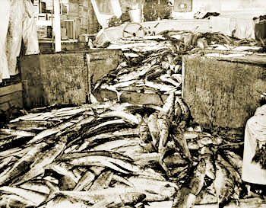  12-14,000 lbs kingfish catch at Chirma docks - Naples | 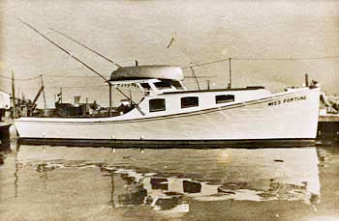  Miss Fortune
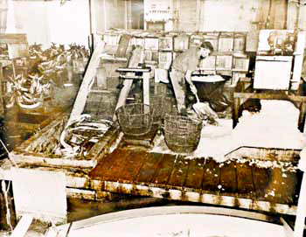  A man shoveling ice Chirma dock worker shoveling ice to pack fish boxes. Naples 1950s | 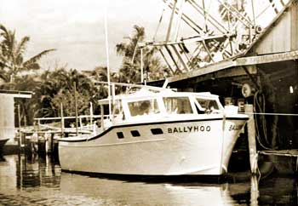  Ballyhoo Commercial Fishing boat at Chirma Docks with net drying wheel in background. Naples 1950s

http://kellysfishhousediningroom.com/a_about1.html
Kelly’s Fish House is a true Naples Original. Established in 1952, it is and always has been family owned and operated. Arriving guests look forward to being warmly greeted as old friends by "Mama Kelly" herself.
Everything about this family-oriented restaurant exudes warmth. The cheery hostess (Terry's been with them for 17 years) the wait-staff, who are always smiling and happy to see you, "Mama Kelly's" son Kelly Ellis, co-owner and most likely the man who will show you to your table and chat with you. Dining there is like visiting a favorite friend's home.
The family strives to keep the rustic feel to the restaurant. You'll see a 1913 cash register, nautical and historical artwork and photos, netting draping the windows...and of course, the shells.
The Bem Storter hand-made glass topped tables filled with shells arranged in sand are unique to Kelly's, and add yet another touch of the sea.
Kelly's food is unpretentious, simply prepared and great tasting.
Below: Hawiian-born "Mama Kelly" by a photo of her beloved late husband Hewitt McGill.
