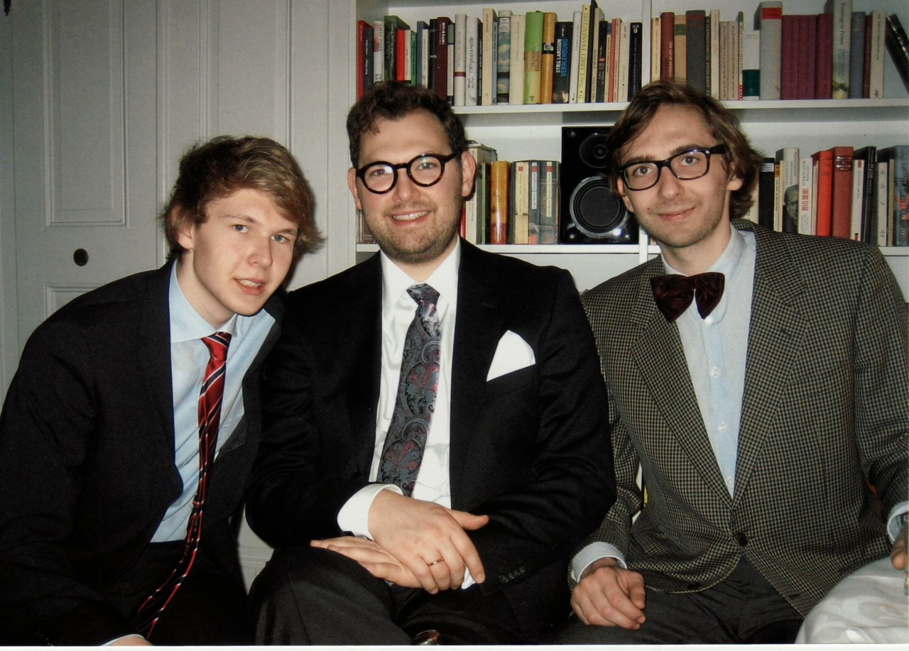

Leopold (16), Gregor (30) and Lukas (27)  on Jan 17th, 2014, the day of Gregor's and Lene's civil wedding ceremony in Munich, at our family party in the apartment of the Sachs family.