NORTHERN OHIO: SONDERGELD FAMILY

You will see from this genealogy of Martin Sondergeld that he was born in Unterhaun near Bad Hersfeld in Hessen, Germany in 1823. He landed in New York in 1855 with his wife, E. Sondergeld. Her name was Elisabeth Wolf. They settled in Black River Township, Lorain County, Ohio, and had three children (John, Charles, and Margaret) between 1856 and 1861. Martin's wife died in childbirth in 1861, and Margaret was raised by a Kress family.

Martin married Catherine Horn in Lorain, Ohio in 1861. They were divorced the following year.

Martin married Anna Barbara Elizabeth Hagemann in November, 1862. Barbara Hagemann was born in Unterhaun in 1834 and emigrated to America in 1862. Martin and Barbara were married in Lorain, Ohio in 1862. Martin and Barbara moved to Benton Township in Ottawa County, Ohio in 1865 where they initially purchased 80 acres. They had eight children, and six lived: Fred, Jacob, Henry, Elisabeth, Anna, and Edward. Martin cleared his land, sold the lumber to the railroad for ties, and used the money to purchase additional land. Over time, his 6 sons each received 40 of his 240 acres. His daughters, Anna and Elisabeth, were each given a lot in Graytown, Ohio. Barbara lived on the original home place with her youngest son, Edward, until she died 40 years later.

It is interesting to see the relationships between the Sondergelds and Hagemanns. Martin's wife, Barbara Elisabeth Hagemann, had a grandmother whose maiden name was Catherina Elisabeth Weiss, who was born in Unterhaun, Gemany in 1775. Martin's mother's maiden name was Catherina Elisabeth Weiss, also born in Unterhaun in 1881. They apparently were sisters, which means Martin married the daughter of his first cousin.

Martin Sondergeld's mother's parents were Johann Weiss (12/24/1727-6/26/1805) and Catharina Elisabeth Stuckert. Barbara Hagemann's father's mother's parents were the same people.

Unterhaun was, and still is, a small town. If you look at the names of Hagemann godparents and Sondergeld godparents in later chapters, you will see similar names.

Barbara Hagemann's younger brother, Jacob Hagemann, also emigrated to America, and was Martin's neighbor and business associate. Family reunions of Sondergelds and Hagemans have been held every year from 1919 through 1987 in northern Ohio and southern Michigan. The first six, called "The Sondergeld Reunion", were held 1919-1924. Average attendance was over 90. The next twenty-nine were called "The Sondergeld-Hageman Reunion", with attendance dropping over the years to 32 Hageman attendees in 1935. Beginning in 1936, the reunion has been called "The Hageman Reunion", with attendance varying between 15 and 40, from 1935-1987.

DESCENDANTS OF MARTIN SONDERGELD
(Born 5/18/1823, Died 11/26/1884)
Born in Unterhaun, Hersfeld, Kurhessen, Germany. He arrived with his first wife Elisabeth in New York Harbor on the Coriolan from Bremen on May 7, 1855. He lived in Lorain, Ohio, from 1855-1865. He moved to Benton Township, (Graytown), Ottawa County, Ohio from Black River Township (Lorain), Lorain County, Ohio area with his third wife, Anna Barbara Elisabeth Hagemann in 1865.
Date of Birth Date of Death
First Wife: Elisabeth Wolf? 1822 or 1823 05/19/1861
(died when Margaret was born
in Black River Township, Lorain
County, Ohio)
Children:
I Johannes (John) Sondergeld 10/19/1856 11/03/1939
II Karl (Charles) Sondergeld 03/02/1859 09/05/1945
III Margaret Sondergeld 05/19/1861 03/19/1943
Second Wife: Catherine Horn
(married on 8/18/1861and 07/15/1823 02/19/1899
divorced 10/23/1862)
Third Wife: Anna Barbara Elisabeth Hagemann 09/1/1834 11/26/1924
(married on November 27, 1862).
She came to America in 1862, and also was from Unterhaun
.Children:
IV Anna Katharina Sondergeld 07/30/1863
V Friedrich (Fred) Sondergeld 08/28/1866 03/11/1945
VI Jacob Sondergeld 10/31/1867 01/28/1943
VII Heinrich (Henry) Sondergeld 09/ 6/1869 03/ 6/1954
VIII Elizabeth Sondergeld 02/19/1871 10/29/1937
IX Anna Sondergeld 04/13/1872 12/13/1954
X Edward Sondergeld 11/19/1873 11/16/1949
XI Infant Son 08/15/1876 08/16/1876

GENERATIONS First Second Third Fourth Fifth Sixth Total
John 1 5 11 34 36 87
Charles 1 4 8 22 26 4 65
Margaret 1 5 12 17 23 58
Anna Katharina 1 1
Fred 1 12 14 25 18 70
Jacob 1 5 7 16 1 30
Henry 1 10 16 44 33 104
Elizabeth 1 11 13 35 16 76
Anna 1 2 3 4 5 15
Edward 1 3 9 17 4 34
Infant Son 1 0 0 0 0 0 1
11 57 93 214 162 4 541

DESCENDANTS OF MARTIN SONDERGELD
Date of Birth Date of Death
I DESCENDANTS OF JOHN SONDERGELD 10/19/1856 11/ 3/1939
Wife: Caroline Gloeckler 1/20/1862 11/11/1944
Children: I-1 Charles Sondergeld 9/28/1882 6/ 1/1947
I-2 Marie Sondergeld 2/11/1887 4/30/1974
I-3 Olvia Sondergeld 11/ 3/1889 10/26/1979
I-4 Rolly Sondergeld 11/16/1893 4/25/1895
I-5 Esther Sondergeld 3/ 3/1900
II DESCENDANTS OF CHARLES SONDERGELD 3/2/1859 9/5/1945
First Wife: Matilda LaCumsky 1/24/1865 5/29/1887
Children: II-1 Matilda Sondergeld 5/15/1887 4/25/1964
Second Wife: Augusta LaCumsky* 9/30/1866 2/21/1942
Children: II-2 Ada Sondergeld 12/ 3/1894 1/18/1981
II-3 Emery Sondergeld 3/26/1897 1/ 5/1984
II-4 Harold Sondergeld 10/24/1902
*Sister of first wife
III DESCENDANTS OF MARGARET SONDERGELD 5/19/1861 3/19/1943
Husband: Henry C. Bechtel 9/4/1856 5/31/1939
Children: III-1 Ada Bechtel 7/ 6/1884 3/17/1962
III-2 Walter J. Bechtel 6/14/1886 9/ 1/1931
III-3 Alice B. Bechtel 8/1/1888
III-4 Hale G. Bechtel 9/4/1893 11/14/1966
III-5 Harold E. Bechtel 5/15/1901 5/11/1978
V DESCENDANTS OF FRED SONDERGELD 8/22/1866 3/11/1945
Wife: Lena Tasch (sister of Henry Tasch, VII) 4/6/1866 8/22/1941

Children: V-1 Emma Sondergeld 4/21/1890 4/28/1921
V-2 George Sondergeld 3/ 5/1892 10/21/1983
V-3 Fredericka Sondergeld 5/ 6/1894 11/28/1977
V-4 Lily Sondergeld 1/28/1897 2/20/1970
V-5 Irene Sondergeld 5/28/1898 7/24/1978
V-6 Elmer Sondergeld 9/15/1900 3/25/1985
V-7 Hazel Sondergeld 5/13/1902 5/14/1924
V-8 Bill Sondergeld 6/30/1904 1/ 1/1978
V-9 Arthur Sondergeld 8/22/1906 ? /?/1906
V-10 James Sondergeld 12/ 8/1907
V-11 Lydia Sondergeld 6/ 9/1910
V-12 Evelyn Sondergeld 2/ 6/1913

DESCENDANTS OF MARTIN SONDERGELD (continued)
Date of Birth Date of Death
VI DESCENDANTS OF JACOB SONDERGELD 10/31/1867 1/28/1943
Wife: Magdalene A. Louis 4/15/1875 10/ 9/1951
Children: VI-1 Martin Sondergeld 4/16/1898 2/17/1976
VI-2 Walter Sondergeld 11/10/1901 5/29/1981
VI-3 Lester Sondergeld 7/19/1904
VI-4 Estella Sondergeld 5/13/1906
VI-5 Ernest Sondergeld 7/22/1913 9/4/1987
VII DESCENDANTS OF HENRY SONDERGELD 9/ 6/1869 3/ 6/1954
Wife: Louisa Juch 1/24/1878 12/28/1964
Children: VII-1William Sondergeld 8/ 2/1897 2/23/1950
VII-2 Clara Sondergeld 7/18/1899
VII-3 Rolla Sondergeld 6/18/1901 11/23/1979
VII-4 Edna Sondergeld 12/ 2/1903 4/20/1904
VII-5 Otto Sondergeld 2/16/1906 6/ ?/1978
VII-6 Louis Sondergeld 4/11/1910 6/ 8/1979
VII-7 Alfred Sondergeld 11/10/1915 12/16/1935
VII-8 Alice Sondergeld 1/30/1917 8/ ?/1984
VII-9 Arthur Sondergeld 9/ 1/1920
VII-10 Allen Sondergeld 4/ 7/1925 4/11/1925
VIII DESCENDANTS OF ELIZABETH SONDERGELD 2/19/1871 10/29/1937
Husband: Henry Tasch (brother of Lena Tasch, 1/ 1/1868 10/18/1926
see IV)
Children: VIII-1 Edward Tasch 8/13/1894 9/ 6/1955
VIII-2 Tilla (Matilda) Tasch 4/22/1896 10/ 1/1900
VIII-3 Mary Tasch 6/17/1897
VIII-4 Otto Tasch 3/ 2/1899 3/19/1978
VIII-5 Irving Tasch 10/26/1901 10/17/1970
VIII-6 Anna Tasch 4/17/1903
VIII-7 Ella Tasch 5/17/1905 3/24/1966
VIII-8 Karl Tasch 2/23/1907 3/23/1907
VIII-9 Ida Tasch 7/16/1908
VIII-10 Lawrence Tasch 6/19/1910
VIII-11 Lillian Tasch 4/15/1912
IX DESCENDANTS OF ANNA SONDERGELD 4/13/1872 12/13/1954
Husband: Emest Witte 1/ ?/1870
Children: IX-1 Elmoe Witte 11/ ?/1896 9/ ?/1898
IX-2 Godfrey Witte 5/30/1900 4/13/1943
X DESCENDANTS OF EDWARD SONDERGELD 11/19/1873 11/16/1949
Wife: Bertha Bast 9/21/1881 12/ 4/1958
Children: X-1 Mildred Sondergeld 11/25/1900
X-2 Malinda Sondergeld 12/13/1904 12/23/1987
X-3 Marion Sondergeld 7/22/1915

MARTIN SONDERGELD CHRONOLOGY

July 31, 1811 | Martin Sondergeld's brother, Johannes Georg Sondergeld, was born in Unterhaun at 5:00 a.m.
March 2, 1816 | Johannes Georg Sondergeld's wife, Katharina Billerbeck, was born in Wetzlos. Her father was Caspar Billerbeck, and her mother was Katharina Noll.
May 18, 1823 | Martin Sondergeld was bom at 9:00 a.m. in Unterhaun, Hersfeld, Kurhessen, also called Hesse-Cassel. Hesse Cassel is now part of Hessen, a state in West Germany. The house in which he was born is one of the five oldest houses in Unterhaun. It was built in 1699. Sondergelds still live in it at 5 Weihersgrund Strasse.
June 12, 1823 | Martin was baptized in Unterhaun. His father was Johannes Sondergeld (1772-6/25/1840), and his mother was Catharina Elisabeth Weiss (6/2/1781- ) His godfather was Martin Benz from Rohrbach.
July 15, 1823 | Catherine Horn, Martin's second wife, was bom in Hesse Cassel.
September 1, 1834 | Barbara Elisabeth Hagemann, Martin's third wife, was born at 8:00 p.m. in Unterhaun, Hersfeld, in Hesse Cassel. Her father was Conrad Hagemann, and her mother was Catharina Elisabeth Gemerod. Her father's mother was Catharina Elisabeth Weiss, a younger sister by the same name of Martin Sondergeld's mother.
September 12, 1834 | Barbara Elisabeth Hagemann was christened in Unterhaun. Her godmother was her aunt, Barbara Elisabeth Germerod.
July 21, 1839 | Martin's brother, Johannes Georg Sondergeld, and Katharina Billerbeck were married in Unterhaun.
August 18, 1841 | Conrad Jacob Hagemann (Barbara's brother) was born in Unterhaun. He died on 12/13/12. His wife was Louise Hein (1853-1942). They are buried in the Old Elliston cemetery.
April 18, 1852 | Anna Barbara Elisabeth Hagemann applied for something like a passport to go to Kalcobes (1 km north of Hersfeld, and 7 kms north of Unterhaun) to work as a maid. She was 4'10" tall, had "brown" hair, an "arched" forehead, "brown" eyebrows, "medium" nose and mouth, "good" teeth, a "round" chin, a "full" face, a "healthy" colour, and "freckles”.
May 7, 1855 | "M. and E. Sandergelt" arrive in New York Harbor on the 400 ton ship, Coriolan, captained by H. Wulf, which sailed from Bremen Harbor. They were from Hessen. The ship's manifest listed "M. Sandergelt", age 32, as a farmer, and "E. Sandergelt", age 34, as wife. They were listed 12th and 13th, respectively.
October 19, 1856 | Johannes (John) Sondergeld, apparently Martin's firstborn child in the U.S., was bom in Black River Township, Lorain County, Ohio.
February 18, 1857 | Martin Sondergeld purchased Lot 227 in Black River Township from Armested and E. G. Lumm for $40 (see attached map).
Unterhaun Census of 1858 | There were 96 families and 576 people living in Unterhaun, Gemany.
March 2, 1860 | Martin's son, Karl (Charles), was born in Black River Township, Lorain County, Ohio.
U.S. Census of 1860 | This census of Black River Township, Lorain County, Ohio, listed Martin Sundergill, laborer, age 40 (although he was apparently only 37), his wife Elizabeth, age 37, John, age 3, and Charles, age 1. The census listed Hesse-Cassel as the birthplace of Martin and Elizabeth, and Ohio as the birthplace of John and Charles.
May 1, 1861 | "Martin Sundergelt" purchased Lot 228 in Black River Township, Lorain County, Ohio from Emeline G. Lumm for $50 (see attached map).
May 19, 1861 | Martin's daughter, Margaret, was bom in Black River Township, Lorain County, Ohio. Apparently, Margaret's mother, Elisabeth, died in childbirth on this date. Margaret was adopted by a Kress family in the Lorain area and did not learn that she was a Sondergeld until almost 30 years later at her adopted-mother's deathbed.
August 18, 1861 | Martin Sondergeld and Catherine Horn were married in Lorain County, Ohio by Jacob Shafer, M.G. (Minister of the Gospel). The 1860 census of Black River Township listed Catherine Horn as a domestic in Conrad Reid's household, indicated she was then age 25 (apparently an error as she was born in 1823), and was born in Hesse-Cassel.
March 13, 1862 | Mayor Hartwig, of Unterhaun, issued a document stating, "Anna Barbara Hagemann has a good reputation and there is no reason against her emigrating to America."
June 9, 1862 | Barbara Hagemann found in:  http://www.immigrantships.net/1800/elisemathilda620609.html  Germans to America, 1850-1874  Age: 27 Gender: Female  Occupation: None  Country: Hessen  Final Destination: OH  Manifest ID Number: 00010594  Ship's Name: Elise Mathilde  Port of Embarkation: Bremen  Date of Arrival: Jun 9, 1862  Captain's Name: B. Gaerdes  Purpose for Travel: Staying in the USA  Mode of Travel: Steerage
October 23, 1862 | Martin Sondergeld and Catherine Horn were divorced. Wlm. H. Canfield, Judge presiding. Catherine Horn subsequently married Conrad Reid on December 25, 1862. They had no children. Conrad Reid (9/30/1802-3/24/1883) was an innkeeper, and first mayor of Lorain, Ohio. He had 11 sons and 1 daughter. His first wife was Abigail Murdock (3/10/1804-4/10/1861) from Connecticut.
November 27, 1862 | "Martin Sandergill and Eliza Hagaman" were married in Lorain County, Ohio by F. Kramer, M.G. (Eliza Hagaman is Anna Barbara Elizabeth Hagemann.)
July 18, 1863 | Anna Katharina Sondergeld was bom to Martin Sondergeld and Anna Barbara Elisabeth Hageman Sondergeld in Black River Township, Lorain County, Ohio.
September 18, 1863 | John (Johannes) Sondergeld, born 10/19/1856, was baptized at St. Peter's Evangelical Church in Amherst, Ohio. The godparent was Johannes Sondergeld. Charles Sondergeld was also baptized. The godparent was Karl Wolf. This record shows Charles was born 5/2/1859, rather than 3/2/1859. Anna Katharina Sondergeld, born 7/18/1863, was also baptized. The godparent was Anna Katharina Deis.
August 8, 1865 | "Martin Sundergelt" and Barbara sold Lots 227 and 228 in Black River Township, Lorain County to John Winie for $450.
September 2, 1865 | Martin Sondergeld purchased 80 acres (Section 28, W.1/2, S.E. 1/4) in Benton Township, Ottawa County, Ohio from George Gerlach for $1,000. Edward subsequently received the west half, and Henry the east half.
August 28, 1866 | Martin's son, Fred (Friedrich Jacob), was bom in Benton Township, Ottawa County, Ohio.
October 31, 1867 | Martin's son, Jacob, was bom in Benton Township, Ottawa County, Ohio.
April 12, 1869 | Martin Sondergeld and Jacob Hagemann (Barbara's brother) purchased 80 acres in Benton Township (Section 27, E.1/2 of S.W.1/4) for $1,200. They each took 40 acres on January 20, 1872.
September 9, 1869 | Martin's son, Henry (Heinrich Wilhelm), was bom in Benton Township, Ottawa County, Ohio.
U.S. Census of 1870 | For some reason, the Sondergeld family was not listed in the U.S. Census for Benton Township, Ottawa County.
February 19, 1871 | Martin's daughter, Elizabeth (Louise Anna), was born in Benton Township, Ottawa County, Ohio. She was called Lizzie.
January 20, 1872 | Martin took the west half, and Jacob Hagemann, the east half, of the property purchased on April 12, 1869. Martin subsequently sold his half to his son, Charles, on January 11, 1883.
April 13, 1872 | Martin's daughter, Anna (Anna Maria Katharina), was born in Benton Township, Ottawa County, Ohio.
November 19, 1873 | Martin's son, Edward (Friedrich Edward), was born in Benton Township, Ottawa County, Ohio.
August 15, 1876 | An infant son was born to Martin and Barbara Sondergeld in Benton Township, Ottawa County, Ohio. He apparently was born dead or died the same day.
June 4, 1877 | Martin Sondergeld purchased 40 acres (Section 33, N.W.1/4 of N.E.1/4) in Benton Township, Ottawa County, Ohio from Eliza Knight for $550 plus dower interest. This subsequently went to Martin's son, Jacob.
April 12, 1879 | Martin Sondergeld purchased Lots 21 and 22 in Block 3 in Graytown, Ohio from Robert and Louisa White for $113. On December 29, 1890, Lot 21 was deeded to Anna Sondergeld, and Lot 22 was deeded to Elizabeth Sondergeld.
U.S. Census of 1880 | Martin, Anna B., John, Fred, Jacob, Henry, Elizabeth, Anna, and Edward were listed in the Benton Township, Ottawa County, Ohio census. Charles was omitted. He was 21 and may have been living away from home. Margaret, at that time, was living in Lorain County under her adopted family's name of Kress. Martin was listed as a farmer. Martin and Anna B. listed their place of birth as Hessen.
May 4, 1881 | Martin Sondergeld purchased 40 acres from Augustus and Julia Cutler for $2,000 (Section 27, W.1/2 of E.1/2 of N.W.1/4). This went to John Sondergeld when Martin died.
May 4, 1881 | Martin Sondergeld purchased 40 acres from Augustus and Julia Cutler for $2,000 (Section 27, W.1/2 of W.1/2 of N.E.1/4). This eventually went to Martin's son, Fred.
May 4, 1881 | Jacob Hagemann purchased 40 acres from Augustus and Julia Cutler for $2,000 (Section 27, E.1/2 of E.1/2 of N.W.1/4). This is north of Jacob Hagemann's 40 acres that Jacob received on January 20, 1872.
January 11, 1883 | Martin Sondergeld sold the 40 acres, purchased on January 20, 1872, to his son Charles for $100.
January 11, 1883 | Martin Sondergeld made out his last Will and testament (in which he spelled his name Sundergeld). He left nothing to Charles, who he sold 40 acres to for $100 on 1/11/1883. He said John gets a particular 40 acres. Fred, Jacob, Henry and Edward would share the remaining 160 acres after their mother died. "Lizzie" and Anna were to share Lots 21 and 22 in Block 3 in Graytown, Ohio.
November 26, 1884 | "Martin Sundergelt killed by engine." He was hit by a train near his house.
February 19, 1899 | Katie Reid died. This is the Catherine Horn, who was Martin's second wife. She is buried in the Cleveland Street cemetary in Amherst, Ohio - as is Abigail and Conrad Reid.
January 4, 1905 | Elizabeth Sondergeld Tasch and Henry Tasch sold Lot 22 in Graytown to Ezekial Floro for $500.
February 26, 1908 | John and Caroline Sondergeld sold their 40 acres to John S. Emch for $4,000.
June 29, 1919 | The first Sondergeld Reunion was held at Henry Sondergeld's farm. It was attended by 93 people, and Jacob Sondergeld was elected president.
Early 1924 | In early 1924, Martin's widow, Barbara, was living with her yougest son, Ed, and Ed's wife, Bertha. One morning Barbara got up to fix her fire and retumed to bed. Unknowingly, she had accidentally caught her clothes on fire, which then set the bed on fire. Her cries awakened her 9 year old granddaughter, Marion, who ran to tell her parents, who were doing chores. Bertha poured a 60 gallon crock of water on the bed, smothering the fire. Nevertheless, Barbara suffered severe burns. Bertha cared for Barbara until later that year, when Bertha was ill. Barbara then moved to Jacob's farm, where she died November 26, 1924, age 90.
June 15, 1924 | The sixth annual Sondergeld Reunion was held at Willys Park in Toledo, Ohio and the name was changed to the "Sondergeld-Hageman Reunion".
November 26, 1924 | Anna Barbara Elisabeth Hagemann Sondergeld died. She was born in Unterhaun, Hersfeld, Kurhessen, Germany on 9/1/1834. Her obituary correctly indicated she came to America in 1862. She and Martin were married on November 27, 1862 - not October 27, 1862, as stated in her obituary. Her obituary incorrectly stated she came from Unterhausen, rather than from Unterhaun. Her obituary indicated she had 8 children (3 daughters and 5 sons), of which one daughter (not shown) and one son died in early infancy. She was one of the charter members of the Evangelical Trinity Church of Elliston, Ohio.
1972 | In 1972, seven small villages, just south of Bad Hersfeld in Hessen, Gemany, formed a town they are now part of. The town is called Hauneck, whose name is partly related to the River Haun that flows through the area, and empties into the Fulda River, south of Bad Hersfeld. More specifically, a castle, south of Unterhaun, was ' located near a bend in the Haun River. As "Ecke" means corner, the castle was called Hauneck. The seven villages (population in 1972 in parenthesis) were: Bodes (206), Eitra (393), Fischbach (95), Oberhaun (564), Rotensee (516), Sieglos (272), and Unterhaun (1,024). This totaled 3,088 in 1972.
Census of 1980 | Benton Township in Ottawa County, Ohio, had a population of 2,446 (of which 457 lived in Rocky Ridge, the only incorporated town). There are three unincorporated towns: Elliston, Graytown, and Trowbridge. Elliston was laid out as a town in 1867, and Graytown in 1874.
May, 1981 | The Elliston Post Office was discontinued in May 1981. Graytown Post Office, which started in 1878, now handles Elliston (about 30 families) and Graytown (about 50 families). The Kern Funeral Home in Elliston is no longer in service. In 1988 there are still two churches in Elliston, what is now the Trinity United Church of Christ, and the Zion United Methodist. Graytown has an Elementary School, a grain elevator, a park, and a small church (St. Mark's Lutheran).
1984 | By 1984, the population of Hauneck had grown to 3,641, with Unterhaun still the largest village with 1,353 people. In 1845, when Martin Sondergeld was 22, Hauneck had 1,860 people, with 568 in Unterhaun.

FAMILY PICTURES

Anna Barbara Hagemann Sondergeld and Family About 1921
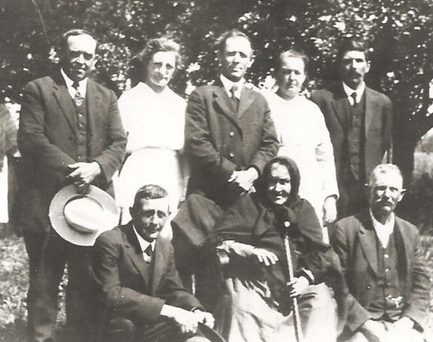
Back Row: Ed Margaret? Jacob Anna Henry
Front Row: Charles Barbara John
__

Martin and Anna Barbara (Hagemann) Sondergeld Family About 1920-1921
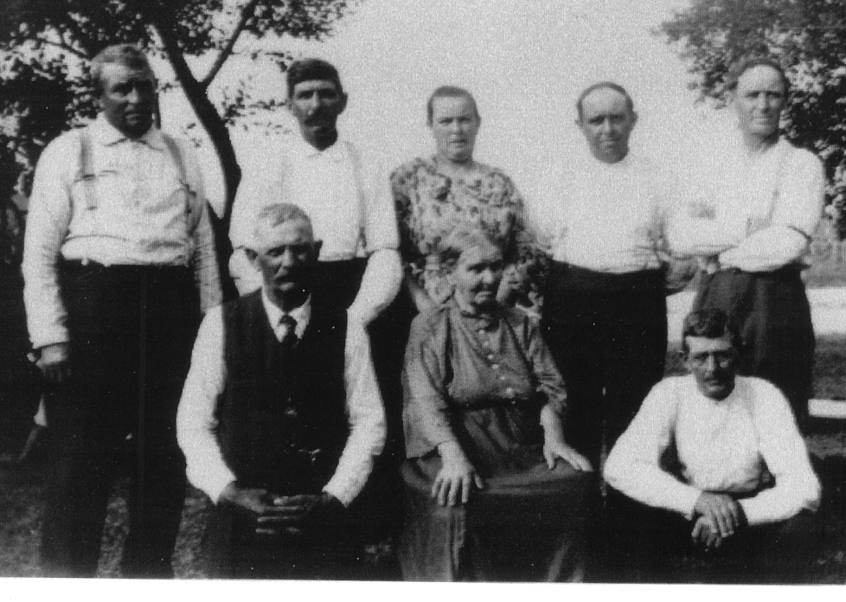

Back Row: Fred Henry Elizabeth Sondergeld Tasch? Edward Jacob
Front Row: John Barbara# (9/1/1834 11/26/1924), Charles
# Is this Barbara? (John and Charles are step children of Barbara)
___
Martin and Anna Barbara (Hagemann) Sondergeld Family About 1920-1921
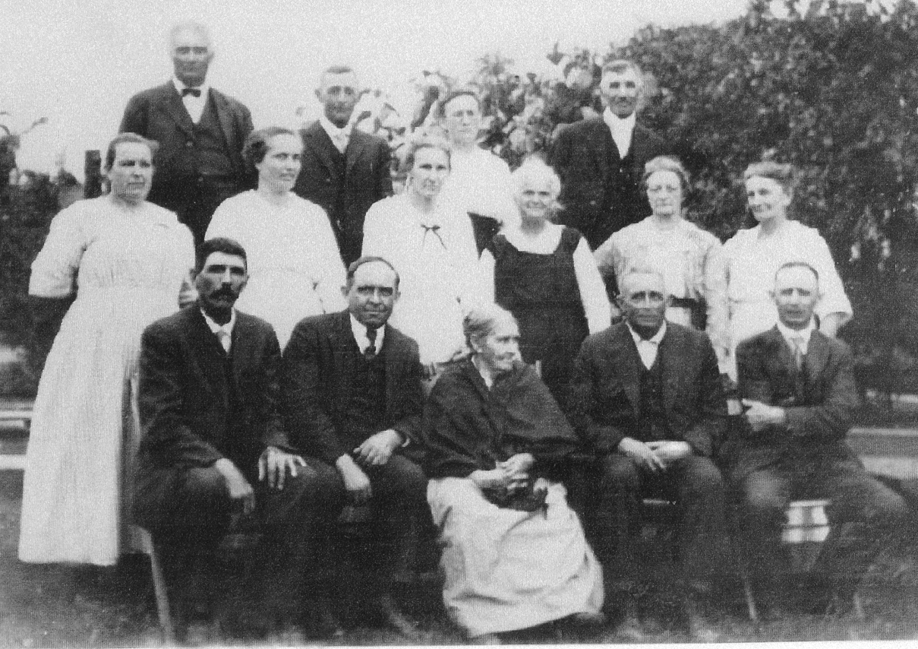

Back Row: Henry Tasch, Charles H Sondergeld, Augusta Lacumsky Sondergeld (?), Ernest Witte (?)
Middle row: Elizabeth Sondergeld Tasch, Bertha Bast Sondergeld, Louise Juch Sondergeld, Anna Sondergeld Witte(?), Lena Tasch Sondergeld, Lena Louis Sondergeld
Front row: Henry Sondergeld, Edward Sondergeld, their mother: Anna Barbara Hagemann Sondergeld (9/1/1834-11/26/1924) Fred Sondergeld, Jacob Sondergeld
___
Children of Martin Sondergeld (5/18/1823-11/26/1884) and his first wife,
who died when Margaret was born Picture about 1920 or 1921
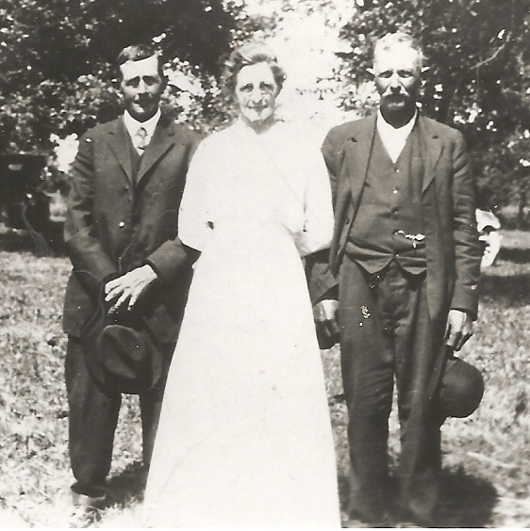

Charles Sondergeld (3/2/1859-9/5/1945) Margaret Sondergeld Bechtel (5/19/1861-3/19/1943) John Sondergeld (10/19/1856-11/3/1909)
___
Fred Sondergeld Family 1920 or 1921
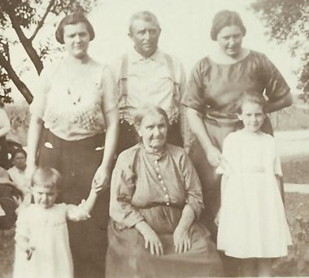

daughter Lily Johnson(1/28/1897) Fred Sondergeld (8/28/1866) daughter “Ricky” Luce (5/6/1894)
granddaughter Irene Johnson Mother # grand daughter Thelma Luce
#Anna Barbara Hagemann Sondergeld (9/1/1834-11/16/1924)

____

V1 Jacob Sondergeld and Family circa 1921
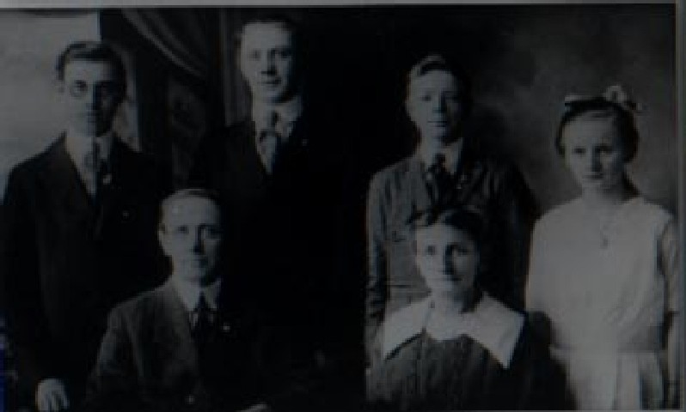
Top: Walter Martin Lester Estella Bottom: Jacob Magdalene
____

1929 Henry Sondergeld and Louise Juch had 10 children
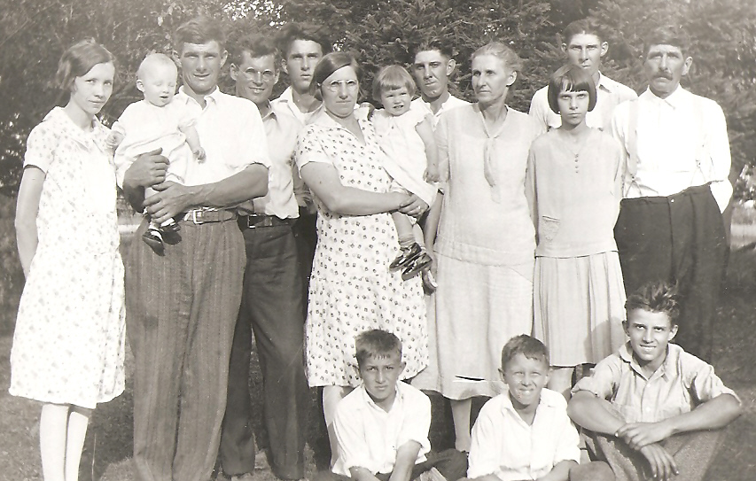

Top: Evelyn(7/23/06) 3Rolla(6/18/01) Clarence(10/9/94) 6Louis(4/11/10) 1William(8/2/97) 5Otto(2/16/06) Henry(9/6/1869)
Middle: Gordon(11/24/28) 2Clara(7/18/1899) Eloise(3/31/28) Louise(1/24/1878) 8Alice(1/30/17)
Bottom: Clayton(11/5/20) 9Arthur(9/01/20) 7Alfred(11/10/15)

Clarence Freimark is the husbamd of 2Clara. Gordon is the son of 3Rolla and Evelyn. Eloise and Clayton are the first two children of 2Clara & Clarence.
Other children died young: 4Edna(12/2/03-4/20/04) and 10Allen(4/7/25-4/11/25)
___

Two of Fred Sondergeld’s sons: Elmer and James
Circa 1936 at Jim Sondergeld’s Farm on Rt 2 (now part of Ottawa Federal Game Preserve)
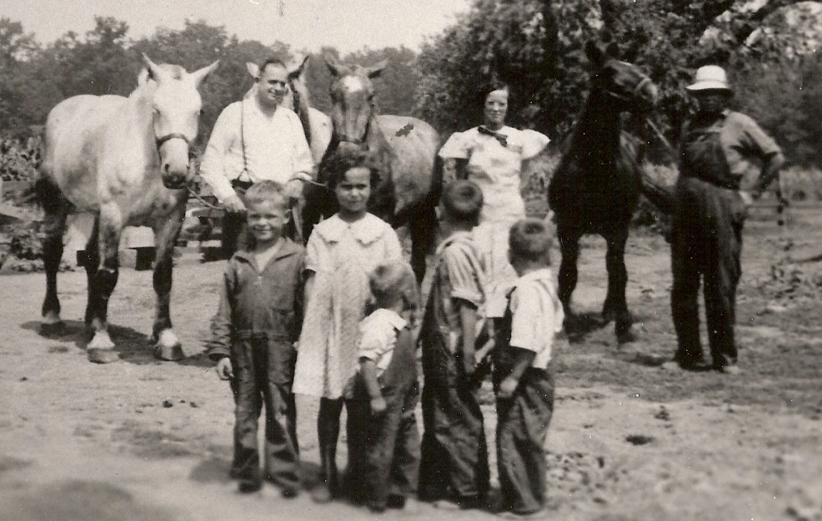

Elmer Sondergeld (V-6)(9/15/00-3/25/85) Annabelle Sondergeld (wife of V-10)( 10/1/12-5/25/90)
James E Sondergeld (V-10)(12/8/07-1/30/1990)

George (V-6-2) Joan (V-10-1) Marvin (V-10-4) James (V-10-2) Kenneth (V-10-3)
______

