http://annasfloridafieldtrip.blogspot.com/

Day 6- Everglades Wetland Research Park, 10000 Islands National Park and Alligator Alley

Everglades Wetland Research Park

What they do
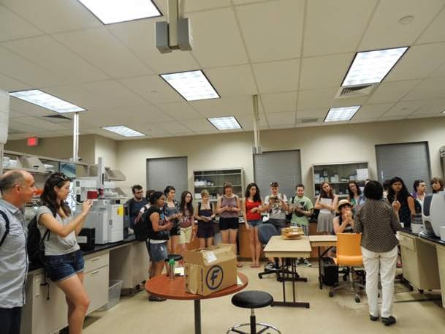
Being shown around one of the labs.
The Everglades Wetlands Research Park is part of the Florida Gulf Coast University, based at the Naples Botanical Gardens. The aim of park is to provide teaching and conduct research linked to wetlands, seeking to understand how wetlands function and how to restore them. Whilst we were there we were given a brief lecture on their current research, before being given a guided tour of the main buildings, including one of their labs, before we saw the Stockholm Water Prize, awarded to them in 2004. For more information on the park see Everglades Wetland Research Park.

Recent Research
Whilst there we had a brief lecture, which explained the current research they are conducting into the ecosystem services wetlands provide, such as:
- Water purification
- Flood regulation and storm protection
- Act as biodiversity corridors
- Climate regulation (carbon sequestration)
- Ecotourism areas
Examples of research they have conducted recently include:
- How the Everglades purify water
- Hypoxia in the Gulf of Mexico
- Wetlands and carbon sequestration
- Mangrove restoration in Naples Bay

10000 Islands National Park

About The 10,000 Islands National Park
The 10,000 Islands are a chain of islands and mangrove islets along the coast of southwest Florida. However, despite the name, they actually only number in the hundreds. Much of the water is shallow and acts as nursery grounds for many marine species. Because of this, the boats must follow a certain path, to prevent potentially harming any wildlife or getting beached on the bottom.

Bottlenose Dolphins
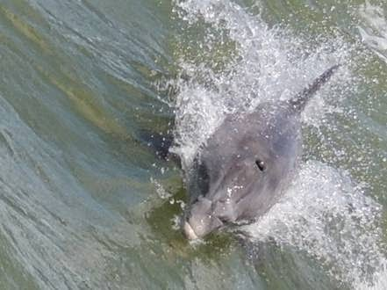Whilst on the boat tour we saw a small pod of common bottlenose dolphins (Tursiops truncatus). The dolphins interacted freely with the boat, swimming alongside and jumping through the air. The also rode the wake of the boat, spinning in it.
The common bottlenose dolphin is usually between 2 and 4m long, with newborn calves measuring between 0.8 and 1.4m. Their pod sizes are usually between 10 and 30 individuals, though they can range from one individual up to more than 1000.
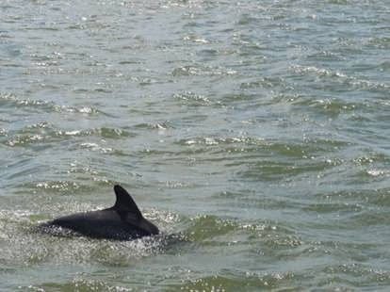
The dolphins are grey in colour and show counter-shading: they are darker on their backs, and gradually get lighter towards their almost white underside. This makes it hard for them to be seen by predators from above or below when swimming.

Dolphins can live for up to 40 years, but most commonly live to around 20 years in the wild.
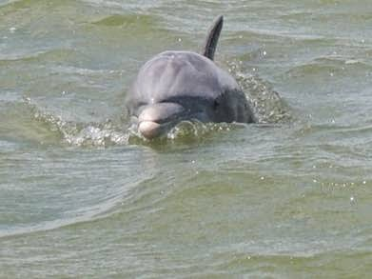

Many bottlenose dolphins show curiosity towards humans, and have even been known to directly interact and protect them in open water. Research has also shown that they will also interact more frequently with tourist boats than with fishing vessels. It is suggested driving behaviour, speed, engine size (judged by engine volume) and distance from the boat all impact whether a dolphin interacts with a boat or not.

Other Species Seen
Whilst on the boat tour we also saw:
- Osprey
- White Ibis
- Royal Turn
- Cormorants
The area is also know to have manatees, though we did not see any.
On the boat tour temperatures reached a high of 27^C.

Alligator Alley
On our journey back from the 10,000 Islands we travelled along Route 41, also known as Alligator Alley, due to the high density of alligators, amongst other wildlife, found either side of the road. We saw at least 15 in roughly 10 minutes of travelling. Part way along the route we stopped to walk along a short boardwalk. During this walk we saw two species of bird that were of great interest.

Bald Eagle
From the boardwalk we were able to see a bald eagle (Haliaeetus leucocephalus) nest, within which there was a juvenile bird. As we were observing the nest, hoping the parent birds would return, we saw the juvenile stretch its wings out and hover above the next, which was possibly the first time it had done so.

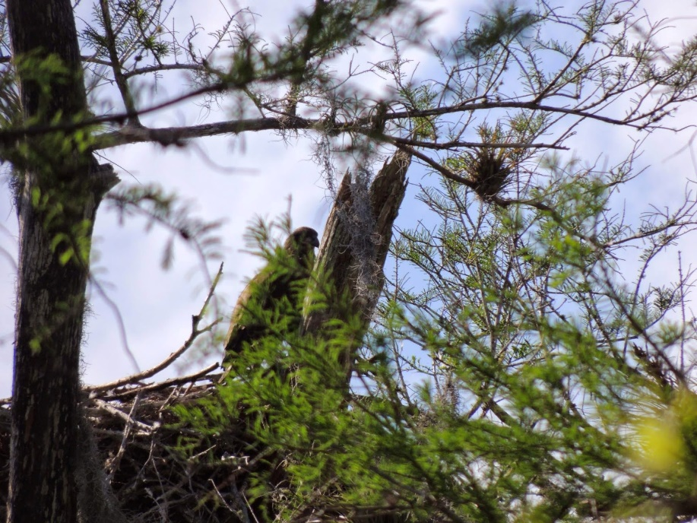
The juvenile bald eagle in the nest (photo credit: Wynn Johnston)
Bald eagles build the largest nests of any American bird, and have been known to build the biggest tree nest ever to be recorded, at 4m deep, 2.5m wide and weighing 1 metric ton.
Adults are mostly brown, except for the white (not bald) head and tail: the term bald eagle comes from an older meaning of the term white headed. Females and males show very little sexual dimorphism, other than females are roughly 25% larger. Juveniles are all brown, with the white head appearing at around roughly 5 years, as they reach sexual maturity.
The bald eagle was declared an endangered species in the U.S. in 1967, due to the use of the pesticide DDT, which caused birds to either be sterile or lay very brittle eggs. DDT was banned in 1972, and since then bald eagle populations have been increasing, with them being de-listed from the Federal threatened species listed on 28th June 2007.

Barred Owl
Also on the boardwalk we saw a barred owl (Strix varia). This individual was sleeping in the middle of some dense vegetation. The barred owl has many other names, including the hoot owl and the eight hooter (due to its distinctive call), as well as the rain owl, the wood owl and the striped owl. They grow to between 16 and 25 inches long, with a wingspan between 38 and 49 inches. It has a pale face, with dark rings around the eyes, a yellow beak and brown eyes, the only owl species in the eastern U.S. to have brown eyes, as the rest have yellow.
The distinctive call is described as eight ascending hoots, ending with oo-aw. The most common mnemonic suggested to help remember the call is 'who cooks for you, who cooks for you all'.
Posted by Anna Newlove at 06:17 No comments:
Email ThisBlogThis!Share to TwitterShare to FacebookShare to Pinterest

Wednesday, 2 April 2014

Day 5- Corkscrew Swamp

A Brief History of CORKSCREW SWAMP
Corkscrew Swamp Sanctuary is a 13,000 acre preserve, which consists of the largest remaining untouched bald cypress forest, at roughly 700 acres. It is part of the wetland system that was the Big Cypress, however in 1881 drainage started on the area. This caused a very dramatic reduction in the number of wading birds found in the area: in 1850 there were 2.5 million, but by 1995 this number had fallen to just 100,000 birds. The total cost to restore and conserve the system is $19 billion, with the hope that by 2030 the population of wading birds will have doubled to 200,000.
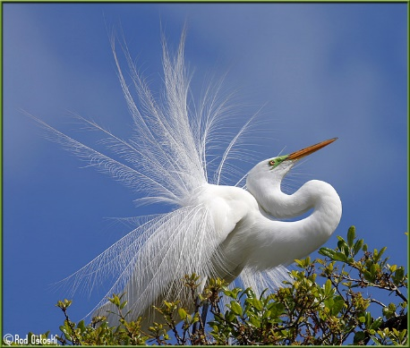
An example of the plumes egrets were killed for.
During the early 1900's it was also targeted by plume hunters (hunters who killed egrets and herons for their plumes, for use in fashion). In 1913, Rhett Green became the first warden to protect Corkscrew, and it's egrets and herons. He also acted as a guide for those who wanted to document the bird life found there. For more information see Corkscrew Sanctuary.
Hurricanes are frequent within Florida, with January and March being the only known months for one to have never hit. They hit Corkscrew Swamp, on average, every 14.5 years, which means some of the trees that have been aged to around 500 years old, have managed to survive roughly 30 hurricanes, however it is not known for certain how they manage this.
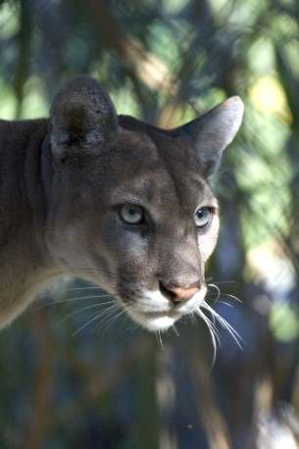
The endangered Florida panther.
The sanctuary is home to a number of Federal and state listed species, including:
- Florida Panther (Puma concolor)
  - There are thought to be only 160 left in the wild
- American Alligator (Alligator mississippiensis)
- Gopher Tortoise (Gopherus polyphemus)
- Roseate Spoonbill (Platalea ajaja)
- Snowy Egret (Egretta thula)
- Tricoloured Heron (Egretta tricolor)
- Florida Black Bear (Ursus americanus)
Sadly we did not see all of these species as we walked around the 2.25 mile long boardwalk, as many are found within the area of the sanctuary the public do not see. During our visit and walk around the boardwalk, the temperatures reached a high of 26^C.

Mitigation Banks
Mitigation banks are used throughout Florida to prevent any net loss to wetland functions within the state. When a developer wants to build on a piece of land, they must purchase mitigation credits, if the development would in any way impact on wetlands. The money raised through the purchase of the mitigation credits then is used towards the restoration, creation, enhancement and preservation of other areas of wetland in the state, preventing any net loss, but still allowing development to occur. Corkscrew Swamp Sanctuary is an area that the money raised by mitigation credits is used to continually protect.
For more information on mitigation banking see Florida Association of Mitigation Banking.

The Wood Stork
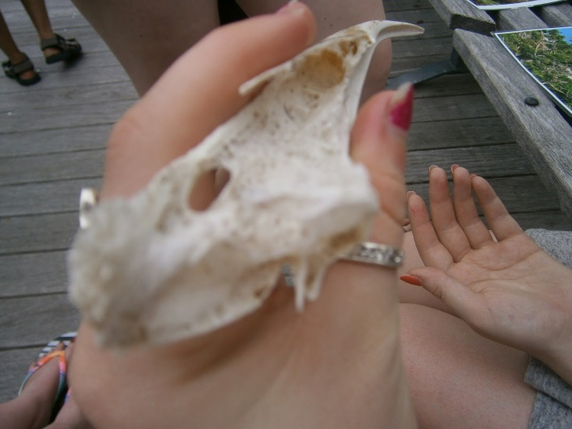
One of the wood stork's hollow bones.
Wood Storks (Mycteria americana) are the only species of stork to be found in North America. They measure 40-44 inches long, with a wingspan of 5 feet. It's bones are hollow and extremely light, with the feathers actually weighing more. It feeds mainly on fish, and forages in shallow water with it's beak open, until it senses a fish, when it snaps it's beak shut within 0.2 seconds.
It takes 440 pounds of fish to fledge one wood stork, so when in 1913 there were 20000 nestlings, it would have taken 8 million pounds of fish to fledge them all. Now there are only 6000 nests, suggesting it would take 2.5 million pounds of fish.
Wood storks are called indicator species, as they can be used to indicate the health of a wetland. Because of the large weight of fish needed to fledge their young, the wood stork relies on the natural ridges and sloughs (mentioned in this blog post on LILA) to allow it to capture fish effectively. However, when a wetland is dredged this natural pattern changes, and so the populations of wood stork decrease. Thus, because they decrease as the ecosystem changes, they can be used as an indicator of a wetland's health.

Grey Catbird
The grey catbird (Dumetella carolinensis) has a very distinctive call, as the name suggests; it consists of a long, irregular succession of musical and mechanical notes/phrases and a cat-like mewing. It has also been known to mimic other bird calls. To hear the different calls visit Grey Catbird.

It is a small bird, measuring 20-23cm, which over-winters in Florida. It is found in very dense vegetation, with it's presence usually only known by it's distinctive call.

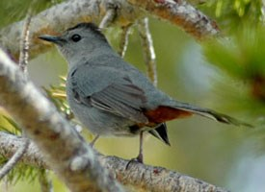
A Grey Catbird.

Northern Raccoon
The Northern Raccoon (Procyon lotor) is found extensively throughout Florida; it's original habitat is deciduous forest, but, due to their adaptability, they are now found in marsh land and urban areas, where they can be considered a pest. They measure between 16 and 28 inches, and weigh between 3.5 and 9kg. They are omnivores, feeding on invertebrates mainly, but also plants and other vertebrates. They are easily identified by their black 'mask' over their eyes and their striped tails.

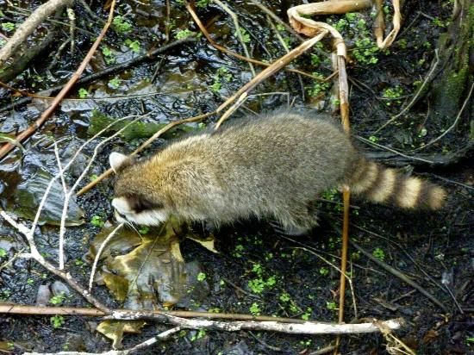
A northern raccoon foraging in the cypress swamp.

Other Species Seen
Whilst at the sanctuary we also saw:
- Alligator Flag
- Strangler Figs
- White Tailed Deer
- White Ibis
- Red Bellied Woodpecker
- Resurrection Fern
  - Pleopeltis polypodioides
  - An epiphyte- it attaches itself to other plants and gets its nutrients from the air and from the bark
  - It can survive long periods of drought by curling up its fronds and appearing dessicated
  - Once water is present it will uncurl and reopen, appearing to resurrect
  - Posted by Anna Newlove at 16:41 No comments:

Day 4- Ding Darling National Wildlife Refuge
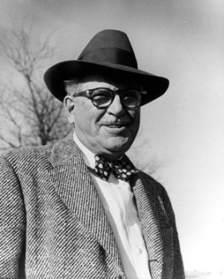
J. N. 'Ding' Darling, the driving force
behind the creation of the refuge.

Background To Ding Darling Wildlife Refuge
Created in 1945 as the Sanibel National Wildlife Refuge, it was renamed in 1967 to honour cartoonist Jay Norwood 'Ding' Darling, to protect and conserve the wildlife habitat on Sanibel Island, allowing the over 220 species of birds found there, along with the many other native plant and animal species, to continue to thrive. As one of 562 wildlife refuges in the U.S. it's objective is wildlife first, before public, hence the management systems they have put in place, which will be talked about below.
The refuge consists of 6,400 acres of mangrove forests and approximately 2,800 acres of the refuge are a designated Wilderness area.
For more information see: About Ding Darling.

Duck Stamps
One of the main ways that money is raised for conservation throughout the U.S. wildlife refuges is through the sale of duck stamps. Ding Darling created the first duck stamp in 1934: it was sold for $1 to hunters, who had to buy one for the back of their licences to allow them to hunt.
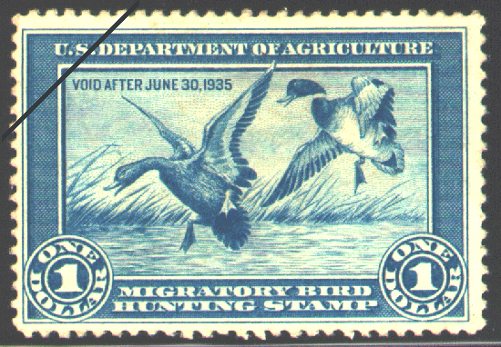
The first duck stamp, drawn by Ding Darling.
Duck stamps are still sold today, now for $15, and are still needed by hunters, but are also bought as souvenirs. They now also provide free entry into any of the national refuges. The money raised through their sales goes towards conservation within the refuges.
Money for Ding Darling Refuge is also raised by the Friends Group, who actually raise the majority of the money needed for the refuge to continue with it's current conservation work. They also raise money for new development, such as the new boardwalk in 2013, connecting the refuge to a local school. For more information on who the Friends Group is and what they do see here, Ding Darling Society.
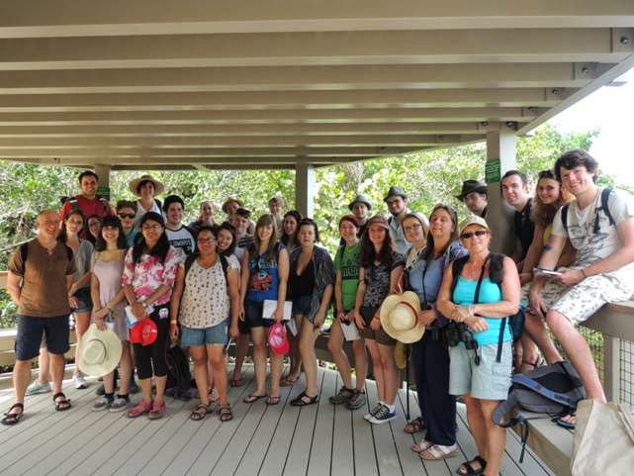
The group who went to Florida on the new boardwalk.

Management Of The Refuge
Because it is a refuge, the primary aim of Ding Darling is to protect and conserve the wildlife first, before then educating the public, as oppose to state parks, where the public are first, and the wildlife are second. This means that there are certain management procedures followed, to prevent excessive disturbance. One way the wildlife is protected is that the wildlife drive (a 4.5 mile road around the refuge visitors can drive along, and stop to see any of the wildlife), is closed every Friday, to prevent excessive disturbance from the noise of the cars and public. It also allows members of staff to go along the drive and collect any rubbish that has been left behind, which could potentially cause harm to the wildlife.
Fishing and crabbing are both allowed in the refuge, though hunting is not. To manage this, members of staff regularly check throughout the refuge and remove any fishing lines that have been left behind. Divers are also used to swim throughout the refuge and clear any rubbish up from below the water's surface.
The refuge gets between 700- and 800,000 visitors a year, and so the amount of rubbish generated can be large. Therefore, in an attempt to combat this, plastic water bottles have been banned on the refuge. Re-usable ones can be purchased from the visitors shop, which is run by the Friends Group, and the money from this goes back into the refuge for conservation.

An Overview Of The Visit
The day started with a brief talk about the refuge, telling us much of the information found above. We then followed the new boardwalk from the Education Centre, to the viewing platform (seen in the photo of the group above). Whilst on our visit temperatures were reached up to 28^C. At the viewing platform we saw many different bird species, which I will speak about below.
After we had finished the boardwalk, we went back to the cars and started to follow the wildlife drive around the refuge. Along the drive we saw many of the refuge's bird species, as well as a number of other species, including:
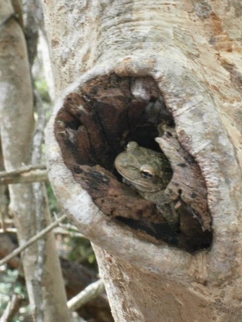
The Cuban Tree Frog.

- Rat Snake
- Southern Water Snake
- Mangrove Crabs
- Striped Mullet
- Long Nose Gar
- Horseshoe Crabs
- Brown Anoles
- Green Anoles
- Cuban Tree Frog
The Cuban tree frog (Osteopilus septentrionalis) is an invasive species to Florida, first introduced in the 1920's. They will predate upon many of Florida's native tree frog species, as well as small lizards and many invertebrates. The tadpoles also outcompete the the tadpoles of native tree frog species. Because of the large negative impact they are having on the native species, it is being advised that if home owners see any, they humanely catch them and euthanize them, with advice offered on how to do this here: Cuban Tree Frogs.
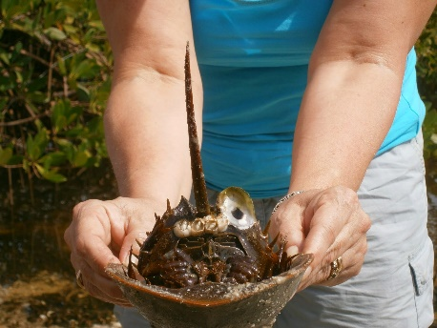
A horseshoe crab.
We also saw a large congregation of horseshoe crabs (Limulus polyphemus) along the drive. The Florida Fish and Wildlife Conservation Commission are currently trying to get the public involved in surveys to try and calculated the size of their populations (more information here: Horseshoe Crab Surveys.), as, since the 1990's there has been a realisation that their numbers are decreasing, which is causing a decrease in the number of sea birds, which feed on the horseshoe crab eggs mid-migration.

Manatees
As we left the wildlife drive, we spotted are large shape under the water's surface, so pulled over and saw a West Indian Manatee (Trichechus manatus). They are the largest surviving member of the order Sirenia, measuring between 2.7 and 3.5m, and weighing between 200 and 600kg. Manatees are an endangered species, and are protected by the Marine Mammal Protection Act (1972) and the Endangered Species Act (1973). Over the winter months they are found along the gulf coast of Florida, in mangrove estuaries, where the water is warm. Over the summer, they disperse into coastal waters as their temperature increases. Almost half of all adult manatee deaths are due to human-related causes, mainly boat collisions, which is why in many shallow areas speed limits are found, that allow the manatees to move away from the boats. For more information on manatees, see West Indian Manatees.
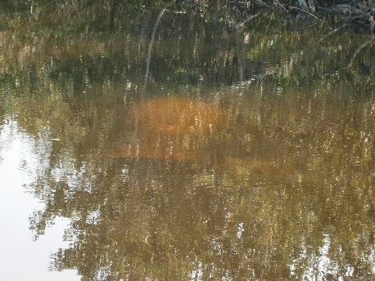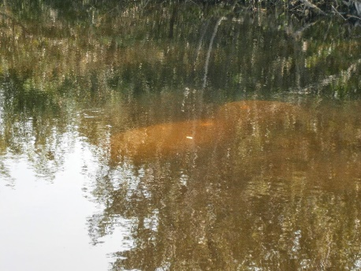

The West Indian Manatee we saw at Ding Darling Refuge.

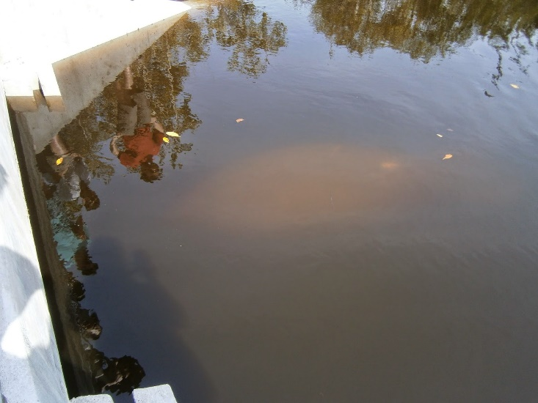

Bird Life In The Refuge
The refuge is home to over 200 species of birds, and is a stop off point for many migrations. Whilst we were there we saw:
- Ospreys
- Anhingas
- White Pelicans
- Brown Pelicans
- Snowy Egrets
- Redish Egrets
- Great Egrets
- Cattle Egrets
The refuge is also home to three bald eagle nests, however we did not see any whilst we were there.

Anhingas.
The anhinga (Anhinga anhinga), also known as the snake bird, is seen throughout southern Florida in the mangrove swamps, where it is able to stalk it's prey, hide from predators in the water and sun itself on the tree tops. Its diet consists mainly of fish, though also includes aquatic invertebrates and insects. They are known as snake birds as often they will swim through the water with just their head and neck out, which looks like a snake. Anhingas feathers are not waterproof as with most other aquatic birds, and so they will often be seen with wings spread on branches, drying out in the sun and wind. For more information see, Anhinga Facts.

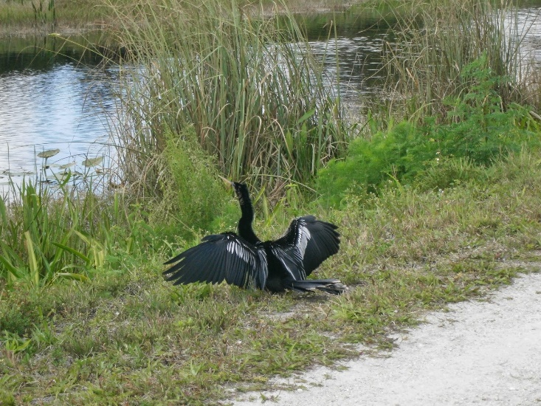
An anhinga drying it's wings.

White Pelicans.
The white pelican (Pelecanus erythrorhynchos) is one of the largest birds found in the U.S.: it is between 50 and 70 inches long, weighs between 4.2 and 13.6 kg and has the second longest wingspan of any U.S. bird (after the California Condor) at between 95 and 120 inches. They catch their prey whilst swimming, which is different to the brown pelican, which dives for its food. At the beginning of the 20th century there was a dramatic decline in their numbers, however conservation efforts now mean that on the IUCN Red List they are classed as 'Least Concern'. For more information see, White Pelican Facts.
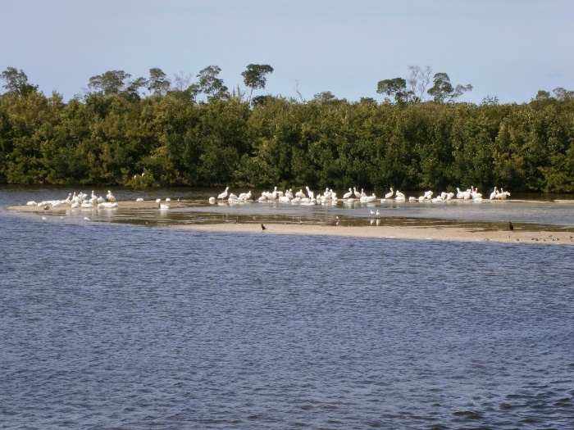
The squadron of white pelicans seen.

Ospreys.
Throughout our time in Florida we saw a number of ospreys (Pandion haliaetus), as fish eating bird of prey found on every continent except Antarctica. Ospreys usually mate for life (though examples of polyandry have been rarely recorded), though courtship behaviours are repeated each year. The female osprey is usually larger than the male, with a ring of brown feathers around her neck. The males and females both raise the young together, until the fledge at 8-10 weeks old. Raccoons and bald eagles can be a threat to the eggs or nestlings of an osprey if they can gain access to the nest. Adults and juveniles differ in eye colour: adults have yellow eyes, whereas juveniles have orange ones.
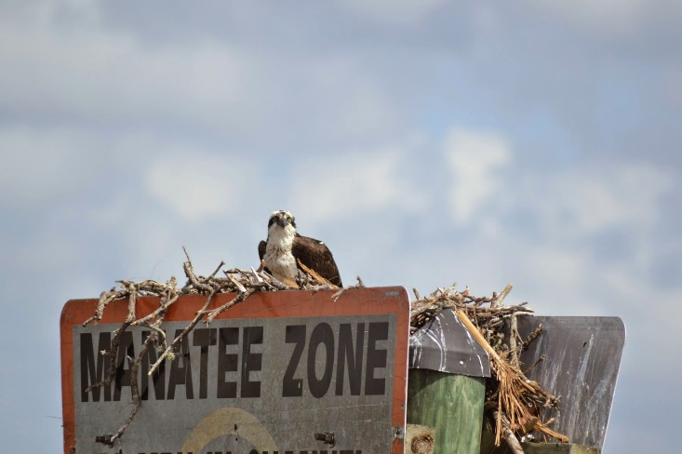
An osprey nesting on one of the speed limit signs found in manatee habitats.
Posted by Anna Newlove

Day 3- Loxahatchee National Wildlife Refuge, LILA and Airboats

A Background To Loxahatchee
The Loxahatchee National Wildlife Refuge consists of 145.800 acres of the northern Everglades, and contains one of the three water conservation areas (WCA's) found in south Florida, that is maintained to provide water storage and flood control, as well as maintaining the natural habitat for native plant and bird species. It was created in 1951 between the South Florida Water Management District and the U.S. Fish and Wildlife Service. It not only consists of Everglades marsh habitat but also a cypress swamp, which has a boardwalk the public can follow. During out visit temperatures were between 28 and 30^C.
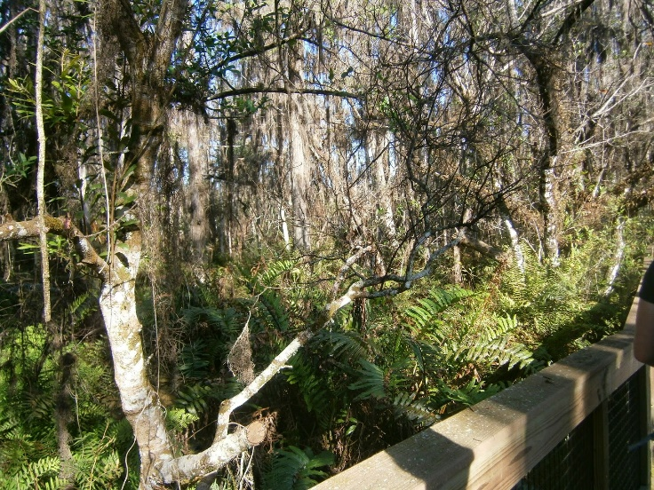
The cypress swamp at Loxahatchee, as seen from the boardwalk.

The Everglades: Ridges, Sloughs and Phosphorus Levels
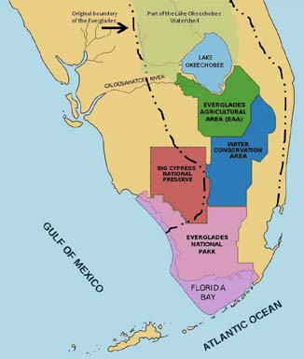 | Map showing the change in the Everglades.
The Everglades used to cover a much larger area than in the present day, with the map on the right showing the extent of the change. This has also caused a large change in the flow of water from Lake Okeechobee. They originally covered almost 11,000 square miles, however from the early 1900's drainage started, severely altering the landscape, until in 1947 it became protected, and conservation
efforts started.
One of the key aspects of the Everglades landscape is the ridge and slough patterns seen, which is shown in the picture below (originally found here: Ridge and Slough Pattern).
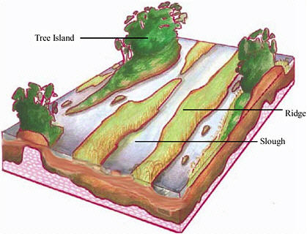
The ridge and slough pattern of the Everglades.
Originally the Everglades consisted of high elevation tree islands, mid-elevation ridges consisting of saw grass (Cladium jamaicense) and low elevation sloughs, with only a couple of feet separating all three. The tree islands are the Everglades biological hotspots, where many wading birds nest and other animals live, whilst the ridges and sloughs are the opposite- the are nutrient, species and abundant poor. However the sloughs are necessary for the wading birds' survival during the dry season, as the fish become concentrated, and therefore easier to catch. The problem caused by the draining of the Everglades is that the natural water flow has changed, affecting how it flows in the sloughs, affecting the wading birds, as successful predation rates have decreased. This has led to a decrease of between 80 and 90% in wading bird populations.
The other key aspect of the Everglades is that they naturally have extremely low levels of phosphorus (ideally at 10 parts per billion), as rainfall is the only natural source of nutrients. However, due to the water flow changes because of drainage, there has been increased phosphorus levels throughout the Everglades. This has led to changes in which plant species are now dominant on the ridges- originally it was saw grass, however now Southern cattail (Typha domingensis) is becoming dominant, and out-competing the saw grass. To counteract this constructed wetlands are now being used to intercept and remove the phosphorus before it reaches more pristine wetlands. The clearing of cattail and phosphorus from the Everglades is slowly leading to increases in wading bird numbers.

LILA: Loxahatchee Impoundment Landscape Assessment
Created in 2003, LILA is an 80 acre living laboratory, consisting of 4 macrocosms, each 20 acres in size, which are scaled down models of the Everglades, with ridge, sloughs, and 2 tree islands each. For more information see Quck Facts on LILA.
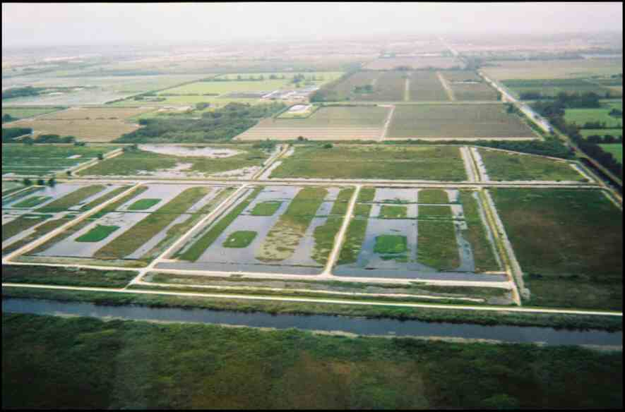
LILA from above. You can see the 4 macrocosms, with the large canal
along the bottom that controls the water flow into each.
In the 11 years since its creation, there have been a number of ongoing, long term experiments, such as the modelling of water flow in the sloughs and projects on the natural wildlife. One such project is currently being undertaken, to look into the movement of the fish at different water levels: PIT tags (which are used in supermarket scanners) are being placed on the fish, and their movements in different water levels are being recorded. They also run experiments into predator/prey population dynamics, in which they actually completely drained 2 of the macrocosms, to simulate a large drought, and compared them with the other two, looking at crayfish populations, which, 1 or 2 years after the drought, were much larger in the drought simulated macrocosms, as the sunfish population, their natural predator, had been significantly knocked back.

Invasive Species
Whilst looking around the refuge and LILA a number of invasive species were pointed out to us. Invasive species are a large problem for Florida's native wildlife: many of them come from the pet trade, and are accidentally released, at which point their populations boom, due to Florida's near ideal conditions and climate, and they usually end up out-competing the native species. For more information on invasive species throughout Florida see Invasive Species.
One species of fish we saw at the refuge, the croaking gourami (Trichopsis vittata) is invasive. It originates in South East Asia, but was brought to Florida for the pet trade, and it has then been released into the natural ecosystem, either through aquarium releases or aquaculture escapes. It produces it's croaking noise by rubbing its pectoral fins together.
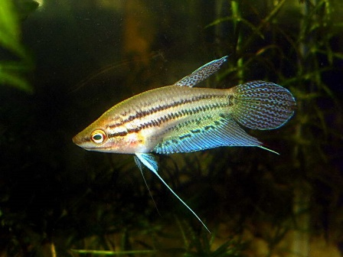
A croaking gourami.
There are also problems in Florida due to invasive plant species. As mentioned above, one species is the Southern Cattail. Another species is the water hyacinth (Eichhornia crassipes), which originates in the Amazon basin, and was brought to North America in the 1880's. In 1910 it was suggested that hippos should be imported to deal with the water hyacinth, but the bill fell one vote short. Currently Neochetina spp. are being used a biological controls, though they are not as effective as hoped.
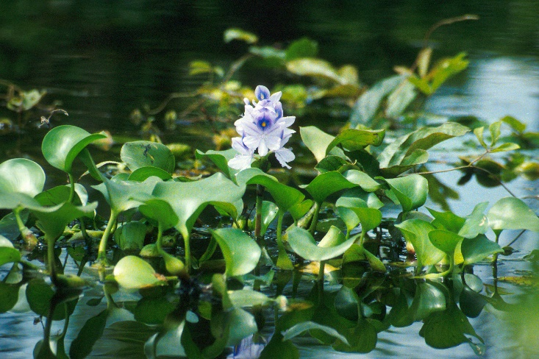
The water hyacinth.

Other Species Seen
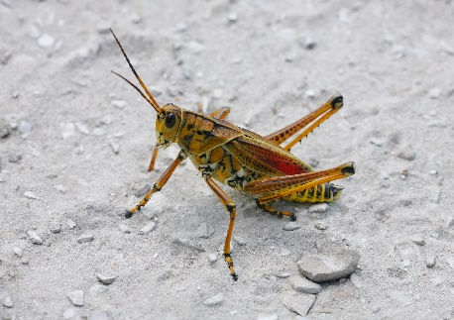
An Eastern Lubber Grasshopper.
Whilst at the refuge we also saw:
- American Alligators
  - We saw a mother with two young, and a yearling
- Blue Winged Teal
- Coots
- Eastern Lubber Grasshoppers
  - We saw juveniles, which, if ingested, have a poison secreted on their skin
  - It looks very different during it's different life stages
  - For more information see: Eastern Lubber.
- Turkey Vultures
- Glossy Ibis
- White Ibis
- Spotted Sunfish
- Golden Top Minnow
- Mosquitofish

Airboats
After we had left Loxahatchee, we went for a ride on the airboats. On these we saw lots of alligators, including one that was roughly 15 foot long. We also saw a number of birds, including a great blue heron (Ardea herodias), white ibis (Eudocimus albus) and anhinga (Anhinga anhinga).

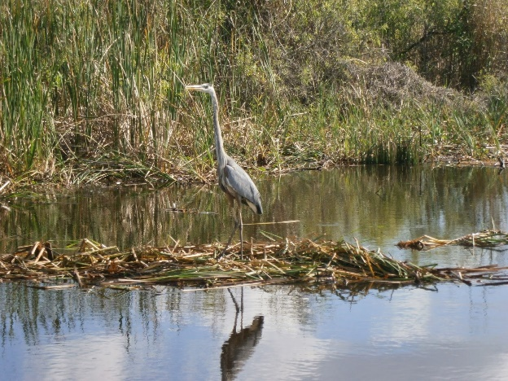
The great blue heron.
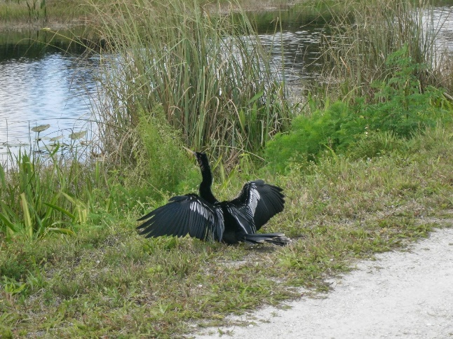
An anhinga- this one was at LILA, seen drying it's non-waterproofed
wings in the sun.
- 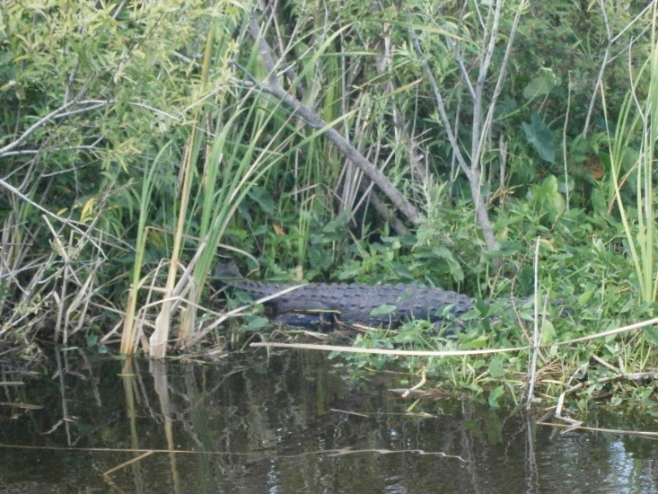
One of the alligators seen.

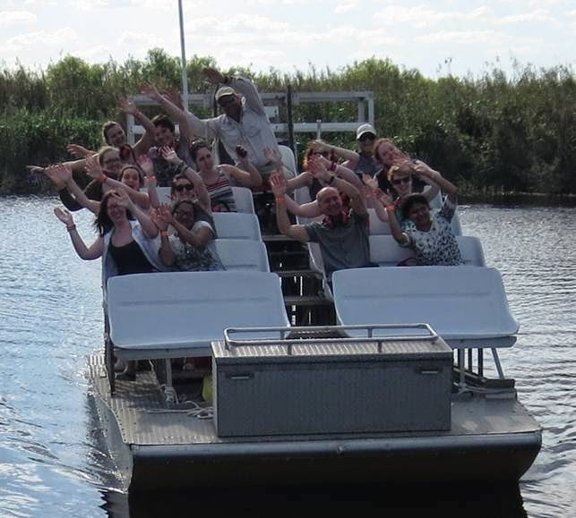
The airboat ride.

Posted by Anna Newlove

Tuesday, 1 April 2014

Day 2- Florida Gulf Coast University

A Brief Background
On Day 2 we went to visit the main campus of Florida Gulf Coast University (FGCU), which has 15,000 students. On their website (found here: FGCU) they claim to be the 5th greenest campus in the U.S, which is easy to believe when you have been there: 50% of the square mile that holds the campus is allocated as preserve for the natural ecosystems, such as cypress swamps and wet prairies, found there.
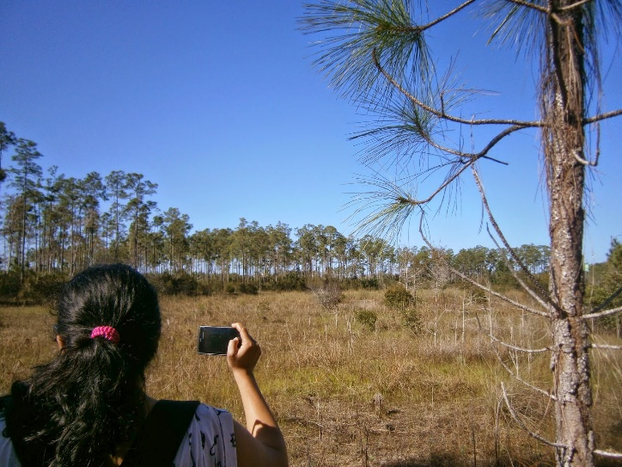
A natural wet prairie, opposite one of the main campus buildings.

An Outline Of The Day
We arrived at the campus around mid-morning and were met by Win Everham (his staff page can be found here: Edwin Everham), an ecologist who looks into reconciliation ecology (managing man made areas so that they are still attractive to the native species) and disturbance ecology (how ecosystems react in response to natural disasters, such as hurricanes and fires). Win gave us a brief talk on what he currently researches, before taking us on a guided tour of the campus.
We walked over a wet prairie on the way to one of the cypress swamps. Before we reached the swamp, we came to a large, man-made pond, in which we placed three fish traps. After we had been to the swamp (which is written about below), we checked these traps and found fish such as the golden top minnow, mosquitofish and blue finned killifish (for binomial names see Species List).
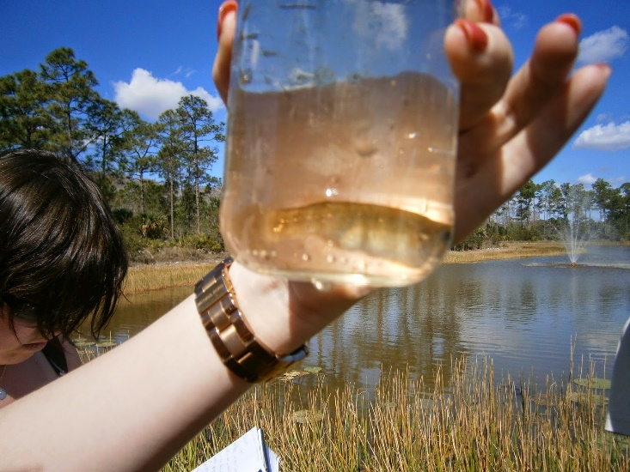
The golden top minnow caught in one of the fish traps.
After checking the traps we made our way to the student led food forest on campus. All students must take part in 80 hours community service, and one way they have done this is by setting up a food garden on what was a constructors car park. The produce grown in the food garden is now sold on campus at farmers markets. For more information see FGCU Food Forest.

Cypress Domes
As part of the tour Win took us into one of the cypress swamps found on the campus. Although temperatures reached up to 28^C this day, inside the swamp it felt cooler. The swamp follows a dome like structure: on the edges the trees are smaller, as the ground dries during the summer, with them getting increasingly bigger, until the very centre, where there are no trees, as the ground stays covered by 1 or 2 feet of water even in the summer, stopping any trees growing.
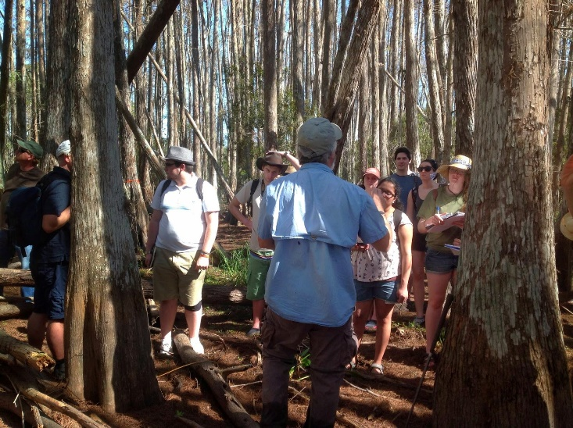
Win talking to us in the cypress swamp.
In the swamp the main plant species we saw were the pond and bald cypress' (Taxodium ascendens and T. distichum respectively) and the alligator flag (Thalia geniculata). The alligator flag is so called because they grow in areas of deep water, and so hunters use them as an indicator of where alligators may be. For more information on them see Plant Profile- Alligator Flag.
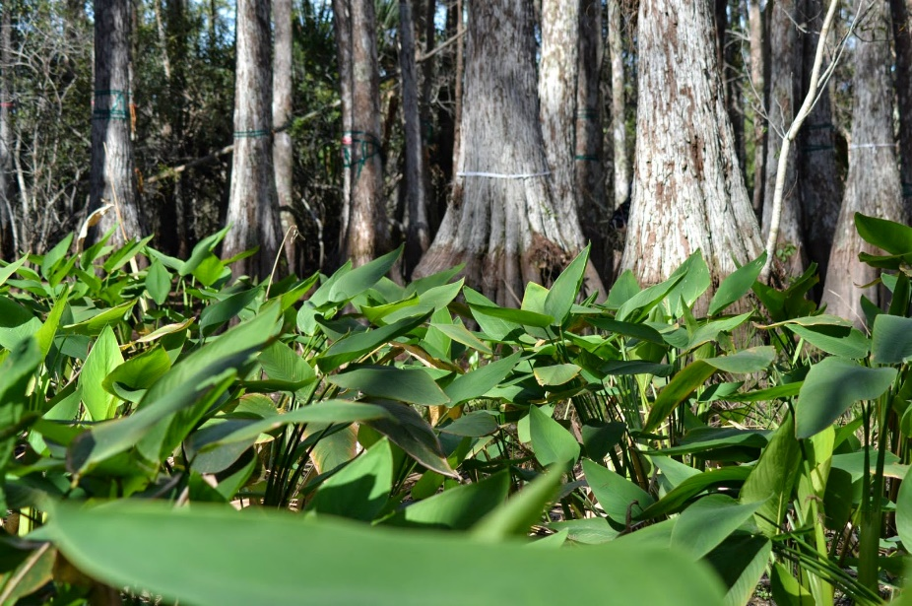
Alligator Flag, with cypress trees in the background.
When we were in the centre of the swamp, Win gave us a talk on the different ecotones seen on the campus, from the pine upland, to the wet prairie, to the cypress swamp, with only a couple of feet elevation leading to these different habitats. Fires naturally control the pine upland, keeping the cypress' out, and water levels control the swamps, keeping the pines out, with the wet prairies forming in the area between the two.
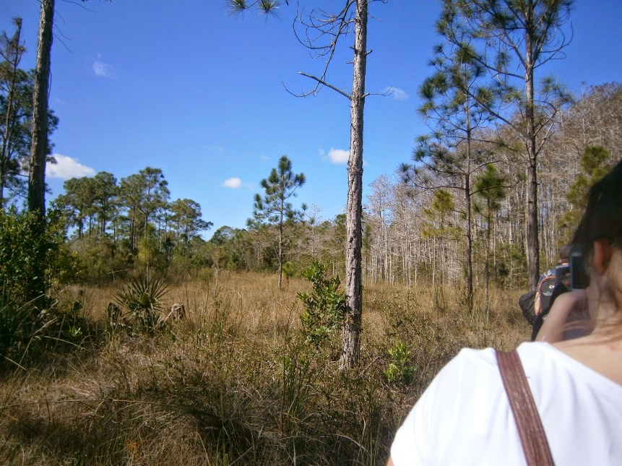
A prime example of the differing ecotones seen on the campus:
on the left is a pine upland, the centre is a wet prairie, and on the right is the cypress swamp.

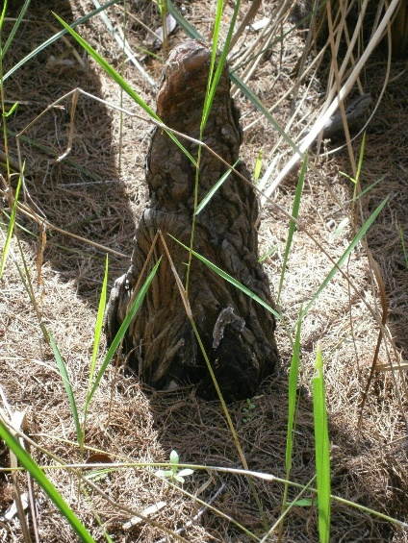
A cypress knee.
Win also spoke about the cypress knees seen throughout the swamp.
These are up-growths of a cypress' roots.
There are three differing theories as to the use of these:
- they transport oxygen to the plant, when it is submerged.
- they interlock with one another to provide support during events such as hurricanes.
- they create habitats- other plant seeds can germinate on them, where normally they would not be able to grow due to the saturated ground.
It is not currently known which is the main reason behind the adaptation, but ongoing research is looking into it, and suggesting that actually they do not help with oxygen intake, suggesting they are there for support or habitat creation.

Florida- The Land Of Flowers
On the way into the cypress swamp Win pointed out many of Florida's wild flowers. In fact the name Florida comes from the Spanish flower festival, because of the many species of flower found there when it was first discovered. Some of the species seen were:
- Swamp Pink (Helonius bullata)
- Penny Royle (Mentha pulegium)
- Tickseed (Coreopsis spp.)
- Purple Star Grass (Cynodon aethiopicus)
From the leaves of the penny royle a mint tea can be made. The tickseed is the state wild flower for Florida.

Alligator
On the way to the food forest we saw our first alligator of the week, the first of many! As we all moved closer to it to get pictures, it swam away from the bank where it had been basking. Win explained this is the behaviour that they want to see in the alligators on campus, as it means they have not become accustomed to humans, at which point they would have to be humanly put down as they would be a threat to the students.
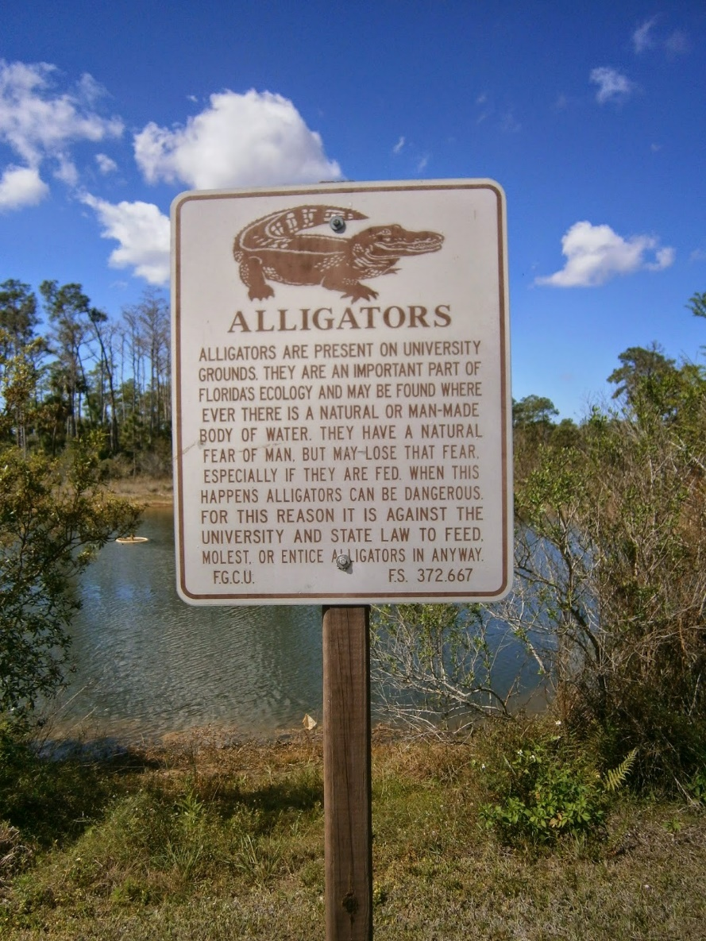
Signs seen across campus, informing the students
about the alligators.

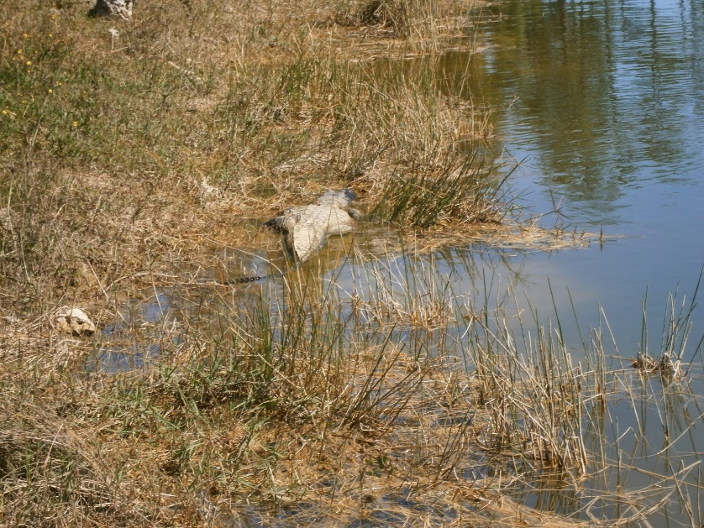
The first alligator we saw, basking at the edge of the pond, before it swam off.
The American Alligator (Alligator mississippiensis) is found throughout Florida, however they are listed as threatened by the federal government because they are similar in appearance to the American Crocodile (Crocodylus acutus), which is an endangered species, and the government does not want hunters to confuse the two. They are classed as a keystone species, as the holes they form when basking or sitting in wait for prey, go on to be used as incubation nest for red-bellied turtles. For more information on the American Alligator see American Alligator Facts.

Other Species Seen
During the day we also saw:
- Crazy Ants
- Cuban Tree Frogs
- Apple Snails
- Florida Slash Pine
- Saw Grass
- Broom Sage
- Saw Palmeto
- Greenhouse Frogs
For binomial names, see Species List.
Posted by Anna Newlove

Monday, 31 March 2014

Day 1- Lover's Key State Park

A Brief History
Lover's Key was completely cut off from the mainland, until fly overs were built during the 1960's to connect it. The name comes from this isolation: prior to the fly overs only lovers made the effort to travel out to the beaches by boat. Following the connection to the mainland, development started, and in the 1980's dredging of the mangroves started. However, this damaged the mangroves, and so the land owner was forced to give the land to the state in 1983, when it became a state park. For more information see Lover's Key State Park History.

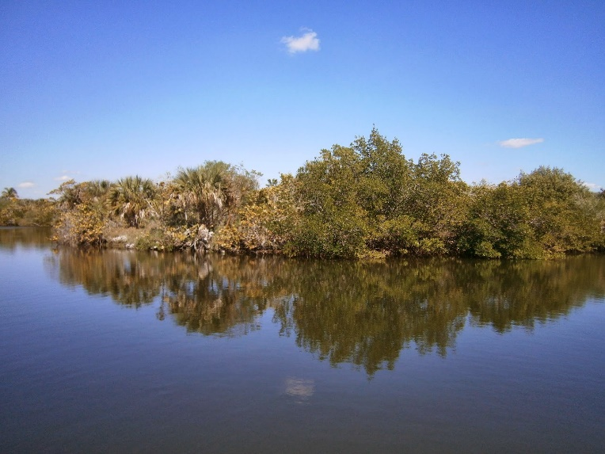
An example of the mangrove habitat that is now protected as part of the state park at Lover's Key.

The Mangroves
Whilst we were at Lover's Key, we had a brief talk on all things mangroves. We learnt that the term mangroves has two meanings:
1) it refers to the genus Rhizophora, which are also known as the true mangroves
Within this genus there are 64 species, 10 of which are found in America, and 3 are found in Florida.
2) it also refers generally to mangroves forests/swamps
It refers to the habitat the trees form and also all trees and shrubs that live within the brackish environment between the sea and land, such as the sea grape (Coccoloba uvifera), buttonwood (trees belonging to the genus Conocarpus) and the white stopper (Eugenia axillaris), which is given it's name as tea made from the leaves is meant to stop diarrhoea.
The three mangrove species found in Florida are:
1) the black mangrove- Avicennia germinans
2) the red mangrove- Rhizophora mangle
3) the white mangrove- Laguncularia racemosa
The red mangrove is found closest to the water, the white furthest inland, and the black in the middle. Red mangroves have adapted to their aquatic lifestyle in a number of ways. An example is their aerial prop roots, which stand above water. A second adaptation is their propagules, which grow and develop when still attached to the parent tree, before dropping off and being dispersed by the water.
The black mangrove is characterised by it's pneumatophores, root-like structures which grow up out of the water to allow for a continual supply of oxygen, even when submerged. For more information on these, see Mangroves and pneumatophores. For more information on mangroves in general see Mangroves.
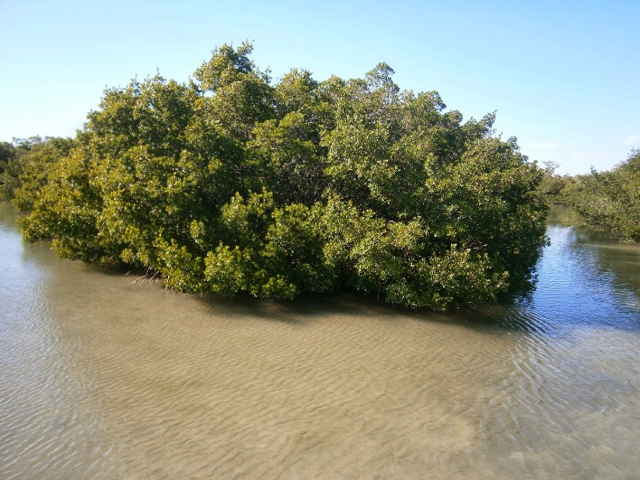
Mangroves at Lover's Key State Park.

The Day At Lover's Key.
We arrived at Lover's Key State Park in the early afternoon, with temperatures for the visit around 25-27^C. Almost as soon as we arrived we saw both turkey and black vultures (Cathartes aura and Coragyps atratus respectively). Both species were circling over the park and so we learnt the way to tell the difference, without binoculars, is that the turkey vultures generally fly lower than the black vultures, with a more unstable looking flight as well.
We then started to follow the paths around the park, starting with manatee bridge. Whilst looking for manatees we saw small shoals of fish darting around as well as some small jellyfish, that showed small amounts of bio-luminescence. From the bridge we spotted briefly a West Indian Manatee (Trichechus manatus) as it surfaced for air, before watching the patterns created on the surface of the water as it swam below.
Moving on from the bridge we started to follow trails around the park and saw many different species including:
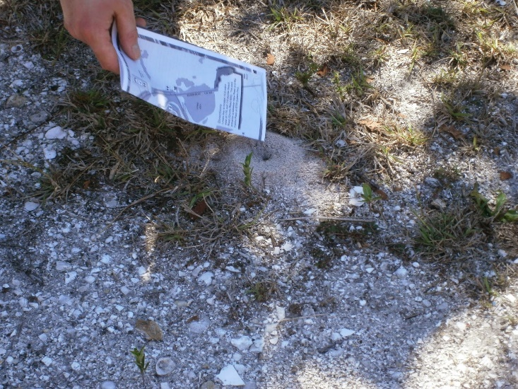
A fire ant nest, seen regularly along the edges of paths.
- Brown Anoles
- Fire Ants
- Eastern Screech Owl
- Grey Squirrel
- White Ibis
- Gopher Tortoise
- Strangler Fig
- Red Bellied Woodpecker
- Gumbo Limbo Tree
- Osprey
- Brown Pelican
For binomial species names, see Species List Blog Post.

Gopher Tortoises.
Whilst at Lover's Key we saw two gopher tortoises (Gopherus polyphemus). These are an important species to Florida, as they are a keystone species, which is defined as a species which plays a critical role in maintaining how an ecosystem works. The gopher tortoise burrows underground and, during Florida's natural forest fires, other species, such as snakes and lizards, are able to use these burrows for cover, allowing them to survive.
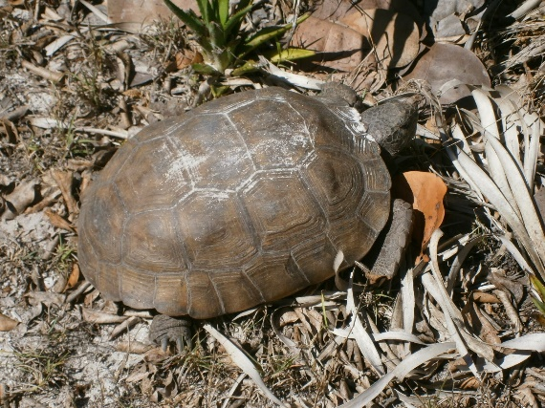
One of the gopher tortoises we saw. Shortly after this picture was taken it moved into it's burrow nearby.

Brown and Green Anoles
Found at Lover's Key are two species of anole, the brown (Anolis sagrei) and the green (Anolis carolinensis). The brown anole is an invasive species to Florida, first seen in 1887. The brown anoles are out-competing the native green anoles for food, as well as forcing them higher into the trees. Large brown males are also known to eat smaller green anoles. Thus, the brown anoles are slowly causing a reduction in the number of the native green anoles. For more information, see Non-natives - Brown Anole.
However it is suggested here (Great Tales Of Florida Anoles) that actually this reduction is not actually occurring, but that the green anoles are re-adapting to a more arboreal lifestyle, as seen in Cuba, where the two species co-exist.

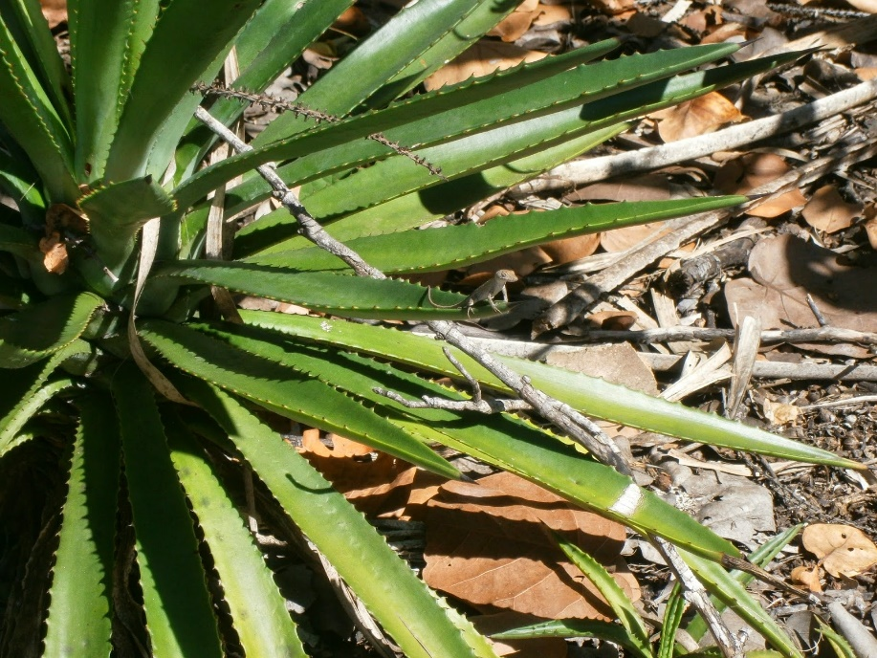
A brown anole basking on the end of a leaf.
Posted by Anna Newlove

Species List
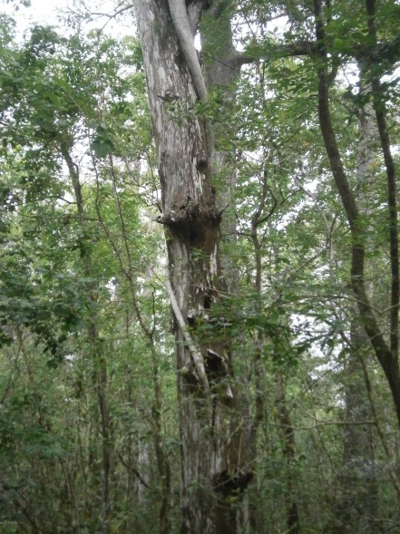
A strangler fig wrapping around a cypress tree.

Plants
Strangler Fig- Ficus aurea
Red Mangrove- Rhizophora mangle
Black Mangrove- Avicennia germinans
White Mangrove- Laguncularia racemosa
Sable Palm- Sabal palmetto
(also known as the cabbage palm)
Saw Grass- Cladium jamaicense
Florida Slash Pine- Pinus elliottii
Broom Sage- Andropogon spp.
Saw Palmetos- Serenoa repens
Swamp Pink- Helonius bullata
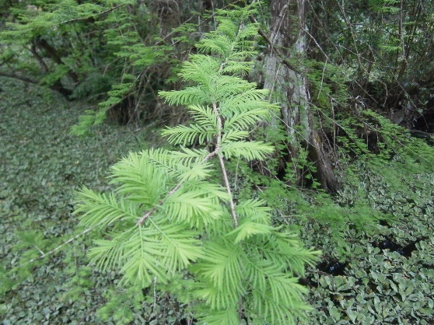
A pond cypress' foliage developing.
Penny Royle- Mentha pulegium
Tickseed- Coreopsis spp.
Purple Star Grass- Cynodon aethiopicus
Southern Cattail- Typha domingensis
Bladderworts- Utricularia spp.
Gumbo Limbo Tree- Bursera simaruba
(also known as the tourist tree)
Pond Cypress- Taxodium ascendens
Bald Cypress- Taxodium distichum
Alligator Flag- Thalia geniculata

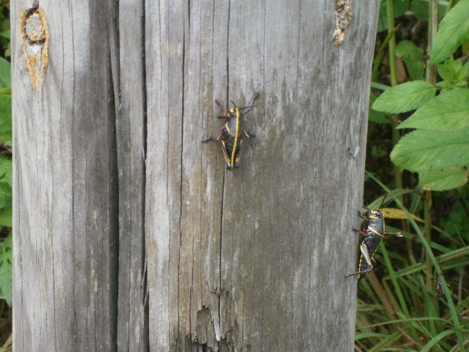
An Eastern Lubber grasshopper.

Insects
Fire Ants- Solenopsis spp.
Crazy Ants- Nylanderia fulva
Eastern Lubber- Romalea guttata
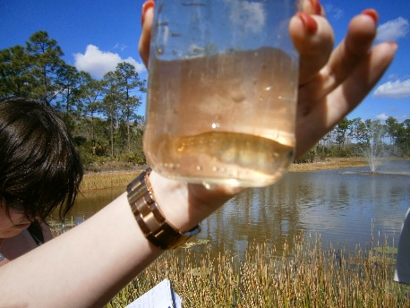
The golden top minnow we caught at the Florida Gulf
Coast University campus.

Fish
Golden Top Minnow- Fundulus chrysotus
Mosquitofish- Gambusia affinis
Blue Finned Killifish- Lucania goodei
Spotted Sunfish- Lepomis punctatus
Striped Mullet- Mugil cephalus
Long Nose Gar- Lepisosteus osseus

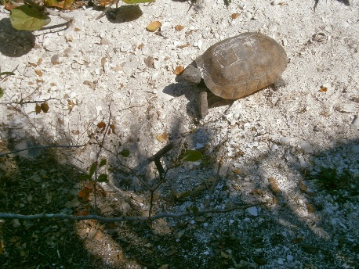
A gopher tortoise.

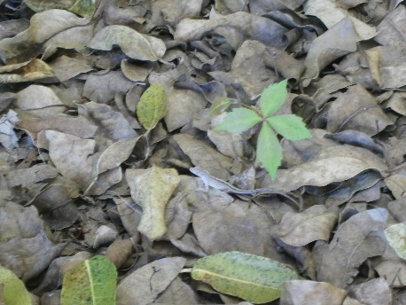
A brown anole camouflaged amongst the leaf litter.

Reptiles and Amphibians
Brown Anole- Anolis sagrei
Gopher Tortoise- Gopherus polyphemus
Cuban Tree Frog- Osteopilus septentrionalis
Greenhouse Frog- Eleutherodactylus plunirostris
American Alligator- Alligator mississippiensis
Rat Snake- Elaphe obsoleta
Southern Water Snake- Nerodia fasciata
Green Anole- Anolis carolinensis

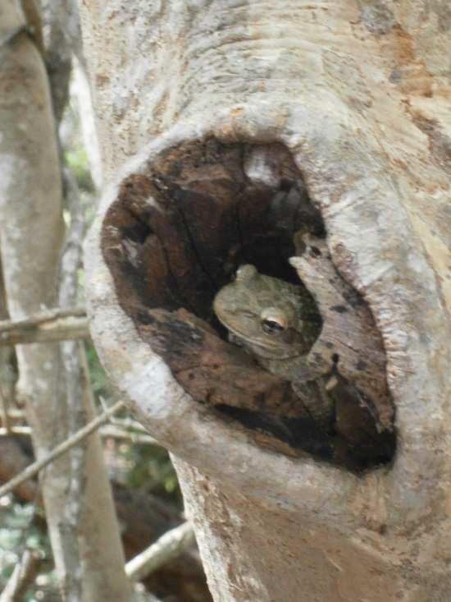
A Cuban Tree Frog, an invasive species to Florida.

Birds
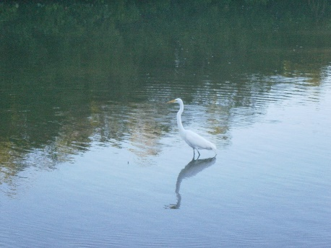
A White Ibis.

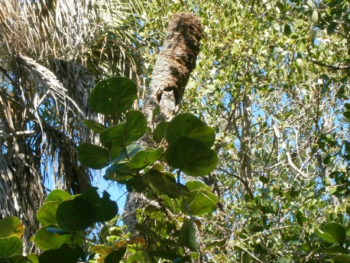
The Eastern Screech Owl seen at Lover's Kay State Park.
Black Vulture- Coragyps atratus
Eastern Screech Owl- Megascops asio
White Ibis- Eudocimus albus
Red Bellied Woodpecker- Melanerpes carolinus
Northern Cardinal- Cardinalis cardinalis
Blue Winged Teal- Anas discors
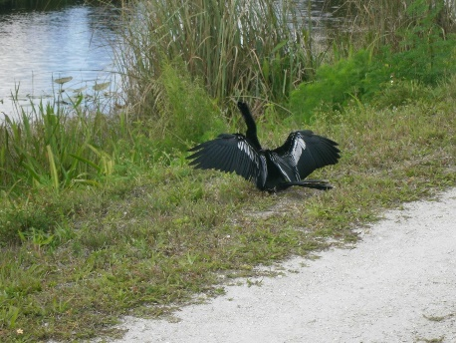
An Anhinga, drying it's wings in the sun and breeze.
Coot- Fulica spp.
Turkey Vulture- Cathartes aura
Glossy Ibis- Plegadis falcinellus
Osprey- Pandion haliaetus
Anhinga- Anhinga anhinga
White Pelican- Pelecanus erythrorhynchos
Brown Pelican- Pelecanus occidentalis
Snowy Egret- Egretta thula
Reddish Egret- Egretta rufescens
Great Egret- Ardea culba
Cattle Egret- Bubulcus ibis
Wood Stork- Mycteria americana
Grey Catbird- Dumetella carolinensis
Bald Eagle- Haliaeetus leucocephalus
Barred Owl- Strix varia
Royal Turn- Thalasseus maximus
Cormorant- Phalacrocorax spp.

Mammals
West Indian Manatee- Trichechus manatus
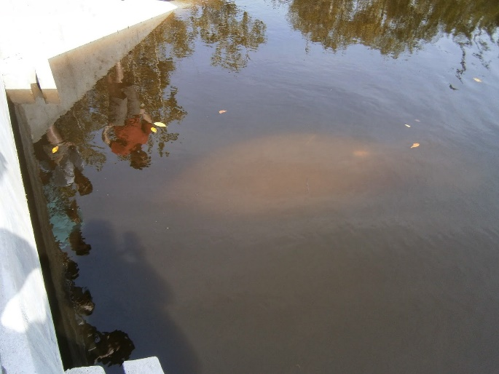
The manatee seen at Ding Darling, as it starts to move under a bridge.
Grey Squirrel- Sciurus carolinensis
Bottlenose Dolphin- Tursiops truncatus
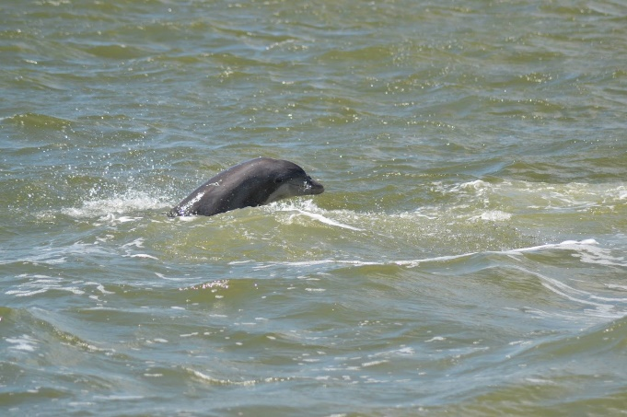
One of the bottlenose dolphins seen on the 10000 Islands boat trip.
White Tailed Deer- Odocoileus virginianus

Invertebrates
Apple Snail- Ampullariidae spp.
Mangrove Crab- Aratus pisonii
Horseshoe Crab- Limulus polyphemus
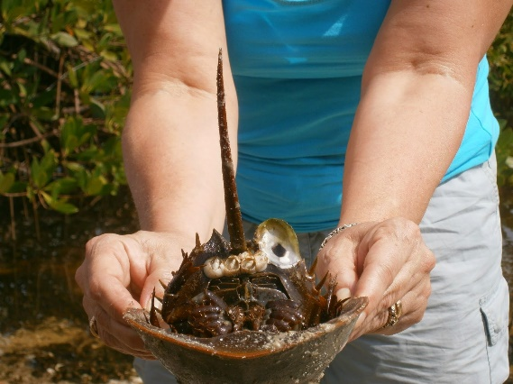
A Horseshoe Crab.

