Naples Jazz Society http://www.naplesjazzsociety.com/about-the-musicians-2/
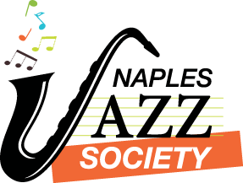

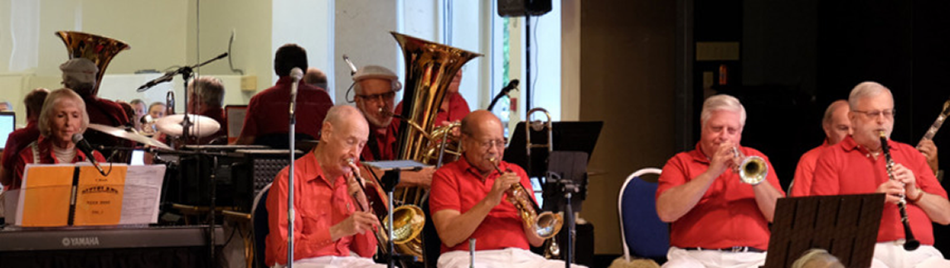

About the Musicians
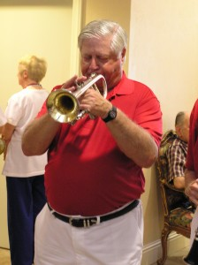 Marc Gerber
Marc is a Retired Civil Engineer/Builder from Mount Kisco, NY now living in Naples. He took piano and music theory lessons as a young boy and determined he could only play one note at a time.. He then discovered Benny Goodman and at age eleven took up the clarinet. His father, who was a dentist, noticed that the clarinet was pushing his front teeth forward. In a successful attempt to avoid orthodontia, his father told him to switch to trumpet which he did at age thirteen.

At Lawrence High School Marc played trumpet in the marching band, symphonic band and the Top Hats, a four piece combo. At Cornell University Marc played in the Big Red Marching Band, the Pep Band and the Symphonic Band as well as a Dixieland Band. He is a member of the Naples Jazzmasters, Marco Island Strumers, Stage Door Canteen Big Band, The Entertainers Dance Band and the Flamingo All Stars. He plays all the old jazz standards & swing tunes from the 30’s – 40’s and loves to play Dixieland. He is Vice President of the Naples Jazz Society, Inc.

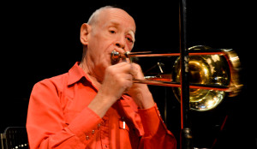Jim Gover
Jim is the leader of our bands. The extent of his devotion and effort to make our kind of music in Naples is unequaled by anyone else. Jim is a graduate of the University of Kentucky. He served with the United States Air Force. He is a retired dentist, expert musician on tuba, trombone, piano and harmonica and Civil War history lecturer. Simply put, Jim makes the music happen here in Naples. He is the Secretary/Treasurer of the Naples Jazz Society, Inc.
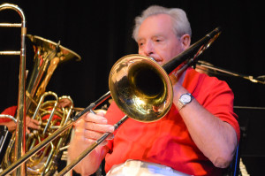Howard Bacon
Howard is a retired corporate executive living in Naples. He played trombone in the Fenton Mich. High School Band & Flint Symphony . Booked out of Mankato Min. with Don Strickland and Sioux Falls and with Fats Carlson dance bands in 1948 &1949. He is a member of Naples Jazzmasters, Marco Island Strummers, Dixierlanders and Blue Dirt Dixieland Band. Enjoys symphony to country western—partial to standards of the 30-40’s and Dixieland.

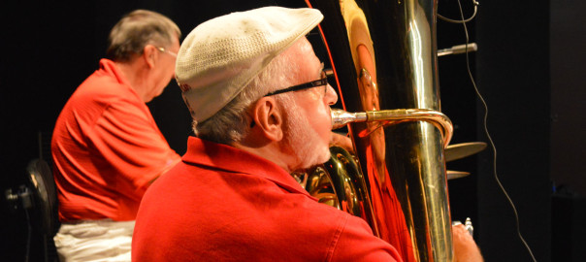Art Blatt
Arthur has a bachelor’s degree and a Master’s degree in Music Performance from Temple University in Philadelphia. He has held Elementary School, Middle School, and High School band director positions at various times in the Philadelphia and New Jersey area. He is just as at home in a symphony orchestra as he is in a jazz band, and he plays tenor trombone, bass trombone, or tuba, whichever is needed. During his long career in the Philadelphia area he played in numerous Dixieland bands in Atlantic City and other locations on the Jersey shore and in the orchestras at all the major Atlantic City Hotels. He has played in the Tex Benecke and Buddy Rich Orchestras, and in the Charlotte Symphony Orchestra right here in Southwest Florida. he has been trombonist in bands backing Frank Sinatra, Sammy Davis Jr. Dean Martin, Liza Minelli and many others

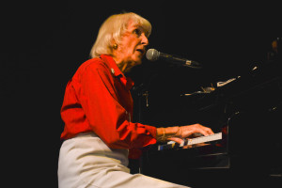Jean Packard
Jean often delights audiences with what could be termed an overture from the Broadway show Cabaret ending the overture with the song “Cabaret” itself. Before and after her association with Cabaret on the Broadway stage with Joel Gray, she studied piano under Hall Overton at a studio known as “The Loft” on 6th Ave in New York City. During the years in New York she mingled with many piano and jazz music greats like Miles Davis, Thelonious Monk, and Dave McKenna as the The Loft became the place where jazz musicians met regularly and played late into the night, swapping ideas and developing jazz styles. Following these years of training she had regular jobs playing at prestigious hotels like the Waldorf Astoria and later eleven years at the Grand Hotel on Mackinac Island, Michigan. Jean is a skilled soloist and accompanist. It is no wonder that she is in such demand here in Naples.

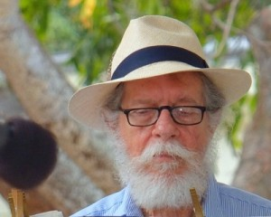 Guerry Boger
Guerry has been a professional piano player for more than fifty years. He plays ragtime, Dixieland jazz, the old standards, and humorous songs. He and his wife Jana play Oktoberfest music the tenth month of every year. Guerry is a talented musician. He is the piano player for the Naples Dixieland Jazz Band
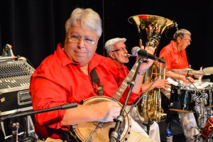Paul Penta
Vocals/banjo/guitar. From Boston, MA, Paul now lives in Naples. Has worked clubs, concerts and cruises from Alaska to Key West. He is a member of the Naples Jazzmasters and also appears locally in several venues.
R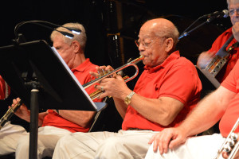Renald Richard
Renald is a professional trumpet player, arranger, and lyricist. He started his career in New Orleans, his home town, toured with many groups including Guitar Slim, Ivory Joe Hunter, and did studio work with Little Richard and other artists. He also was an area representative for Atlantic Records.
He joined the “new” Ray Charles Band in 1954 and was Ray’s first Band Leader and Solo Trumpet. The group toured all over the South and West, and he and Ray wrote “I Got a Woman” sitting in the back seat of the car on the way to a gig. It became Ray’s first Number One hit and put him on the map. Renald has many other tunes that have been recorded by Joe Turner, Guitar Slim, Louis Prima, the Beatles, Elvis Presley, the Rolling Stones, Ricky Nelson, and other artists around the world. Of course, he was delighted when Kanye West used his tune, “I Got A Woman” as the basis for his hit “Gold Digger”, which was number one in the world for sixteen weeks, and at the top of several Billboard Charts, 2006-2007.
Renald has taught in private and public schools in Louisiana and New York for over 30 years and retired in 1991. He moved to Marco Island, Florida, in 2007 with his wife, Lesley, a fellow musician and French Horn player, who he met while teaching at a summer music clinic in New York.
Renald is often called upon to give talks, clinics, and concerts, and in 2012 was honored by the Berkeley School of Music in Boston for his work in Jazz.
Guerry Boger
Guerry has been a professional piano player for more than fifty years. He plays ragtime, Dixieland jazz, the old standards, and humorous songs. He and his wife Jana play Oktoberfest music the tenth month of every year. Guerry is a talented musician. He is the piano player for the Naples Dixieland Jazz Band.

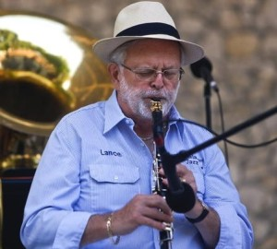Lance Schulz
Lance holds advanced degrees in music from the University of Wisconsin, Vandercook College of Music, Northwestern University and the University of Illinois. He was Director of Bands at J. E. Murphy High School in Hurley, Wisconsin and Director of Bands and Chairman of the Department of Music at North High School in Downer’s Grove, Illinois.
Lance has performed with most of the Chicago based Dixieland Bands including the house bands at The Gaslight Club, Playboy Club, Bourbon Street Club and the Velvet Swing Club. He also traveled with the Ralph Marterie Orchestra and the Dukes of Dixieland in addition to playing with some of the most well known Dixieland musicians.
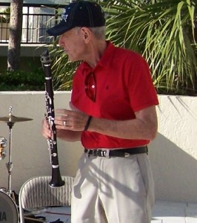Richard Steinberg
Richard grew up in Brooklyn, NY. He began to take tenor sax lessons in the 7th grade. After high school, he was drafted into the Army and ended up at Fort Dix where he found his way into the Continental Army Band. There he played sax and clarinet until he completed his tour of duty. After his time in the service he played on and off with the Larry Elgart band. He then attended the Manhattan School of Music and later played with the Charleston Symphony in performances of “Porgy and Bess.” Richard has a lot of fun on the bandstand and that fun is infectious. We all get his bug including our audiences. It is easy to forget how good a musician he really is.
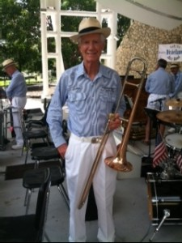Corbin Wyant
Corbin A. Wyant played trombone and was student conductor of the Kittanning, PA, High School Boy’s Band in the ’40s and ’50s. He was principal trombone in the Chautauqua, NY, student symphony the summer of 1953, studying with Edward Herman, principal trombone of the New York Philharmonic. Playing in dance bands in high school and college, Wyant played in the Bucknell University marching and symphonic bands.He played second trombone for the first six season of the Naples Philharmonic and for the two following seasons with the Southwest Florida Symphony in Fort Myers. He is one of three of the original members of the Naples Traditional Jazz Band still with the group and has played 38 years with the Naples Concert Band. He has performed with the Temptations, the Four Tops and the Fifth Dimension. Wyant is the retired publisher of the Naples Daily News. He and his wife of 52 years, Donna, have three children and families including six grandchildren, all living in Naples or Englewood.
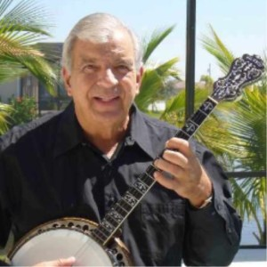Mike Currao Mike Currao plays and teaches banjo, guitar, ukulele and mandolin. His musical career of 60 years includes theater, recordings, radio, TV, concerts and philharmonic performances. In September 2014 Mike was inducted into the American Banjo Hall of Fame in OKC. He is the lead player for the Gulf Coast Banjo Society in Venice FL. He also performs regularly with the Naples Jazz Masters, the Marco Island Strummers, the Memory Makers big band and dixieland combos, and many other ensembles and theater groups throughout Southwest Florida. He is actively teaching tenor banjo via the Internet using Skype. To learn more about Mike, and to enjoy sound and video bytes, please visit his website at www.flbanjo.com.
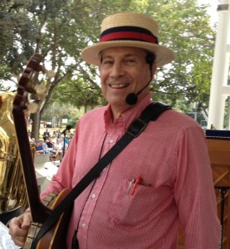 Wes English
In about 1950, at the age of 15, Wes began to develop an interest in playing the banjo, influenced no doubt by hearing his father play a beautifully decorated Weyman banjo that he had played in the Greymont Garden Orchestra in Berlin, Germany, in the late 1920’s. Wes learned the rudiments of playing tenor banjo from his father, and by his second year in college, he knew enough to play in a square dance band at the University of Maine, the same school where his father had first heard his classmate Rudy Vallee perform. After many years of amateur playing at neighborhood parties, Wes formed a banjo band in Portland, Maine. He decided to switch to plectrum banjo and took lessons for a year and a half from one of Maine’s best banjo players, Don Nichols. He played in various Dixieland bands in the State of Maine for 20 years, formed his second band (the Penobscot Banjo Company) in Bangor, Maine, then moved to Florida where in 1999 he organized his third band, the Marco Island Strummers. He has been the Director of the Marco Island Strummers since 1999. He is a member of the Naples Dixieland Jazz Band and the Naples Jazzmasters.

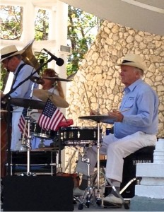Jim Hansen
During his college years at the University of Illinois, Jim played in a Hot Dixieland Band on RUSH Street, in downtown Chicago, at Bourbon Street and in the Music Room of Mr. Kelly’s. He also played in a “classic “1960’s rock and roll Band that toured and recorded rock and roll records. After college he moved to St. Louis and played with some of the top Dixieland Bands of the time in the Music Room of the Robert E Lee Riverboat and under the St. Louis Arch. He participated in the creation and management of the Mississippi River Festival at Southern Illinois University. Jim moved to Naples in 2000 and became the drummer for the Naples Dixieland Jazz Band. He is the president of the Naples Jazz Society, Inc.

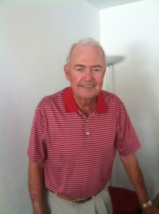John Keyes
John learned Piano as a boy. He grew up in Idaho listening to hymns, Gospel music and old favorites. His aspirations and talents were put on hold through an active business career as an electrical contractor. When he retired, he joined the Marco Island Strummers and his talent and aspirations were finally met. John plays with several musical groups in Southwest Florida focusing primarily on Dixieland Jazz and Ragtime. With his wife Jacki he founded “The Keystones” which provides fun time sing-a-longs for senior citizens living in assisted living facilities. John is a Director of the Naples Jazz Society, Inc.
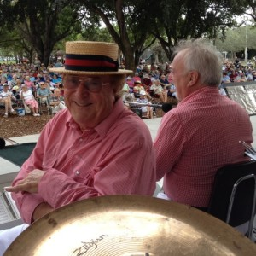Marty Krebs
Marty’s participation in the Marching Band, Concert Band and “straight-ahead” Jazz combo at the University of Wisconsin-Madison convinced Marty that the trumpet was to be an important part of his life. When not playing trumpet, Marty operated a printing company. He continued playing his trumpet by performing with national headliners including Jay Leno, Isaac Hayes, Johnny Mathis, Maureen McGovern, Glen Campbell and Lou Rawls. Marty played with the Beale Street Jazz Band every Friday night for ten years at the Red Mill in Brookfield, Wisconsin. World class clarinetist Chuck Hedges was part of the group. During those years he was also a member of the Basin Street Saloon Band which performed at the Sacramento Jazz Festival and other International Jazz Festivals. Now in Naples, Marty was a member of the Naples Jazz Orchestra and is presently playing trumpet with the Naples Dixieland Jazz Band.
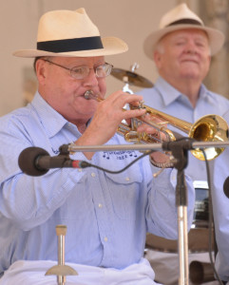Bob MacInnis
Bob started on the trumpet in the 4th grade, continuing to play in the school band and orchestra and then in the U.S.Army Band. Today he brings a wonderful tone tempered by years of experience and knowledge not only to the Naples Dixieland Jazz Band but also to The New Liberty Jazz Band and to many other groups in the Boston area playing everything from classical to swing as well as traditional jazz. Bob has an MA in education. He brought his 15 years as a skilled Precision Toolmaker/Machinist as well as his teaching abilities to Shawsheen Regional Vocational High School in Massachusetts from which he recently retired. He resides in Billerica, Mass and Naples, Florida. .
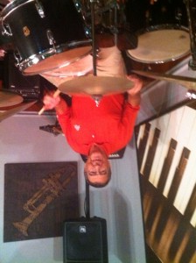Frank Michota
Frank’s musical career started in Toledo, Ohio at age two and a half by beating on his Dad’s guitar case with spoons when his parents had friends over for jam sessions. He got a set of drums and started taking lessons when he was six. He marched in a drum and bugle corps when he was ten. He played in the grade school orchestra, the high school band and orchestra and formed a dance band. During high school and four years of pre-med he played in groups that played rock and roll, then Dixieland, then jazz, then big band and finally country. Frank also played in the Toledo Junior Symphony. During this time Frank’s voice matured and he started singing.
Frank entered Podiatry College in the fall of 1959 in Cleveland, Ohio, following in his Dad’s profession. Music had to go on the back burner for a while. Although drums were still very important he sold his drum set for the money to marry the love of his life, Carol, in 1962. Some years later, back in Toledo and with the addition of two children , Carol told him he needed to get some drums. Eventually, he was able to get some playing time with jazz combos and doing some singing with a big band. For eight years Frank played every Wednesday night with the Cakewalkin’ Jass Band at a joint in Toledo called Ragtime Rick’s.
Frank retired to Naples in 1997, he thought his performing days were over but was lucky enough to meet some local musicians who allowed sitting in at jam sessions. He then spent nine years as the vocalist/ announcer and fill in drummer with the Gulf Coast Big Band, three years with the Stan Spiro Townsmen Band and, now, the Naples Jazzmasters. He has also been playing with trio and quartet groups that play at retirement communities and country clubs where the audiences still remember and appreciate good music.

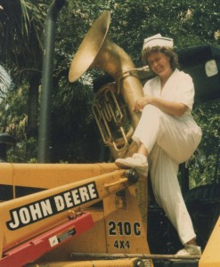Jana Boger
Jana is a tuba player with Sounds Of Yesteryear. She has played with Dooly’s Dixie Five, The Ron Bill Show, Palm City Jazz, and subs in occasionally at Erin’s Isle, Naples Dixieland Jazz Band and The Jazzaster’s. She has been a street musician in New Orleans, played at the Sarasota Jazz Festival and played extended past engagements at The Fun cruise,The Gas Light, The Witch’s Brew, The Jacaranda, Ballard’s Inn Block Island, Cypress Garden’s and performed Civil War reenactment and theme events. She also performs Oktoberfest. She is a registered nurse and works for NCH.

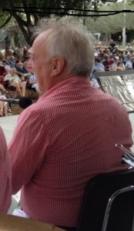 Paul Monat
Paul moved to Davenport, Florida from Plainville, Massachusetts. He has over 35 years experience playing a driving Dixieland/Swing horn. He started on tuba (still plays it) and string bass in 1963, and played with Italian bands and “Up with People” in Springfield Mass. during the late 60’s. In the ’70s he played with Art Hodes, Teddy Wilson and other members of the Coon Saunders Nighthawks Club in Wethersfield CT. He played harmony cornet & trumpet with the Yankee Rhythm Kings from 1974 to 1981. He helped start the Blue Horizon Jazz Band in 1981. Paul went to the Japan Kobe festival in 1982 with the Uptown Lowdown Jazz Band second cornet to Bert Barr. He has recorded with the premier jazz group in Albany, NY, Skip Parsons’ Riverboat Jazz band (with Eddie Hubble on trombone). He is currently the cornet sub for Tony Pringle in the New Black Eagle Jazz Band and played the Sacramento Jazz festival in 1977-8-9, 1980, 1982. He also plays lead horn in the Beale Street Jazz Band and has recorded 2 CDs with them. In Massachusetts Paul is an active part the Northeast Jazz scene with his own Band The New Condon Mob amongst other bands.

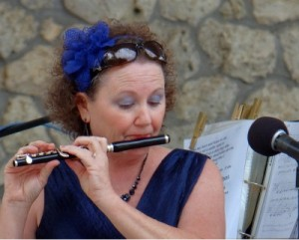Jenny Bintliff
Jenny began performing at age 12 when her family started a gospel singing group called “The Reynolds Family Singers.” The family mainly performed out west-close to where they lived, but they also went on short singing trips on the weekends, and a tour to various parts of the country once or twice a year. Jenny went to college majoring in flute/vocal at Oklahoma Baptist University but missed performing with the group so much that she returned home after one year. She married her husband, Gary (who also spent many years in the group), in 1980 and moved to Naples in 1988. She is very involved with the music at her church (Center Point Community Church), and helps lead worship. She is a vocalist for the Dixieland Jazz Band who also performs here at Cambier on Sundays. She joined the Naples Concert Band in 2004 and states she is honored to sing with the band.

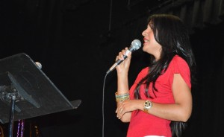Lucia Belen Lucia Belen is a Colombian singer and songwriter from the city of Valledupar, Colombia, She is a professional in the areas of communications and journalism. Luci studied at the Jorge Tadeo Lozano University in Bogota, and also studied vocal technique and performing arts at Javeriana University of Colombia, .
Throughout her career Lucia has worked with several music groups and recorded three solo albums: Santa Enamorada , Te Canto and Llueve, fusing folk, African rhythms and Latin Jazz.
Lucia composed and performed songs for movies, radio, theater and Latin American TV shows with international recognition. Visit her web site at www.luciabelen.com.

