http://www.floridarambler.com/florida-canoeing-kayaking-paddling/manatee-park-orange-river-fort-myers-kayak-trail/
Kayak & Canoe / Southwest Florida

Manatee Park & the Orange River: Fort Myers kayak trail ideal for winter day
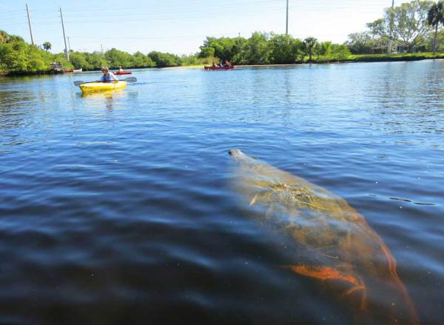
In the Orange River near the Fort Myers FPL plant, kayakers can paddle amidst dozens of manatees on cold winter days.
We came for the manatees.
But we spent the whole day kayaking the beautiful Orange River and would have called it a great outing even if 20 sea cows hadn’t floated around our kayak.
Manatee Park in Fort Myers is one of those places where a power plants discharges warm water, creating a cozy spa for manatees avoiding the winter-chilled Gulf waters. If the water in the Gulf is below 68 degrees, you’re likely to see manatees gathering in the canal used by the Florida Power and Light plant. (Manatees are more likely to be present November to March.)

Visiting Manatee Park in Fort Myers
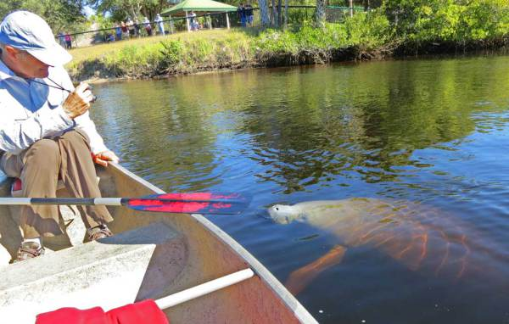
Curious manatee at Manatee Park, Fort Myers, on the Orange River, Feb. 14, 2015
Nine years ago, Lee County made it easier for manatee lovers to gather by building this popular and free park, with extensive viewing areas, butterfly gardens, educational exhibits, playgrounds and restrooms. There are videos about manatees and seasonal talks by manatee experts.
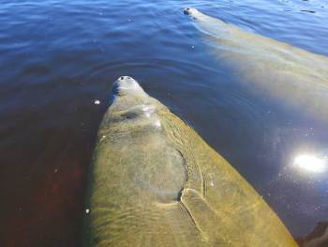
The manatees at Manatee Park in Fort Myers loll about in the warm water discharged from an FPL plant.
The warm-warm discharge canal is fenced off from boats and visitors must view it from the banks. The water is not clear like Central Florida springs, so in the area closest to the warm water discharge, you only see manatee body parts as they emerge from the water – a snout loudly exhaling here, a bulbous stomach there, a scarred back rolling by, a flipper briefly waving. On the day we visited, there were so many manatees swimming and rolling around together it was hard to distinguish one from another.
A little further from the source of the water, there is shallower, calmer area where you can see the entirety of individual manatees.
Don’t miss two exhibits ar Manatee Park – an audio stream piped from underwater where you can hear manatees communicating and, hilariously enough, farting. Next to it is a polarized glass panel that allows you to better look into the water. (Bring your polarized sunglasses!)
The best view of the manatees, however, is from a canoe or kayak. Outside the fenced canal area, plenty of manatees are hanging around and kayakers can float among them. Here, manatees swam under our kayak and curiously came up to look at us. Some were huge, some were babies, one was covered with barnacles. Sadly, it is the white scars on their backs that you see best and are often the easiest way to spot a manatee submerged in the reddish water.
At this close range, you can see the manatees well and it is easy to float here for a long time mesmerized.
If you want to see manatees, here are a few tips from Mike Hammond, Calusa Blueway coordinator who spent many years as a park ranger:
“On the cusp of cold weather, they will often spend the night in the park and then leave in search of food as it warms up in the morning. On these days, it is best to arrive early before they leave for the day,” Hammond says. “You can also see large schools of cow-nose rays swimming right where the warm water flows out from under the road and into the park. Lots of tarpon as well. Many people mistake the tarpon for sharks or dolphins.”
While it is against the law to touch or feed the manatees, some manatees are so curious they reach out to kayaks.
Hammond tells this story: “Several years ago we bought small green sit-on-top kayaks for the park. The manatees loved them and would feel the kayaks with their prehensile lips. Some visitors loved the experienced, others were freaked out. I’ve also witnessed a kayak fisherman have a manatee hold onto his kayak and paddle him around the Orange River. The fisherman explained it was the same manatee, which he assumed was a female. ‘She’ would greet him, roll on her back, clasp the kayak, and give him a ride. The fishermen just pulled in his line until she got bored and let go.”
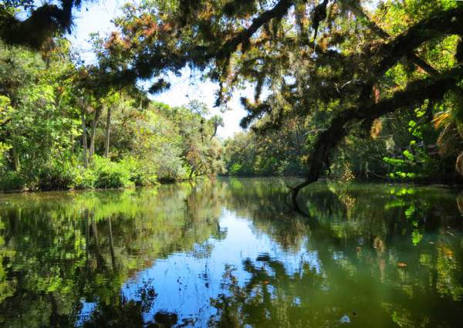
A scene along the Orange River in Fort Myers, accessible from Manatee Park.

Kayaking the Orange River
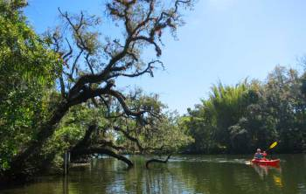
The Orange River in Fort Myers is not a wild river, but it is a beautiful and peaceful kayak trail.
There’s more to see, however, than just manatees. Kayaking up the Orange River is a beautiful and peaceful trip, one of many that are part of the Great Calusa Blueway.
There is a great launch site in the park and, conveniently, you can rent kayaks and canoes there from an outfitter.
The brackish Orange River starts out wide and deep with pleasant scenery. As you paddle upstream, it gets narrower and the Old Florida ambiance grows, with live oak branches arching overhead fuzzy with airplants. After a few miles, the water is shallower and clearer and you begin to see small schools of fish. The farther upstream you paddle, the prettier it gets.
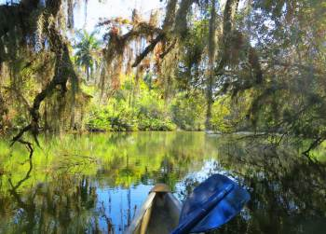
The further upstream you paddle on the Orange River in Fort Myers, the more Old Florida the ambiance becomes.
We saw a variety of heron and ibis with the real treat being a barred owl that flew across the river right in front of us and watched us from a perch in the woods. Another paddler told us to watch for an eagle that is frequently seen.
The Orange is not a wild river; you’ll pass widely spaced homes the entire way. It is all a no wake zone, however, so there are few motor boats and little traffic. On a warm and sunny February afternoon, it was very quiet with no traffic sounds to disturb the natural beauty. We passed perhaps a half dozen boaters.
We paddled about four miles upstream and you can paddle beyond our turn-around point for another mile or two, according to the maps from the Great Calusa Blueway. (Note: Don’t expect anything at what the map calls the Orange River Canoe Park. It was never developed and the banks are too steep there to even get to shore.)
There was little difference in current upstream or downstream. The Orange River would be good for families or beginners because you can turn around whenever you’d like.
I hadn’t heard much about the Orange River before this visit, so I didn’t expect to like it as much as I did. Sure, a flotilla of manatees put me in a good mood, but the river was a slice of Florida natural beauty that I am happy I experienced for its own sake.

Visiting Manatee Park and kayaking the Orange River
Manatee Park
10901 Palm Beach Blvd
Fort Myers
- Manatee Park is five minutes off I-75. (Take exit 141 SR 80 east five miles.) Here are visitor comments from TripAdvisor on Manatee Park.
- The park is free except for parking — $2 an hour or $5 for all day. On cool winter weekends, the park can get very busy.
- Calusa Blue Outfitters operate out of Manatee Park in the winter seven days a week from 9 to 5. Rates start at $15 an hour for a single kayak. A three-hour rental is $40 for a single, $60 for a double and $55 to $60 for a canoe. Information: 239-481-4600.
- The Great Calusa Blueway is a network of paddling trails around Fort Myers totaling 190 miles. The Orange River is one of the trails.

Places to explore near Fort Myers
- Six Miles Cypress Slough Preserve
- Fort Myers Beach: Charming seaside getaway
- Lovers Key State Park for manatees, kayaking and beaches
- Mound Key State Archaeology Site
- Cayo Costa State Park: Dreams of a private island
- What makes Sanibel special and nine ways to experience it.

Places to explore near Naples
- Naples: Rich in nature, beaches and boating
- Corkscrew Preserve in Naples
- Barefoot Beach is on Southwest Florida’s wild side
- Clam Pass Park, a Naples beach where you ride the tide
- Koreshan State Historic Site: Wacky Florida history; lovely spot preserved
Other places to see manatees around Florida.
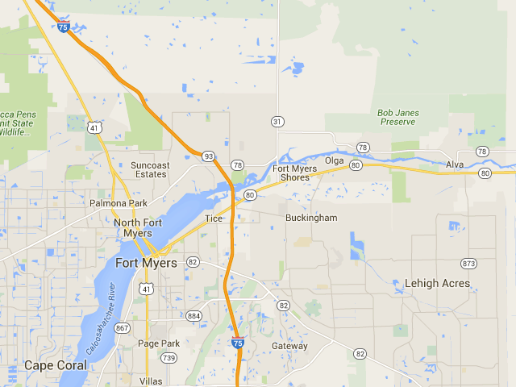
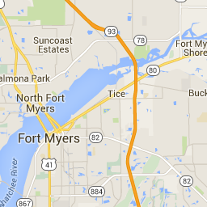

Orange River

Fort Meyers Florida Sea Kayak Tours

Florida Roundups / Kayak & Canoe

Where to see manatees in Florida; best places to see manatees
Posted by Bonnie Gross
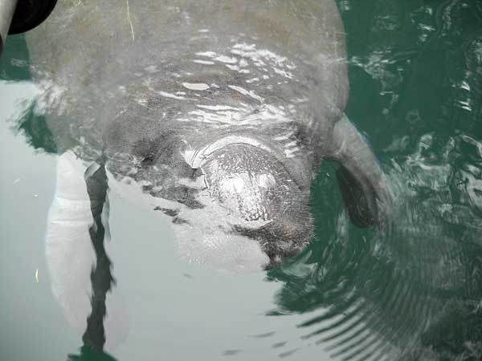
Best places to see manatees: Weeki Wachee. Was this manatee begging? Just curious? We looked but didn’t touch.

You’re more likely to see manatees on cold winter days in these spots
~ If Florida’s endangered species held a beauty pageant, the manatee wouldn’t win for its looks.
But it would be a shoo-in for Miss Congeniality.
That’s why most Florida residents and visitors prize any opportunity to admire manatees. They’re just charming creatures.
I’m lucky. I live on the Middle River in Fort Lauderdale and I see manatees in my backyard with some regularity, especially in winter.
The best place to see manatees, however, are in Florida’s springs because the clear water allows you to see more than a snout or back briefly emerging from the water and, in winter, the warmer spring waters draw manatees for an annual spa vacation.
You can see manatees in Florida waters any time of year, but manatees are more commonly spotted from November to March, when they gather in places with warmer water. The suggestions here are for winter viewing of manatees.

Manatees at Blue Spring State Park
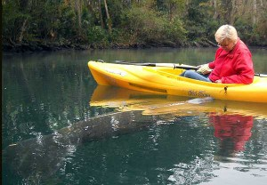
A manatee nudges our kayak at Weeki Wachee.
Florida’s springs offer some terrific manatee viewing opportunities and the best of all is Blue Spring State Park . When are manatees in Blue Spring? It depends on the weather.
On Nov. 16, 2014, for example, the manatee specialist for the Save the Manatee Club counted 169 manatees in Blue Spring after the an unusually cold (for Florida in November) cold snap. But two weeks before that chilly weather, the daily count was 22. (You can see up-to-date information on how many manatees are in the spring here. )
The spring’s usual schedule is to close it to swimmers and and kayakers from Nov. 15 to March 15, when manatees are generally present. If weather keeps manatees in residence later, the park may delay re-opening the spring to swimmers and boaters.
The most reliably chilly weather, and thus the best manatee viewing at Blue Springs, is in January.
You also can watch live manatees in real time via the webcam at Blue Spring from Save the Manatee organization.
Blue Spring has an extensive walkway around the water, offering many vantage points of the manatees. You cannot swim or kayak in the spring in the winter, to avoid disrupting manatee life.
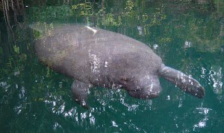
A curious manatee at Weeki Wachee springs.
If you go to Blue Spring State Park in the winter, be aware that at times the park closes its gates when it reaches capacity. One year when that happened to us, we came back 45 minutes before closing time and managed to gain admission and see an incredible gathering of manatees. If possible, go on a weekday.

Manatees at Crystal River and Three Sisters Springs
Crystal River wraps around Kings Bay, where more than 70 springs attract hundreds of manatees during cool weather. This is the place where you can swim with manatees; there are several dozen outfitters to take you out on boats and rent you gear.
But you can also see manatees by kayak — your own or rented — and from land at a boardwalk around the most beautiful spot in Crystal River, Three Sisters Springs. Here’s our practical guide to visiting Crystal River and seeing manatees.
Three Sisters Springs is a complex of three springs that are part of the Crystal River National Wildlife Refuge and there is no parking at the site. To visit the spring from land, take a trolley from the Visitor Center, 915 U.S. 19 in Crystal River. Tickets are $15 for adults; $12.50 for seniors 62 and older and $5 for children 5 to 13. There’s more about the boardwalk experience in our Crystal River guide.
You can kayak to Three Sisters Springs easily from various put-ins around Kings Bay. The most popular put-in is Hunters Spring Park, 104 NE 1st Ave, Crystal River. Details

Other springs where you can see manatees
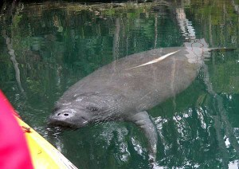
Manatee with a large scar at Weeki Wachee
I’ve had a magical experience kayaking with manatees on the Weeki Wachee spring at Weeki Wachee State Park in winter. I spent a half hour with just me, my husband and five or six friendly manatees who nudged our boat and peered at us with the same curiosity with which we looked at them. (I have video from that encounter at the Weeki Wachee link.) At Weeki Wachee, you must go by kayak or canoe to see manatees, as they are most commonly located a distance upstream from the actual spring.
Spring Bayou/Craig Park, West Tarpon Avenue, Tarpon Springs. This small city park has a freshwater spring that attracts manatees in winter.
Manatee Springs State Park, Chiefland. This spring on the Suwanee River attracts manatees to the mouth of the spring during cool weather, but, despite its name, is not a highly reliable place to see manatees. I was lucky; on a November visit, we floated in our canoe with a half dozen manatees at the mouth of the spring.

Seeing manatees outside springs
If the Gulf water is below 68 degrees, Manatee Park in Fort Myers will have dozens of manatees lolling around in the warm water from a Florida Power and Light plant. While the water is not clear like Florida springs, this free park offers extensive viewing areas as well as playgrounds and picnic tables. The best way to see manatees is from a kayak in the water and you can launch here or rent kayaks here. Here’s a comprehensive story on Manatee Park and kayaking the Orange River. Note: Manatee Park is five minutes off I-75, so it can be a quick and easy stop.
Nearby, manatees are also viewed regularly in winter at Lovers Key State Park in Fort Myers Beach. Lovers Key State Park is worth exploring for two major draws: A 2.5 mile beach lined with natural vegetation that is perfect for beachcombing and bird watching, and mangrove-lined waterways that are major draws for both manatees and kayakers.
In South Florida, there used to be good manatee viewing spots in the waters warmed by the Riviera Beach and the Fort Lauderdale power plants, but they are no longer accessible for security reasons. Good news: Riviera Beach is building a new $4.8 million manatee viewing area that will open in February 2016. The plant routinely attracts hundreds of manatees in winter; during a cold snap, 800 manatees have been counted here.
The warm-water discharge area for the Fort Pierce power plant, however, is still open to the public and, on cool days, attracts as many as 30 manatees and their fans. The free viewing area is now the Manatee Observation and Education Center in Fort Pierce, which is just west of the Atlantic ocean overlooking the Indian River Lagoon, a saltwater estuary, and Moore’s Creek, a freshwater creek and historical resting spot for the Florida manatee. I’ve also seen manatees hanging around the Fort Pierce marina, which is adjacent to the manatee center.
Tampa Electric’s Manatee Viewing Center is a designated manatee sanctuary where tons of manatees return annually to the warm discharge waters of the power plant. Viewing platforms, tidal walkways, and an environmental education center are located at this 50-acre facility. Yelp comments on the TECO viewing area.
Merritt Island National Wildlife Refuge, Titusville – The Haulover Canal connects Mosquito Lagoon and the Indian River, and on the east side of the bridge is a manatee observation area. Viewing platforms, interpretive signage, a boat ramp, and polarized viewer are located at the observation area. (Note: I’ve been here several times but never spotted manatees.)
You can also get lucky and see manatees in many waterways in winter. My partner in the Florida Rambler site, Bob Rountree, fondly remembers the time his kayak was lifted out of the water by a manatee in the St. Lucie canal that links to Lake Okeechobee. (He was camping at the Army Corp of Engineers campground at the St. Lucie lock.) I’ve seen manatees in the Intracoastal Waterway in Delray Beach, the New River in Fort Lauderdale, Biscayne Bay, off docks in the Keys and on Sanibel Island. None of these places, however, provides a reliable viewing opportunity like Blue Springs and other locations where manatees are drawn to warm water.
Seeing manatees in captivity At Homosassa State Park , you can see manatees every day via the park’s underwater observatory of its resident manatee population. Visitors start a visit on a pontoon boat ride down Pepper Creek to the wildlife park, where you also see Florida panthers, bears, bobcats, deer, alligators and a wide variety of birds. In winter, the gates into the first-magnitude spring are opened and wild manatee flock to the warmer waters. On cold days, you may see dozens of wild manatees. The park has many attractions and charges an adult admission of $13. Kids over 5 are $5.
Other zoos and aquariums with manatees, all of which charge an admission fee, include Disney’s Epcot Center, Lowry Park Zoo in Tampa, Miami Seaquarium, Mote Marine Laboratory and Aquarium and Sea World of Florida.
A note about a special manatee at the South Florida Museum and Parker Manatee Aquarium in Bradenton. This terrific small museum built a special tank for Snooty, the oldest manatee in captivity, who turned 65 in 2013. Snooty was born in captivity in a small Miami restaurant/attraction on July 21, 1948. He came to Bradenton the next year. His tank is designed to also host manatees in rehab, and Snooty has had 28 tank-mates over the years. There are manatee feedings and presentations several times a day. Located at 201 10th St. W | Bradenton.
Links and details on where to see manatees in Florida:
- Blue Spring State Park, 2100 W. French Ave., Orange City.
- Weeki Wachee spring, 6131 Commercial Way, Spring Hill.. Kayak and canoe rentals are through Paddling Adventures.
- Kings Bay and Three Sisters Springs. Crystal River.
- Lovers Key State Park, 8700 Estero Blvd., Fort Myers Beach
- Tampa Electric’s Manatee Viewing Center, 6990 Dickman Road, Apollo Beach.
- Lee County Manatee Park, 10901 State Road 80 Fort Myers
- Merritt Island National Wildlife Refuge, Titusville
- Homosassa State Park, 4150 S. Suncoast Blvd., Homosassa . Adult admission is $13; children 6 to 12 are $5.
- Manatee Observation and Education Center, 480 N. Indian River Drive, Fort Pierce.
- Kayak tours with manatees sponsored by Save the Manatee non-profit organization, provides manatee viewing without disrupting natural behavior. The site says: “What people fail to hear or acknowledge is that the manatees are not here for our amusement, rather they are here for their survival.”

More about manatees:
- Save the Manatee organization
- Manatee FAQ
- How wildlife researchers identify manatees at Blue Spring: A chart of their scars (pdf)

