http://orchidswamp.org/ Fachahatchee Swamp Tours

TRAM RIDE PLUS SWAMP WALK

New Fakahatchee Wet Walk & Tram Tour sets February, March dates
The Friends of Fakatchee have announced dates in February and March for their new Wet Walk & Tram Tour adventure. “This new offering combines elements of our longer tram tours and swamp walks to give participants a great introduction to the Fakahatchee,” says volunteer naturalist Glen Stacell.
Each Wet Walk & Tram Tour begins with a three mile ride on the group’s Ghost Rider tram to the site of the swamp walk. After about 90 minutes of walking in the knee to waist-high waters through the swamp, participants board the tram for the return trip. Naturalists leading the group will share their insights about the Fakahatchee’s flora and fauna on both wet and dry portions of the adventure. Fakahatchee Strand is called the “Amazon of North America” and is home to the famous ghost orchid and many other rare plants and animals.
The new Wet Walk & Tram Tour will be offered for $60 per person on Wednesday, February 26 and Thursday, March 6. The tours begin promptly at 9:30 am and conclude by 12:30 pm. Participants should sure to wear sturdy lace-up shoes and to bring dry clothes for the drive home. This is an outdoor event, so dress appropriately for the weather.
The Wet Walk & Tram Tours begin at the ranger station off Jane’s Scenic Drive. The park entrance is on the west side of SR 29 between I-75 and U.S. 41. (See map above.)
____

GHOST RIDER TRAM TOURS
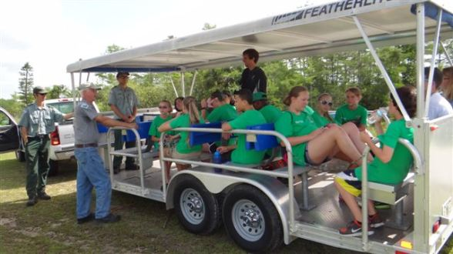

WELCOME ABOARD THE GHOST RIDER
You don’t have to get your feet wet or drive your car down Janes Scenic Drive to see the wonders of the Fakahatchee Strand Preserve State Park. The new “Ghost Rider” tram, named in honor of the famous Ghost Orchid found in the park, lets you look at wild life and plants without concentrating on the road.
Possible sightings along the way!
- The tram is wheel-chair accessible. Some seats face backwards so arrive early. Tours cost $25 per person and reservations are required.
- The tram leaves at 10am from the ranger station at 137 Coastline Drive, Copeland, off Janes Scenic Drive.
- An experienced volunteer guide will interpret along the way.
DRIVING DIRECTIONS:
- (look online for Coastline Drive, Copeland, FL, 34137)
- From I-75 (Alligator Alley): take Exit 80, drive south on SR-29 about 12 miles, turn right on CR-837 (Janes Scenic Drive) and follow it to the right, past the Fire Tower, to the Ranger Station opposite Lake Gloria.
- From US-41 (Tamiami Trail): turn north on SR-29 at the flashing light in Carnestown and drive about 3 miles, turn left on CR-837 (Janes Scenic Drive) and follow it to the right, past the Fire Tower, to the Ranger Station opposite Lake Gloria.
  - 12/10/2013 from 10:00 AM to 12:30 PM
  - 12/17/2013 from 10:00 AM to 12:30 PM
  - 12/28/2013 from 10:00 AM to 12:30 PM
  - 01/07/2014 from 10:00 AM to 12:30 PM
  - 01/14/2014 from 10:00 AM to 12:30 PM
  - 01/21/2014 from 10:00 AM to 12:30 PM
  - 01/28/2014 from 10:00 AM to 12:30 PM
  - 02/01/2014 from 10:00 AM to 12:30 PM
  - 02/04/2014 from 10:00 AM to 12:30 PM
  - 02/11/2014 from 10:00 AM to 12:30 PM
  - 02/18/2014 from 10:00 AM to 12:30 PM
  - 02/25/2014 from 10:00 AM to 12:30 PM
  - 03/01/2014 from 10:00 AM to 12:30 PM
  - 03/04/2014 from 10:00 AM to 12:30 PM
  - 03/11/2014 from 10:00 AM to 12:30 PM
  - 03/18/2014 from 10:00 AM to 12:30 PM
  - 03/25/2014 from 10:00 AM to 12:30 PM
  - 03/29/2014 from 10:00 AM to 12:30 PM
  - 04/01/2014 from 10:00 AM to 12:30 PM

