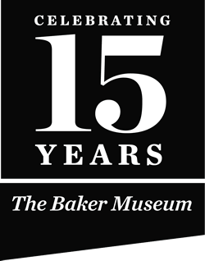

Current exhibition
at The Baker Museum
November 8, 2014 — February 1, 2015

Western, Wildlife and Contemporary Art
from the National Museum of Wildlife Art and the Stonehollow Collection

Exploring America brings together artwork from the National Museum of Wildlife Art and the private Stonehollow Collection. Both have significant holdings of art created by 19th and 20th century European-American artists fascinated by native peoples, wildlife and wilderness. Though a significant portion of work on display depicts the American West, the exhibition also presents depictions of wildlife from locations across North America and includes contemporary art that engages with current issues such as invasive and endangered species. The exhibition is divided into five sections: Eastern Wilds, Exploring the West, Wildlife in American Art, Modern Movements and Contemporary Works on Paper.
The first European artist-naturalists to tour North America in the 18th and 19th centuries were awed by the continent’s varying landforms and abundance of animal life: vast herds of buffalo, majestic horned stags and a bewildering variety of birds. The earliest sketches depicting such fauna began the remarkable tradition of wildlife in American art, a tradition that evolved along with the US as a nation and that still thrives today. For more than two decades, the National Museum of Wildlife Art has honored and sustained this tradition by assembling the most comprehensive collection of paintings and sculptures portraying North American wildlife in the world. Exploring America presents a generous sampling of the museum’s holdings, charts the history of this enduring theme in American art and explores the evolving relationship between Americans and the natural resources of this continent.
Exploring America is curated by Adam Duncan Harris, Ph.D., Petersen Curator of Art and Research at the National Museum of Wildlife Art, in consultation with Steve Good, Rosenstock Arts.

Western, Wildlife and Contemporary Art from the National Museum of Wildlife Art and the Stonehollow Collection. Organized by The Baker Museum and the National Museum of Wildlife Art.
This exhibition has received generous support from Anne and Richard ‘O Leary.

Naples Daily News 11.27.2014 Neapolitans interested in nature and the environment should not miss a large and beautiful exhibition at Artis—Naples' Baker Museum. The show is: "Exploring America: Western, Wildlife and Contemporary Art from the National Museum of Wildlife Art and the Stonehollow Collection," of Jackson Hole, Wyo.

In March Frank Verpoorten, Baker director and chief curator, helped to select 123 artworks from the museum at the invitation of former NMWA board member Dick O'Leary. He worked with Adam Duncan Harris, Petersen curator of art and research there with consultant Steve Good of Rosenstock Arts, Denver, for what should be a popular exhibition for nature lovers. Several works from O'Leary's personal Stonehollow Collection are included.

The paintings and prints speak as their creators wanted them to, mostly realistic but sometimes semiabstract depictions of animals in the wild. Many of the artists, such as 19th-century painters Albert Bierstadt and Thomas Moran, are much admired for capturing superb views of the American West. Many other artists are not as well known, but good labels abound.

O'Leary and his wife Ann, who live here part-time and in ski resort town Jackson Hole, are underwriting the Naples exhibition. It returns to Jackson Hole after Feb. 1, its last day here.

The National Museum of Wildlife Art opened in a Jackson Hole Square storefront in 1987. After raising many millions of dollars, it moved to its present 51,000 square-foot building in 1994. Designed to resemble the craggy ruins of 13th century Slains Castle in northeastern Scotland, the museum has 14 galleries, a three-quarter-mile-long sculpture trail, children's gallery, library and café. The museum is set against the majestic background of the National Grand Teton National Park and rises beside a national elk refuge. http://www.wildlifeart.org/

The great disparity today between 19th-century American artists who virtually worshipped the natural wonders of untamed America and today's angry disputes between people who believe in human-made global warming and those defying its evidence could hardly be more vivid. That explains why this exhibition is noteworthy and not just a handsome survey. The earlier artists cherished the land, the animals and the birds they depicted. Many Americans still do — but perhaps not enough of us.

It is surprising how well the National Museum of Wildlife has acquired masterpieces of natural subjects; the market for major works has vastly increased since 1975, when interest in collecting all kinds of period art returned to popularity.

Thomas Moran's painting "Great Falls of the Yellowstone," 1884, is among the finest works in this collection. Joining it are four Bierstadt oils, including "Prong-Horned Antelope," about 1865, capturing brilliant sunlight on the animals in a plain with mountains in the distance. Bierstadt's portrait of a mountain goat on a rocky ledge is an oil painting on paper done in the 1875 period but appears as totally refreshed.

Another handsome and unusual evocation of a natural wonder is Thomas Hill's "Great Falls of the Yellowstone" circa 1884, in which slender stone towers in the foreground thrust upward before a distant white cascade high above the river gorge.

The exhibition also presents natural paintings by John James Audubon's son, John Woodhouse Audubon (1812-62), who helped his father compile "The Birds of America" in England and later illustrated a book on American mammals. He is represented with a very dark "American Grizzly," about 1840.

The show is full of many kinds of animals in paintings and bronze sculptures by such masters as Worthington Whittredge, George Catlin, Charles M. Russell, N.C. Wyeth, Rockwell Kent, Louis Agassiz Fuertes, Carl Rungius, Georgia O'Keeffe, Paul Manship and Leonard Baskin. It also includes Andy Warhol's ten brilliantly bold silkscreen prints of worldwide endangered species, reflecting the museum's wide reach of subject matter.

Most contemporary in impact here are Penelope Gottlieb's impressive acrylic and ink renderings done in homage over John J. Audubon print reproductions.
This is very unusual, an unexpected exhibition for the Baker, made possible by a rare and generous local connection. Animal and nature lovers should not miss it.

Art critic Donald Miller lives in Naples. Reach him at miller88@embarqmail.com.

The Baker Museum

Exploring America

Western, Wildlife and Contemporary Art

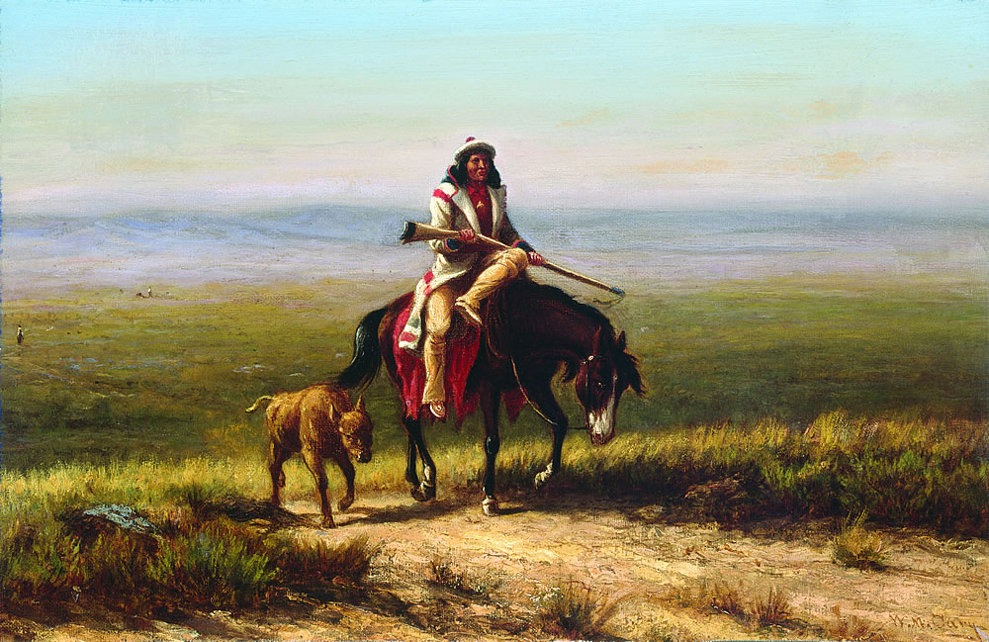

William de La Montagne Cary (United States, 1840 – 1922), The Lost Buffalo Calf, 1865. Oil on Canvas. 11 × 16 1/2 inches. JKM Collection, National Museum of Wildlife Art.
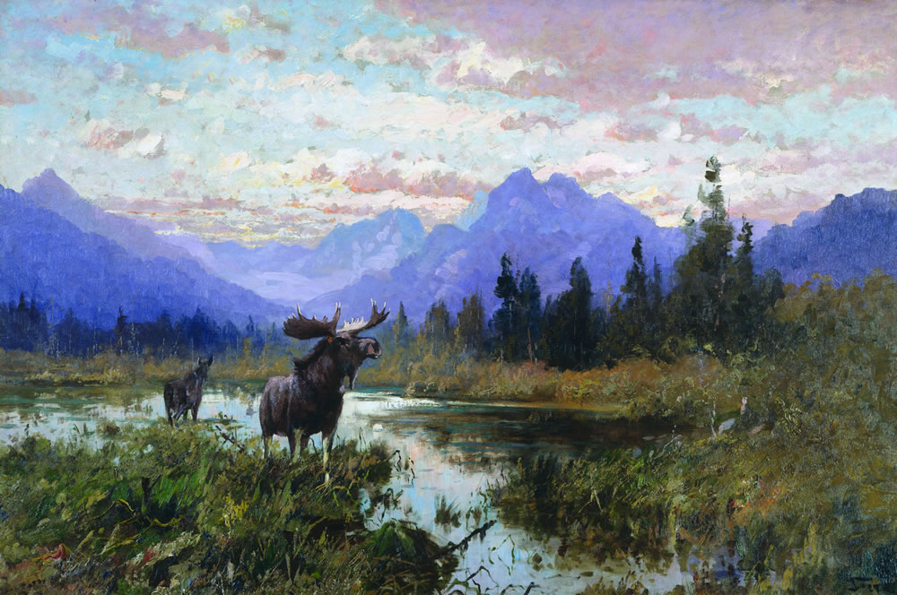

John Fery (Hungary, 1859 – 1934), Red Eagle Lake, Glacier National Park, 1915. Oil on Canvas. 40 x 60 inches. JKM Collection®, National Museum of Wildlife Art.

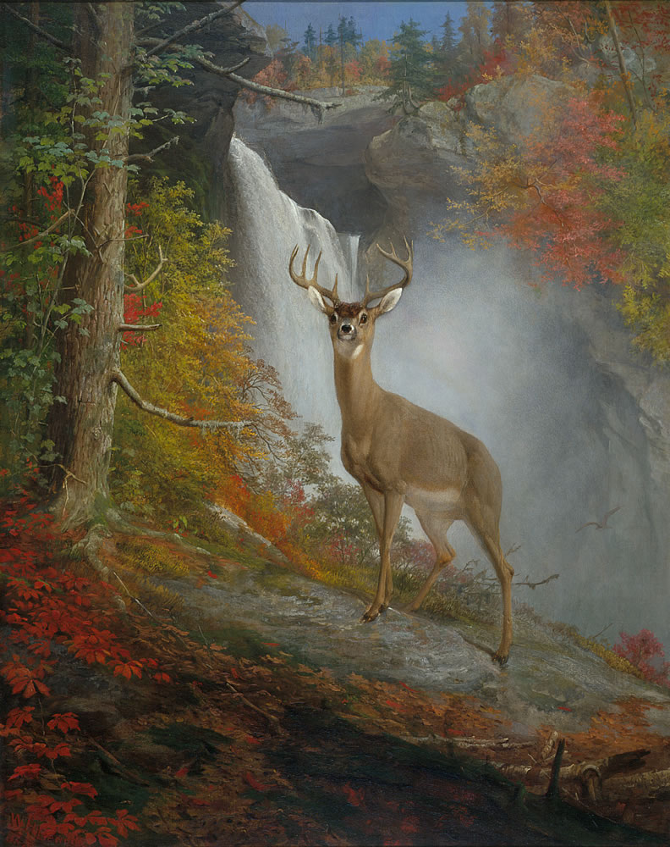
William Holbrook Beard (United States, 1824 - 1900),Majestic Stag, 1873. Oil on Canvas. 36 x 29 inches. JKM Collection®, National Museum of Wildlife Art.

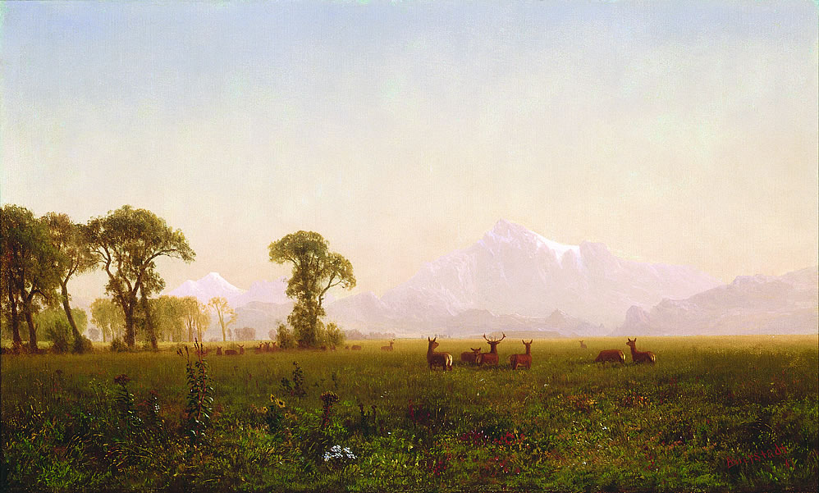

Albert Bierstadt (Germany, 1830 – 1902), Elk Grazing in the Wind River Country, 1861. Oil on Canvas. 15 1/8 x 25 1/4 inches. JKM Collection®, National Museum of Wildlife Art.

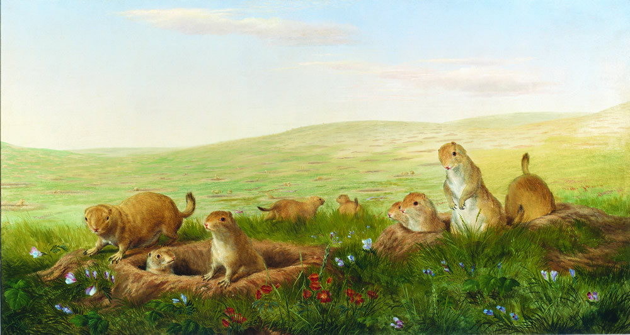

William Jacob Hays (United States, 1830 – 1875),Prairie Dog Village, 1860. Oil on Canvas. 25 ½ x 47 inches. JKM Collection®, National Museum of Wildlife Art.

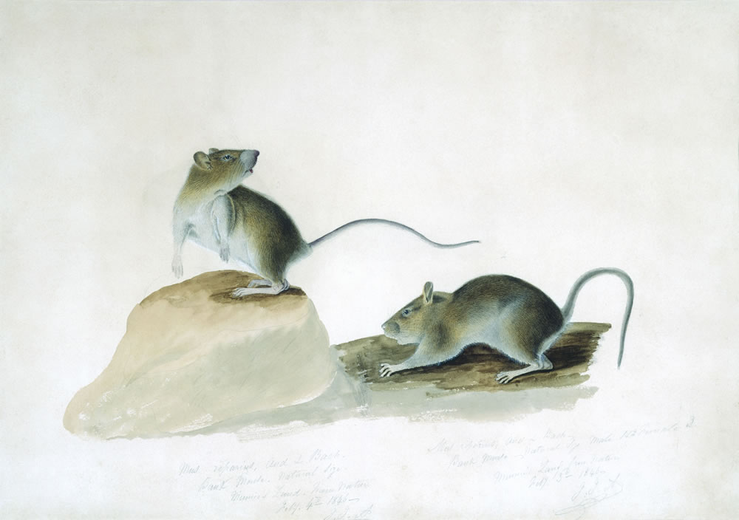

John James Audubon (Santo Domingo, 1785 – 1851),Two Bank Mice, 1846. Watercolor and Pencil on Paper. 12 3/4 x 18 5/8 inches. JKM Collection®, National Museum of Wildlife Art.

