Lecturer Elaine Newton to celebrate 25 years of book talks at Artis–Naples
Harriet Howard Heithaus Mar 6, 2015

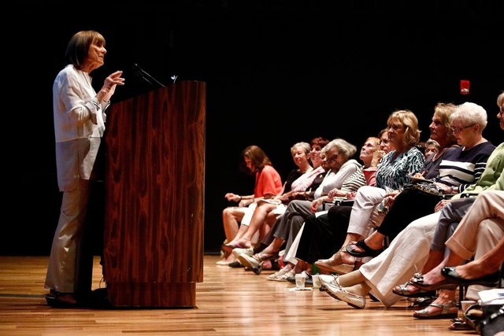

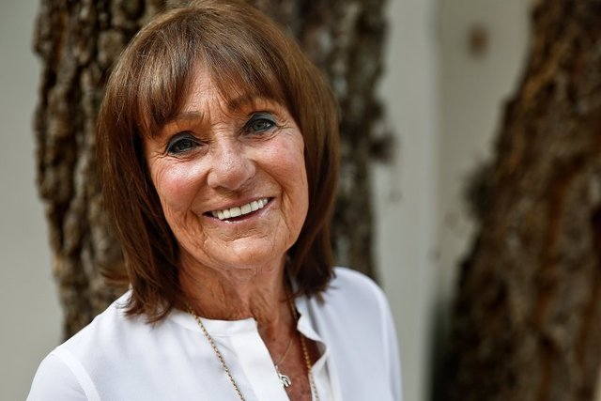

NORTH NAPLES, Fla. - Elaine Newton, the blue-eyed muse of a better-read Florida, is having one big birthday party March 21. The figurative cake cutting is at Artis—Naples, celebrating her 25th anniversary of the Critic's Choice lecture series.

The event is open to the public, and actually honors all of Artis—Naples' Lifelong Learning classes. The celebrants include Joan Jacob, whose classes discuss art, and Jodie DeSalvo, familiar for her piano-centric takes on music.

Still, Newton attracts more — and has done it longer — than everyone else, probably twice over. She packs the Daniels Pavilion for her monthly Thursday talks; they are often sold out by the time the season starts. She also flirts with a full downstairs at Hayes Hall, which has a capacity of around 1,440, for Saturday reprises of her Thursday lectures.

"Well, I thought we'd set the record attendance with ‘The Help,' " she conceded at her Feb. 7 talk, gazing out at an audience of 850 who had paid up to $45 (the individual ticket price) to attend. "But just look at you all here!"

The audience wasn't there to assure an invitation to the March 21 event. They were there — some even before reading the appointed novel — to have its landscape carefully painted in by Newton, who researches her books as if she were the one writing them. Go to an Elaine Newton talk and you come away seeing what you just read — or viewed, since she also offers a film talk series — in a new and exciting way.

"She gives perspective to the story," said Marilyn DiGasper, of North Kingstown, Rhode Island, who had come to the talk with her friend, Estelle Benzi. "She brings so much insight into the books, insight you missed when you were reading it."

"We leave feeling we missed so much in the movie, we'll see it again after her talk," said Naples resident Donna Ohye, who is a regular with her husband, George, at Newton's "4 O'Clock at the Movies" series.

A denizen of Barnes & Noble, Newton gets book suggestions from its staff as one of her sources: "I bless Barnes & Noble and pray on their behalf," she quipped, but she's serious.

She prefers the feel of the pages — and their margins are ready-made sticky notes for her own commentary.

Newton has been lecturing since Artis—Naples opened its mammoth glass doors in 1989. She and her husband, Alan, were in Naples from Toronto on a lark, deserting their usual Tampa haunt to try another Florida city's Ritz-Carlton. Elaine Newton took a left-hand turn from her run along the beach and saw the sign advertising a philharmonic hall to be built in North Naples.

"I thought ‘Wow, a place that has a beach AND a philharmonic AND tennis courts,'" she recalled, excited again at the memory of it.

"I've always been teaching adult ed apart from my classes at York University. The lure of adults is that they bring a whole new world of experience. It's not a really a class. It's a dialogue, it's an interchange."
And a philharmonic center with a small pavilion for lectures seemed an ideal fit for her passion. She called on founder Myra Janco Daniels. Daniels concedes she wasn't so sure.

"I thought, ‘Are we ready for this?' But I decided we'd find out in a real hurry," Daniels recalled. She expected no more than two dozen to come to the first lecture; 42 people showed up. Neither woman looked back: "She was such a find," Daniels said.

Newton's book lectures grew from one to two to three in the Daniels pavilion within five years. She instituted her film series; it was much harder than she realized, she recalled.

"I had to do so much research," she said of the first years. "I had to learn the technology of filmmaking and that was new to me."

It has paid off. Former Artis—Naples board member David Drobis and his wife are regulars at the film series, and Drobis said Newton's revelations "always makes me want to see the movie again."

There was, for a while, a dramatic reading group, and a small group that called itself The Questors — "No more than 40," was Newton's law — who studied one topic in depth for a season.

Elaine Specter, who moved here from Pennsylvania, called it a very rich experience.

"You're in a group with 15-20 adults and it's kind of like a seminar. But there are no exams, and people with deep life experiences and varied life experiences would share them as reflected in this book (that was being studied).

There were too many other demands to continue The Questors for more than several years. In her 15th year, Newton learned that Daniels was moving one of her sessions to Hayes Hall.

The venue's main concert hall, it seemed daunting.

"Why would that many people come to see me?" Newton asked.

It was an easy answer for Daniels.

"No matter how large her audience is, everyone thinks she's talking directly to them," she said.
That she is at least a dramatic storyteller was apparent Feb. 7. Newton, in the midst of explaining the dismal mores of the slaveholder era, suddenly proclaimed to the audience: "And then, in the early 19th century, God makes a comeback!"

That was a prelude to outlining personalities of both heroines, an abolitionist and a slave, in Sue Monk Kidd's "The Invention of Wings." Newton punctuated her talk with wry commentary — that a central character's suitor considered her ordination into "the ministry as a consolation prize" for the lack of a marriage proposal. She laid out the map of the author's vast research into each character's milieu.

Even when some of her commentaries over the years have ruffled individual feathers, Daniels observed, "It was always first-class ruffling."

Specter remembers her first Newton talk, on "Independence Day," by Richard Ford:
"She didn't start by talking about the book," she said. "She started by placing Ford in a group of post-World War II writers at the end of the 20th century, who realize we're living in an age when we have explored the seas. We've been to outer space. Where is the next frontier?

"The next frontier, she told, is looking inside ourselves and learning what our capabilities are. ... That's the kind of insight that makes you really just want to weep," Specter said. "And I think many people, when they go to her talks, get that feeling: They find something illuminating and personal in what she says."

Newton has retired from York University. But she is still in peak form, and high demand, at Artis—Naples. The sequence of her year is finding Critic's Choice books during the summer, followed by an intense September at the Toronto Film Festival. That's where she seeks the potential Academy Award contenders her January to April film series explores.

She leaves her audiences with a list of good summer reading, and everyone interviewed who claims to be part of her unofficial "largest book club in America" says they choose their summer fare from it.

But first they'll celebrate her, and Artis—Naples', 25 years as a local mother lode for the human mind and spirit.

"The entire Lifelong Learning Center is an important part of the institution Artis—Naples is at its best, and I think Elaine is the cornerstone of that," Drobis said.

