Facing an uncertain future, stories from an old wonder
Joseph Cranney Feb 21, 2015

BONITA SPRINGS. Fla. - In the backyard of the Everglades Wonder Gardens — blocked by the jungle’s overgrown foliage, outshined by the appeal of the park’s otters and alligators, and trapped for decades behind a chain-link fence — the beauty of a great tree was forgotten.
The Banyan here is an old fig, with groups of aerial trunks that drop from the parent tree and grow outward. The web of roots gives the Banyan a sprawling, almost fantastic look.

But when John Brady became director of the Gardens in 2013, you couldn’t see any of it. Under old management, invasive weeds were allowed to grow thick and, for years, they covered the Banyan’s rustic-gray bark from bottom to top.
Brady and a team removed hundreds of pounds of the clutter. They used a ladder to cut the weeds growing over the Banyan’s front and pulled down the fence that wrapped around the back. The work took weeks.
It was a project, one of the first of many. Brady started here in June 2013 after David Piper, Jr., announced his family was selling the Gardens, which have been owned by the Pipers for close to 80 years.
Since then, Brady and a small staff of mostly volunteers have transformed the place, from a boxy old zoo into a nature reserve rich with wildlife and bio-diverse plants. They donated most of the animals (the bears, lions and otters are no longer here). They manicured the trees and have made them a featured attraction.

It’s a “botanical jungle with birds and reptiles,” Brady likes to say. But that’s just the beginning. What Brady wants, coming up on his third summer here, is new ownership that will preserve the park. The Gardens and its approximate 3.5-acre property are still for sale and could be razed for development. And Brady says he can’t continue paying for the day-to-day operations, which has essentially brought all of his maintenance projects to a halt.

The Banyan is doing better now, but it still needs care. The weeds require almost daily trimming and the branches at the top, devoid of healthy sunlight, have decayed into dead limbs.
“We took it all down and here it is growing back,” Brady says while leading a tour on a recent afternoon. Still talking, he wraps a bare hand around a plant leeching off a trunk. “Every once in a while,” he says, yanking out the weed, “we have to come and reclaim it.”

THE OLD BOSS
Every year in December, the Old Timers hold a Wonder Gardens reunion.
They’re old men who love the old place where they used to work. Decades ago at the Gardens, they hatched crocodile eggs, butchered cows and horses for feed, rescued injured birds and led tours under the canopy of exotic trees.
They revere their old boss, Lester Piper. He was a cantankerous man who sometimes threw tantrums in the slaughterhouse, but he loved animals and helped teach the Old Timers how to care for them.
Piper died in 1992. But on his birthday, each Dec. 13, the Old Timers remember him. They get lunch, drink and tell stories.

In 2014, three Old Timers were there for Piper’s birthday. This time, they took a detour. They heard about a plaque that honors Piper at The Quarry on Immokalee Road. They wanted to see it.
Now home to a sprawling golf and beach community, The Quarry’s more than 1,800 acres were formerly owned by the Piper family. Back when Piper and his brother, Bill, lived up north, the Pipers got rich during prohibition. The brothers used a fleet of boats to transport cases of refilled whiskey bottles, illegally, from Canada to Michigan. When bodies of water froze, they wore ice skates and the boats became sleds.
The brothers took the bootlegging money and bought land in Southwest Florida, including the property where the Everglades Wonder Gardens sit, on Old 41 Road between the Imperial River and Terry Street. The park was opened as the Everglades Reptile Gardens in 1936, before evolving into a large-animal zoo with a different name.

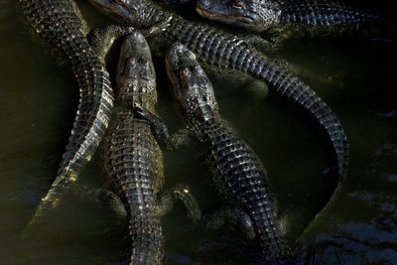

Every Saturday, visitors can help feed alligators at the Everglades Wonder Gardens in Bonita Springs. The "gator fishing" involves dangling a hot dog on a string above a pool of 40 alligators. (Carolina Hidalgo/Staff)

One of those old whiskey-shuttling boats is still here. It hangs above the glass case of taxidermy sea-life in the small back-room museum of the Gardens’ cracker house.

Nearby on the wall is an even more prized display — the large, rare skull of a Goosebeak Whale. In the 1940s, the story goes, Lester Piper heard that a “sea monster” washed up on the shore of a local beach, before he made the trip there to cut the thing’s head off.

THE NEW BOSS
On a Saturday at the Gardens in January, it’s blue-skied and sunny with the temperature in the mid-70s around 2 p.m. Beach weather. Damn beach weather. John Brady and his team can’t afford it on the weekends. On a good Saturday, one where it’s probably cooler and overcast, the Gardens welcome about 300 customers. The ticket money is never enough — to cover the cost of operations, to maintain rent, even to pay the park’s employees.

In April 2013, David Piper, Jr., announced the Gardens were closing. Piper, who is 52 years old and grandson to Lester Piper, cited his declining health. At the time, Brady was an environmental photographer with no ties to the Gardens. But motivated by his love of nature, he wanted to try to revive the place.

“I’m not going to be able to make another summer,” says Brady, who works at least six days a week and only just started paying himself. “And I’m not going to keep that a secret anymore. It’s too late to keep it a secret.”
Brady has been trying everything he can to increase revenue. Since he’s been here, he’s raised admission prices to about a dollar more for children and adults. He’s added an event called “gator fishing” where customers can lower a hot dog via twine into the pool of alligators. It costs $5.

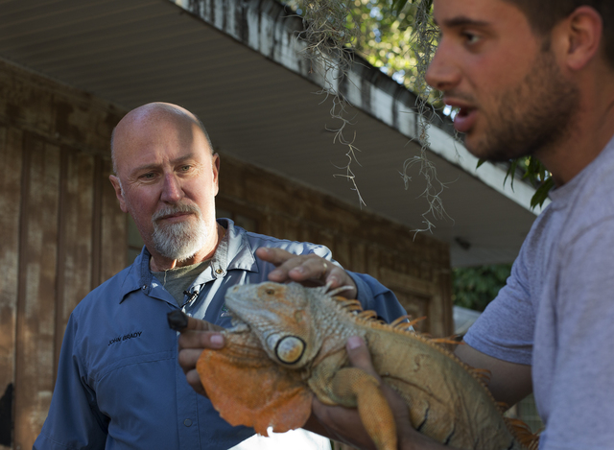
John Brady, director of the Everglades Wonder Gardens, pets Buddha the iguana as Zach Murphy, right, speaks to visitors on Feb. 18, 2015. (Carolina Hidalgo/Staff)

Now, Brady, who made a living as a retail businessman, says he’s spent his life savings (a number he won’t disclose) on renovations.

That same Saturday afternoon, Brady is standing behind the gift-shop counter and introducing himself to a walk-in. Brady, with a shaved head and a graying goatee, looks just right for his 56 years. He’s well-spoken and polite, even in the face of a presumptuous customer. An elderly woman asks Brady if he is related to David Piper, Jr. “You’re his son, then?” she says. No, Brady tells her. He says why he’s here. He explains his mission to save the place. She scoffs and walks away.

THE HEYDAY
The Old Timers stopped by the Gardens that day on Lester Piper’s birthday. They hadn’t been back since Brady took over and hadn’t met him. But once they introduced themselves as Old Timers, Brady let them walk through the park for free. They appreciated that.
They like what Brady has done, but it’s nothing like what they knew. When they worked there, as one Old Timer says, the Gardens were the “premier wildlife attraction in the state of Florida.”

Florida used to have a lot of places like it. When the highways were built after the land boom of the 1920s, entrepreneurs across the state sought to capitalize on new tourism business.
David Breed Lindsay and Pearson Conrad opened the Sarasota Jungle Gardens in 1939. Ross Allen founded his Reptile Institute in Silver Springs a decade earlier. In 1936, Dick Pope debuted Cypress Gardens, long thought of as Florida’s top tourist attraction. The places were parts of small communities.

In Bonita Springs, kids played Little League games on the field where Riverside Park is now, before grabbing a soda at Benson’s or Lawhon’s groceries. Ben Nelson, now mayor of Bonita Springs, grew up here. Nelson and his friends used to fish for sharks off the Bonita Beach Causeway. When they caught one, they beached the fish and loaded it onto the bed of a pickup truck. Then they drove it to the Gardens, where Lester Piper cut the shark up and fed it to the alligators. From his bedroom during nights, Nelson heard the calls of the Gardens’ cranes and peacocks. In the mornings, the Gardens’ roosters woke him up.
The Gardens’ assortment of wildlife, along with the sprouting of indigenous and non-native trees, led to what one Old Timer called the “heyday” in the 1950s. The Tampa Tribune took note of the city’s influx of tourists.
“Not many years ago Bonita Springs was only a dot on the map south of Fort Myers on the Tamiami Trail,” read a Tribune article from April 1947. “But now it is a bustling little boom town.”
It didn’t last. Advances in infrastructure in the 1950s, like the interstate highway, and entertainment in the 1960s, like Disney, gave way to modern interests, and Florida’s roadside Gardens were left behind on long drives to big parks.

Historians lament the losses.
“This is not just a Florida problem, this is a national problem,” said Gary Mormino, a professor emeritus in the history department of the University of South Florida in St. Petersburg. “Every place is no place anymore.”

THE BREAK-IN

April 15, 2013. At the Gardens, around 5 a.m. Jack Wollman, park employee, arrives early to find the north gate open and several of the padlocks to animal cages cut and lying on the ground. Not good. Wollman calls David Piper, Jr., and tells him there’s been a break-in. This was the morning after Piper announced the Gardens were closing. Piper was living with a non-cancerous tumor inside his spinal cord. It caused lengthy seizures and excruciating pain. He’s since had it partially removed, but at the time, Piper couldn’t keep working.

Still dark that morning, Wollman sees a 12-point buck out of its cage and moving freely in the park (the deer later escaped and was hit and killed by a motorcycle). Then, more movement near the gift shop, and the silhouette of a man. Wollman chases after him. He catches up with the man in the Gardens’ parking lot and tackles him. Later, the man was arrested and all the animals, except the buck, were accounted for safely.
Who was the man? Steven Ernest Trew, 58 at the time, from the area. He said he was an Old Timer, that he used to work at the park. As far as anyone can tell, that wasn’t true.

What was he doing there? He heard on the news that the Gardens were closing. He was going to free the animals. Why? Because, he said, it’s what Lester Piper would have wanted.

FOR SALE

In 2013, Brady and a board of directors started a nonprofit, the Bonita Wonder Gardens, with the goal of raising the money to purchase the Gardens. It’s what Brady wants. It’s what the board wants. It what David Piper, Jr., says he wants, along with his brother Lester “Buck” Piper, who co-owns the property. But fundraising is just beginning. Bert Parsley, David Piper, Jr.’s broker, said the property is for sale for $3.7 million, but that the Piper family is offering a discount to the nonprofit.

At a City Council meeting Wednesday,Bonita Springs took the first step toward granting a $3.5 million loan to the nonprofit. But the measure, pending contracts, would still require final approval at a future meeting.
If the deal falls through, the Gardens’ property could become multi-story condos or a dockominium or whatever else fits the bill. The animals would be donated or sold. Most of the trees would be bulldozed.

“It would suck, quite frankly,” Brady says, the sounds of shells crunching beneath his feet as he walks through the courtyard. “You stand here, this looks like what Florida should look like. You think of Florida, you think of this. What does Florida really look like today? Go stand on condo row.”

Meanwhile, Bonita Springs is moving forward with a $16 million redevelopment project meant to spur business on Old 41 Road. Ben Nelson, the mayor, said he could envision a future where the Gardens are partially transformed into a commercial entity that still honors the property’s history.Picture something like a hybrid version of a Rainforest Café, Nelson said.

ONE LAST SHOT

That day on his birthday, the Old Timers paid Lester Piper a visit.

They do this part every year. They go to the Naples Memorial Gardens Cemetery on the beach end of Immokalee Road. They find the thick-rooted sausage tree growing in the west yard. They put their backs to it and walk 50 paces toward the sun.

Piper is buried there alongside his wife, Lucille. Engraved in the bottom left and right corners of their marker are roses. Underneath Lucille’s name is a pair of panther kittens. Underneath Lester’s name is the profile of an American alligator. Or maybe it’s a crocodile.

Among the Old Timers, the eldest member is responsible for bringing the booze — a jug of Old Overholt Rye Whiskey. It was one of Lester’s favorites. Now, more than a decade into the tradition, the Old Timers are on their second bottle.

This time, there were three of them, so the oldest of the Old Timers filled four shot glasses. The men drank to their memories and, standing over his grave, they poured one out for their old friend.

