http://www.ustream.tv/SouthwestFloridaEagleCam and https://www.facebook.com/SouthwestFloridaEagleCam and www.DickPritchettRealEstate.com

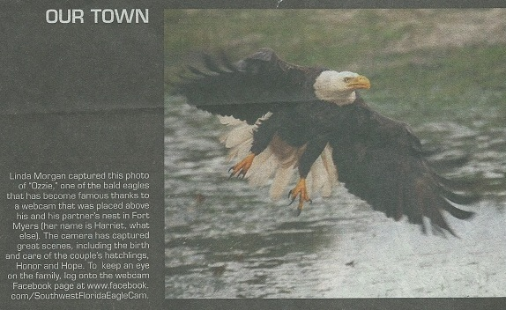

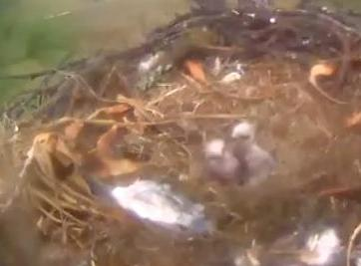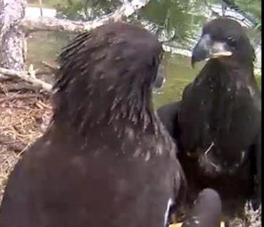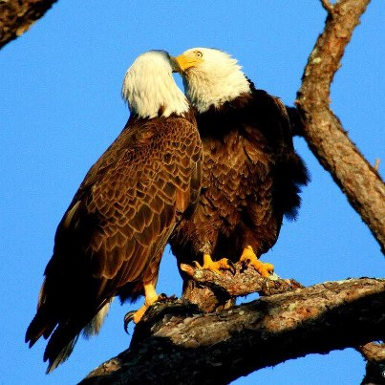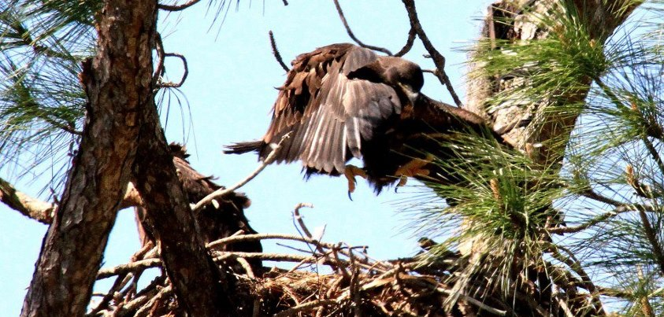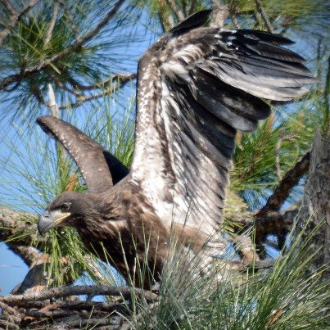

"The eagles are wild birds, and anything can happen in the wild. SWFL Eagle Cam does not interfere or intervene, and allows nature to take its course. You'll see life and you might see death, but this is real nature in action!"

First egg was laid on November 26 at 1:47 pm. First egg hatched on January 1, 2013 at 10:44 pm.
Second egg was laid on November 29 at 6:38 pm. Second egg hatched on January 3, 2013 at 9:49 pm.
History of chicks at this nest...2011/12 - 1 chick, 2010/11 - 1 chick,2009/10 - 1 chicks, 2008/09 - 2 chicks
The eagles have had their names ever since they moved onto the property in 2006/07. Ozzie and Harriet. The new chicks are Hope and Honor.
The nest resides 60 feet above the ground, in a Slash Pine tree. The camera faces South East.
Nesting season begins here in South FL Oct. 1. The eagles stay until late April or May.
These bald eagles have been coming to this nest for the past 6 years. They reside in this nest between the months of October and April. Before building this nest in 2006/07, the pair had a nest on the opposite side of Bayshore Road. This location is now known as Eagle Landing. This mature, mating pair continue to make Southwest Florida their winter home.
This year, DPRE is excited to have a live look into their Southwest Florida nest. We have installed a camera that will film the birds 24/7 and stream live video directly to this site. The camera is positioned 6 feet above the nest. It is attached to a tree limb using no screws or nails in order to preserve the tree. The camera's night vision is an infrared light which emits no actual light. Nor does it make any noise. The birds do not see or hear anything coming from the camera.
The objective of this camera is to bring these beautiful birds into our homes. The goal of DPRE is to foster appreciation, admiration and respect for these magnificent creatures. Our intentions are to learn from these birds so we may better understand them and their habits.
This nest is labeled LEO26B of the Florida State Monitoring Program. It has been monitored for 5 years. The first year was when the nest was across the street in 2007. The pair relocated the nest in 2006/07 to its present location. There are 133 nests in a 25 mile radius. Closet nest is one mile.
Eagle Watching Etiquette (recommendations for avoiding disturbance to nesting eagles):
- Park in a safe location and remain in or immediately next to your vehicle while viewing.
- Do not approach the nest directly or attempt to make an eagle fly.
- Avoid loud noises, such as yelling, door slamming, or horn honking.
- Use binoculars or a spotting scope instead of trying to get “a little bit closer.”- Persons on foot can be disturbing to bald eagles.
- Respect private property.
- Maintain a buffer of 330 feet from the nest and respect restricted areas.
- If you feel you must visit the nest, view from sidewalk across the street near commercial parking (south side of Bayshore Rd).
- Please remember the closer you are to the nest, the less you can see. The best viewing location is from your desktop at home.
We want all to enjoy these beautiful birds for years to come so please be respectful of the nest and the eagles.

